I
I SUMTER , SOUTH CAROLI
I
I I I (
r

r
f
r DESIGN REVIEW GUIDELINES MANUAL
I
i
[

TABLE OF CONTENTS
- INTRODUCTION I
- WHY II
- PURPOSE III
- HISTORICAL OVERVIEW IV
  - COMMERCIAL BUILDING GUIDELINES 1
  - NEW COMMERCIAL BUILDING GUIDELINES - SITE AND SETTING 19
  - RESIDENTIAL GUIDELINES - SITE AND SETTING 30
  - RESIDENTIAL GUIDELINES - REHABILITATION 37
  - NEW RESIDENTIAL CONSTRUCTION 69
APPENDIX A 82
APPENDIX B - MAPS - 2 86
APPENDIX C - SECRETARY OF THE INTERIOR STANDARDS FOR
REHABILITATION 88
APPENDIX D - DEFINITIONS 89
INDEX 94

IN DEX
Pa r k ing 1

Pa r k ing Lot s Setba ck 1

Landscaping 2

Sidewa l k & St reet Impr ovement s 3

St r eet L ight s 4

COMMERC IAL BU IL DING REHAB IL ITAT ION

St or e£ ront s 5

Ent r ances 6

Displa y W indows 7

Pr eserve Columns 8

Prese rve Bu lkhea ds 8

T r an soms & Bu lkhea ds 9

Awnings ( P ictu res ) . . . . . . . . . . . . . . . . . . . . . . . . . . . . . . . . . . . . . . . . . . . . 10 & 11

Uppe r Fa c;:ade W indow 11

Roof Corn ices 13

Color s & Textu r es 14
Sign s 14
# Sign s 14
Sign Ma ter ials 15
Sign Color s 15
Avo id Colonial T ype 15
Locat ion ( N eon ) 16
Let t er ing 17
H ist or ica l Wa ll 17
L ight ing 17
Ad j acent Bu ildings 18
Symbols & Logos 18
NEW COMMERC IAL BU IL D INGS GU I DEL INES
Cont emporary in Design 19
H istoric Reconst ruct ion 19

Fa i;ade Wa lls 2 0
Ve r t ical D ivision s 2 2
Ma int ain Setba ck 2 3
Uppe r Floor W indows 2 4
Bu ilding Height s 2 6
Addit ions at Rea r 2 7
Roof t op Addit ions 2 8
Const ruct ion Ma t er ia ls 2 9
RES IDENT IAL GU I DEL INES
Landscape Featu re s 30
Or ivewa y 31
Pa r k ing Lot s 32
Fence & Wa ll Ma t er ials 33
Fence Des ign 34
Ext er ior L ight ing 35

Signs 36
RES I DENT IAL G U IL DE INES - REHAB IL ITAION
Wood Siding 37
E f f ect s of Vinyl Siding 38 -4 0
Ma sonr y - Br ick - Founda t ion Wa lls 4 0 -4 4
Po r ches-Decks and St eps 4 5-4 9
Ha ndicap Ramps 50
Ent rances and Screen Door s 50-53
Ext er ior St aircases 54
W indows and Shut t er s 55-59
Roo f 60 -61
Chimneys 61
Ornamen t at ions 62 -63
Pa int Color s 63-64
Secondary Fa cades ( Cover HVAC ) 64
Awn ings 65-66

Solar Panels 6 6
Rec rea t iona l St ruct u res 67
Sat ellit e Dishes 68
Outbu ildings 68
NEW RES I DENT IAL CONST RUCT ION
Cu r r ent Per iod 6 9
Reconst ruct ion 6 9
He ight - Founda t ion - Floor t o Ceiling 7 0-72
E nt r ance s - Porches - Door s - W indows - Spacing 7 3-7 5
Setba cks 7 6
Roo f and Ma t er ial 7 6-7 8
Addit ions 7 9
Pa r k ing 8 0
Bu ilding Loca t ion 8 0 -81
Demo lit ion 81

I. Introduction

The City of Sumter Historic Preservation Design Review Committee has established the design guidelines presented in this manual to be used in evaluating the appropriateness of proposed exterior alterations and additions to properties within the city's two historic districts. In addition, these guidelines are intended to provide property owners with a clear understanding of the components of appropriate and compatible designs as well as an understanding of the design review process. These guidelines, however, should not be considered as a rigid set of restrictions; they should be viewed as guiding principles that, when followed, will result in sound historic preservation practices.

The designation of local historic districts has become a powerful tool that municipalities nationwide are using to protect their unique characteristics. The subsequent implementation of the design review process is intended to preserve the character of entire neighborhoods and business districts that are recognized as having valuable historic and architectural resources. The ultimate goal of the design review process is to allow active use and adaptation to properties within historic districts while maintaining the architectural integrity that gives the district significance.
The City of Sumter Historic Preservation Design Review Committee was created in 1996 as a means to protect the historic and architectural integrity of Sumter's two historic overlay districts: the Hampton Park neighborhood and the Central Business District. By ordinance, the committee is composed of individuals with diverse professions and experiences that can view proposed designs from many different perspectives. Therefore, it is possible for the committee to view proposed designs form numerous points of view; not only that of the professional architect.

It is the hope of the Historic Preservation Design Review Committee that these design guidelines will assist property owners in the development of compatible and appropriate designs. Thereby preserving some of the unique qualities that help to make Sumter a wonderful place to live and work.

- Why Have Design Guidelines
  - Enhance and Protect Property Values
The past two decades have seen a surge of interest in historic neighborhoods and commercial districts. Property values have soared as buyers have increasingly sought the historic and architectural character that a historic neighborhood or commercial district can offer. Design Guidelines assure property owners that their investment in that historic character is protected.

  - Promote Heritage Tourism
Heritage tourism is the visitation of historic sites and communities. Many communities, large and small, have used heritage tourism to stimulate local economies. If properly protected, Sumter's historic districts can help to draw thousands of visitors every year.

  - Reinforce Community Identity
Every year communities across the nation are becoming less and less distinct. Every town has the same fast-food restaurants, grocery stores, and professional businesses. Often, the only part of a community that is distinct from other communities is a historic neighborhood or commercial center. Protecting these areas will allow future generations to see what Sumter used to be and hopefully visualize what Sumter can be.

  - Tool For Economic Development
All of these factors combine to make Historic Preservation a powerful tool for economic development. This tool has been used time and
again in communities across the nation to remarkable success. An essential element in using a community's historic districts as a part of an economic development strategy is ensuring that the historic integrity that gives these districts value is protected in perpetuity.

- Design Review Guidelines-Purpose and Format
  - Provide Uniform Design Standards
Design Guidelines provide Design Review Committees with a means to review all requests with an established set of standards. This removes much of the subjectivity from the review process.

  - Provide Rehabilitation and Construction Information to Property Owners
Property owners often enter the review process with little or no information on what Design Review Committees look for. These Design Guidelines should provide insight into the review process.

  - The Review Process By Design Committee The review process is triggered by the property owner applying with the Planning Commission for a building permit in one the historic districts or applying directly for design review. Meetings of the Historic Preservation Design Review Committee are held on the second Thursday of every month. Applications must be received 22 days prior to a meeting to be placed on the agenda. This is to allow

adequate time for the request to be advertised to the public. Inmost cases, applicants should include with the application a description of the requested alteration to the building as well as any drawings, color samples, material samples, and photographs (new or historical).
The committee may approve, approve with conditions, or disapprove an application. If approved, the applicant will be granted a building permit and allowed to do the approved work. If disapproved, the applicant can appeal the decision of the committee to the Board of Appeals. All appeals must be filed within 30 days of the decision.

  - Is the Property in a Design Review District? Sumter City Council can establish whether or not a property is in one of the historic districts.

  - What Kind of Work Requires a COA (Certificate of Appropriateness)?
The Historic Preservation Design Review Committee (HPDRC) must review any new construction or demolition of a building in one of the historic districts and most exterior alterations. The committee must also review any new signs for businesses in the Central Business District.

  - What Kind of Work Does Not Require a COA? The Historic Preservation Design Review Committee does not review any interior alterations or renovations to buildings, changes in landscaping, or the use of the property. The committee has also approved certain paint color choices that they feel are appropriate for buildings in the historic districts. If paint colors are
- - -

chosen from these choices by the HPDRC, then review is not necessary. Approval and documentation will be obtained from the Staff.

  - What Other Regulations Are There?
All properties are subject to building codes and the City of Sumter Zoning and Development Standards Ordinance. Any disputes between building codes and these Design Guidelines will be decided by the Building Official or Planning Director.

  - How Do I Apply for a COA ?
Applications to the Historic Preservation Design Review Committee may be requested at the Planning Commission located at 33 North Main Street, or on­ line at www.sumtersc.gov. For minor changes nothing more may be required than to provide a detailed description of the work to be done on the application. For major rehabilitation work, new construction, or demolition, drawings, photographs, plans, color and material samples, and historical photographs may be necessary. These documents should be submitted along with the application.

Applications are reviewed first by the Planning Commission Staff for completeness. The applicant will be contacted if additional information is necessary. Once reviewed, the staff will decide upon a recommendation to the committee. Requests are reviewed on the second Thursday of each month by the Historic Preservation Design Review Committee. The requests are advertised in the Sumter Daily Item at leastl 5 days prior to the meeting so the public may attend to meetings and comment on the requests.

The committee has the right to delay action on a request in order to gather additional information or documentation.

  - Changes Without Board Approval
If a property owner initiates work without the prior approval of the Historic Preservation Design Review Committee, a stop work order may be issued. The property owner will then be required to explain the work and why design approval was not sought. Completion of the design review process may then be required. Once the design review process is completed the property owner must follow the committee's requirements. If these requirements are not met an owner may face fines or an order to restore the property back to its original condition.
IV. Historical Overview

The present City of Sumter, one of the oldest of the backcountry settlements, is an area that was originally part of Craven County, which was established in 1682 under the tenure of the Lords Proprietors of South Carolina. Almost a century later, in 1769, Craven County became part of the Camden Judicial District. In 1783 the Camden District was divided into seven counties, two of which were Claremont and Clarendon. Settlement in these counties consisted of two small villages. In 1792 land taken from Claremont and Clarendon Counties was used to form Salem County. Eight years later, in 1800, the state legislature merged Claremont, Clarendon, and Salem Counties to form the Sumter District and authorized the construction of a
district court house. 1 The state appointees who oversaw the establishment of the new court house chose as its site a
plantation owned by John Gayle. The Gayle Plantation site located near the center of the district became the nucleus for the village of Sumterville. The Sumterville settlement grew slowly during the first part of the eighteenth century, and through the 1830's numbered only twenty houses. In 1845 the village was incorporated as a square with sides one-and-one half miles long with a centered court house. The layout of the streets in the downtown area remained much as it was in 1845.

As was the case with many backcountry settlements, it was the advent of the railroad that opened the way to economic prosperity. A section of the Wilmington and Manchester

, Bruce G. Harvey, Sumter Preservation Planning Project (1997), pp. 4-5.

Railroad (W&M RR) connecting Sumterville to the Camden Branch was opened in 1852 and acted as the catalyst for the town's first economic boom. The impact of the railroad on Sumterville, which in 1855 changed its name to "Sumter," was profound. The decade of the l 850's saw unprecedented growth in the construction of new residential, commercial, and warehouse buildings; the town drained its streets; and its residents acquired their first bank. Many fine homes of the neoclassical and Victorian types, a number of which survive today, were built during the period between the advent of the railroad and the outbreak of the Civil War.2

The Civil War had a profound impact on all of South Carolina, including the town of Sumter; but the economic structure of the area, a pattern of small farms rather than large plantations dependent on slave labor, provided a better base for recovery than existed in many other counties. The Camden Branch of
the South Carolina Railroad reopened in 1867. The Wilmington, Columbia, and Augusta railroad opened in 1871. The second railroad provided Sumter with direct access to Columbia. By 1900 six new rail lines entered Sumter County and helped to promote infrastructural development in the village. The Sumter Electric Light Company opened a power plant near the railroad depot inl 889, and the village boasted a wide range of stores, including an insurance agency, two printing stores, various general merchandise stores, two drug stores and liquor stores, a millinery, and a Masonic Hall.

:Ibid . pp. 9-12.

The village began to grow beyond the original one-and-one half mile square around the courthouse; and prominent additions included the grand new First Presbyterian Church, the Sumter Iron Works, and an unusual housing development of four precise rows of four houses each at the corner of Canal and Sumter Streets.

Sumter's economy continued to diversify during the late nineteenth and early twentieth centuries; and Sumter increased its industrial base to include brick manufacturing; flour, lumber, and grist mills; a turpentine factory; and other factories associated with lumber and cotton products.

Sumter enjoyed another significant boost to its economy in 1941, when the federal government opened an Army Air Corps training base which would become Shaw Air Force Base. The large number of neighborhoods, houses, and apartments dating to the late l 940's and l 950's offer testament to the impact that Shaw Air Force Base has had on the city of Sumter. 3

Sumter's architectural development mirrors the city's economic development and its overall patterns of growth. With the exception of a small sample of modified Greek Revival houses, most of the older structures date from the later nineteenth and earlier twentieth centuries, the period that coincides with the surge of growth brought about by the railroads and new manufacturing enterprise. The second wave of prosperity and the accompanying explosion of residential construction spurred by the presence of Shaw Air Force Base resulted in a large

3 Jbid, pp. 14-16.

sample of immediate post-war housing, both single and multiple family, in a variety of styles.

The city contains a rich mix of residential styles, but not as many historic commercial and manufacturing buildings. Unfortunately, even the commercial building which still stand have suffered greatly from demolitions and alterations to facades, and the historic character of the downtown is difficult to identify .4 According to architectural historian Bruce Harvey, it is important to recognize two sets of distinctions when analyzing the types of residential architecture represented in Sumter. The first is a time distinction: those built before World War II and those built after the War. Residential
architecture, particularly in the late nineteenth century, featured an eclectic mix of recognizable styles, many of which were loosely derived from European styles. By the early twentieth century, however, the emphasis had shifted to more identifiably "American" styles such as Prairie and Craftsman. After World War II, the styles became more difficult to identify as having either European or Victorian American precedents, even though they remained eclectic.

The second distinction to be made when analyzing historic architecture is spatial. Before the Civil War, there was rarely little separation of residential and commercial structures. After the War, however, residential areas became much more clearly distinct from commercial areas. By the time that Sumter's modem growth appeared at the end of the nineteenth century, the division between residential and commercial areas of the

,Ibid., P. 24.

city was clearly in evidence. Two different residential neighborhoods appeared during this period, one on each side of Liberty St., with the most prominent clusters of historic buildings being the neighborhood around Memorial Park. This neighborhood, known today as "Hampton Park," soon became the principal neighborhood for Sumter's wealthier residents, and the styles of houses reflect what was appropriate for members of what Harvey calls "an up-and-corning urban elite." Houses surrounding Memorial Park provide examples of what were in the late nineteenth and early twentieth centuries considered the latest styles: Italianate, Queen Anne, Craftsman/ Art and Crafts, Prairie, Spanish Mission, and International.

Another residential neighborhood that developed in the late nineteenth and early twentieth centuries was the area immediately south of West Liberty Street. While the range of styles was not as great, the density loses nothing in comparison with the area around Memorial Park. Two other clusters of pre­ World War IIhouses can be found in the areas on either side of South Main Street and Manning Avenue and in the northeast section centered around Anne Park between Crosswell and Loring Drives. 5

Sumter's second period of economic prosperity, that immediately following World War II, brought a corresponding surge residential development. Two types of housing are evident: small single family homes and one-story apartment buildings. The area along Carolina Avenue, Jackson Street,

5 Ibid.. pp. 24-27.

Woodlawn Avenue, Highland Avenue, Miller Road, and Dixie Drive contain the largest number of smaller post-World War II houses, built originally for young military families. The Mason Croft area, just north of the Hampton Park historic district, was home to more substantial post-World War IT houses.6

The City of Sumter has one National Register of Historic Places (NHRP) Historic District, which was listed on the NHRP in 1975. This district is centered on Main Street between Canal and Caldwell Streets and extends less than one block to the east and west of Main Street. The City of Sumter has also designated the Hampton Park area as a local historic district. In addition to the two historic districts, there are several individual buildings in Sumter that are listed on the NHRP. The names of these and the dates on which they were listed are as follows:

Sumter Town Hall/Opera House 1973 May 24, 1973
Charles T. Mason House July 3, 19977

Harvey lists several threats to Sumter's historic districts and building. The first is a change to the pattern of buildings in historic neighborhoods, such as the addition of modem buildings which bear no relation to their surroundings in terms of style, scale, or setback. A second threat to historic districts is the demolition of buildings within the historic neighborhoods. Demolition does more harm than simply the removal of a significant building because a neighborhood is more than the sum total of its constituent elements. The third threat to historically significant buildings is modification that reduces or
eliminates defining characteristics, thereby eliminating the buildings' historical and architectural significance. 8

Historic districts and buildings are truly community treasures: They support economic development; they enhance quality of life; and they provide a vital link between a community's past,

Elizabeth White House

Carnegie Public Library (now the
March 21, 1978
its present, and its future. Unfortunately, when such treasures are lost, they can never be replaced. Design guidelines for historic districts and buildings, therefore, are more than rules

archives of the Genealogical Society) August 5, 1994
Henry Lee Scarborough House January 20, 1995
and regulations; they are they key to helping a community retain its identity.

O'Donnell House

,Ibid., P. 32

April 12, 1996

1 /bid, P. 39.
slbid.. pp. 35-36.

COMMERCIAL BUILDING GUIDELINES-SITE AND SETTING

#1) PARKING LOTS SHOULD BE SCREENED FROM PEDESTRIAN VIEW

Normally Required
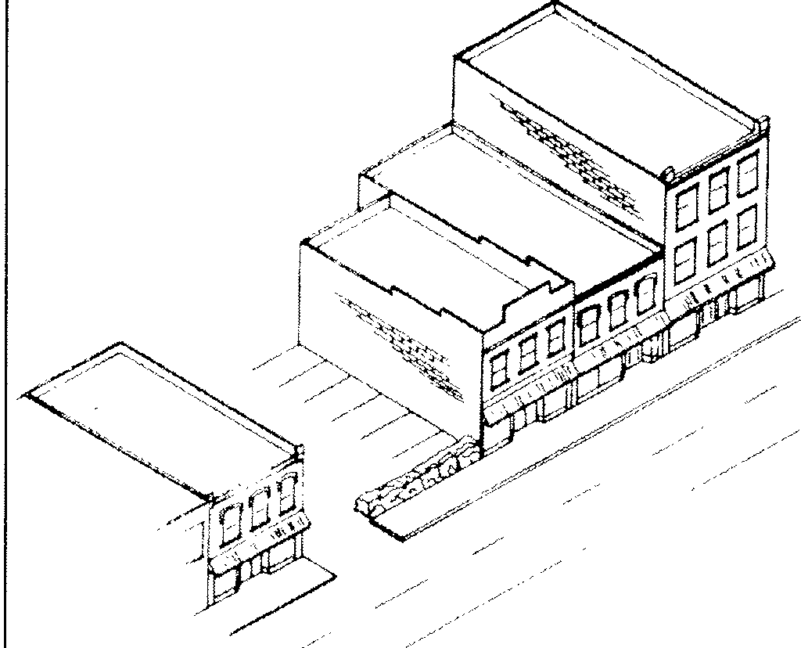
a . Parking lots in Sumter shall follow the minimum landscaping requirements as set forth in the Zoning Ordinance. Landscaping beyond that which is required is encouraged.
..

Parking lots should be screened from view.

#2) PARKING LOTS SHOULD MAINTAIN SETBACK

Recommended

a. Parking lots should repeat the general setback found along each block in the downtown area. Almost all blocks have buildings flush with the sidewalk level. This rhythm should not be broken by a parking lot or park area which does not continue this setback. This rhythm can be maintained along parking lots' and sidewalks through landscape elements such as trees, hedges, or brick and wood fences.

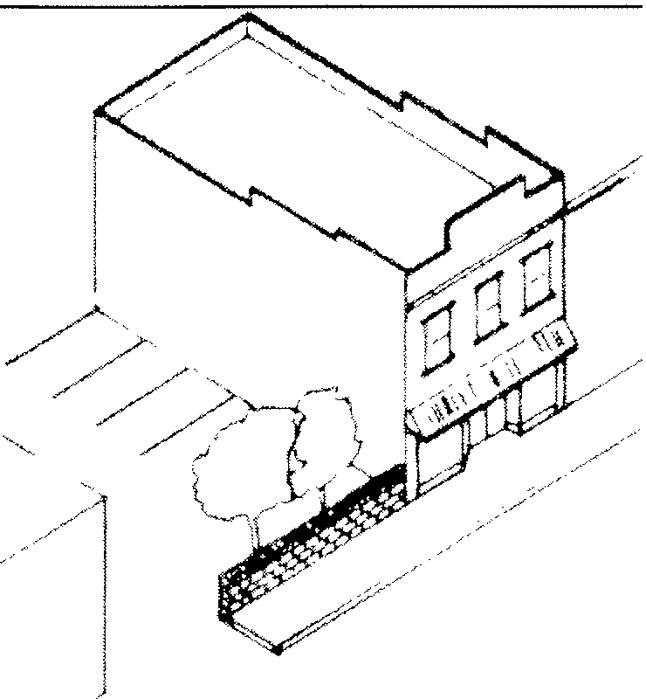

Parking lots should maintain setback.

#3) LANDSCAPING SHOULD COMPLEMENT RATHER THAN DETRACT FROM BUILDINGS

Recommended

- Trees of limited height and dimensions should be considered for the downtown area. His t or ic comme r cia l area s such as downt own Sumt er of t en had nume rous shade t rees to shelter pedest r ians . Wit h the coming of the aut omobile man y of these t rees we re r emoved t o ma ke wa y f or pa r king . The int rodu ct ion o f new t r ees int o the downt own area is appropr iat e as long as the t rees selected are o f limit ed he ight and dimension . When ma tu re , t r ees should not over ly ma sk bu ildings and ma ke signs and det ails dif f icult t o observe . T rees should be spaced at least 30 f eet f rom each othe r and have plant ing beds o f at least n ine squa re f eet .

- Low plants and shrubs at sidewalks are appropriate. The int r oduct ion o f low hedges or plant er s with f lower s or othe r decora t ive plant s is appropr iat e . These ma y be desi red as pa rt o f an overa ll str eet scape pr ogr am by the city or added on an individua l ba sis by pr opert y owne rs .

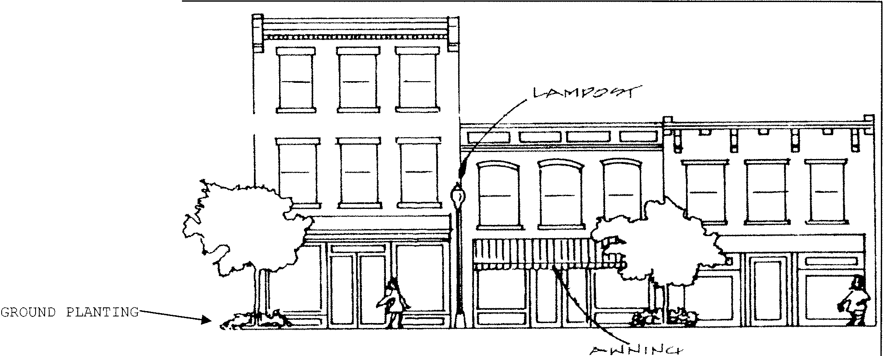
T REES ---- -.

Traditional landscaping in historic commercial areas.

#4) SIDEWALK AND STREET IMPROVEMENTS SHOULD RESPECT DOWNTOWN CHARACTER

Recommended

a . Streetscape improvements should be in keeping with the traditional character of downtown . Appropriate improvements include the introduction of brick sidewalks or textured concrete which imitates the appearance of brick. The use of brick or textured concrete can be of particular assistance in defining pedestrian crosswalks across streets. Simple street furniture such as wood benches would also be appropriate. The addition of elements such as continuous metal or concrete canopies, oversized kiosks or gazebos, and ornate wrought iron street furniture should not occur.

b . Streetscape improvements should be selected f or their simplicity and durabili ty . Many streetscape improvements completed across the country in the 1960s and 1970s are now in varying degrees of deterioration. In many of these cases materials or construction methods were selected which were incompatible with exposure to the elements or could not withstand the constant use by vehicles and pedestrians. Before any major expenditure for street furniture, sidewalk materials, or curbing, the longevity and lifespan of te proposed improvements should be carefully studied. Once selected, street furniture should be sited away from vehicular areas and be bolted or anchored in place to discourage vandalism.

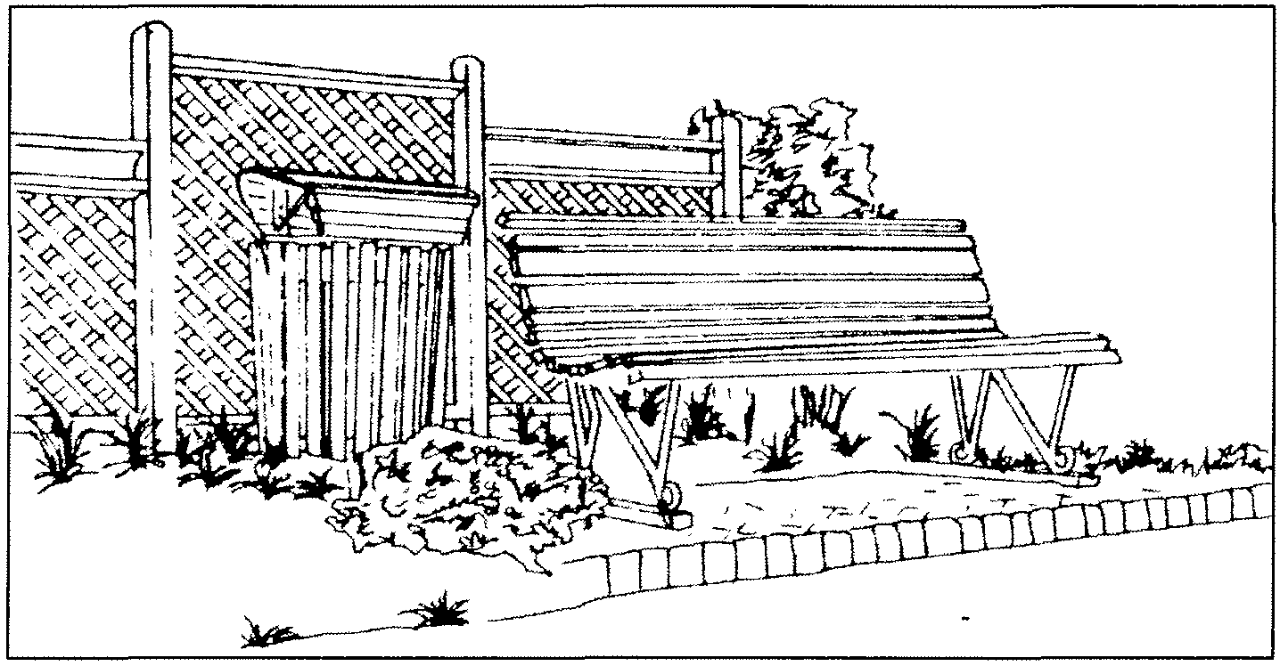

Streetscape elements should be simple and durable.

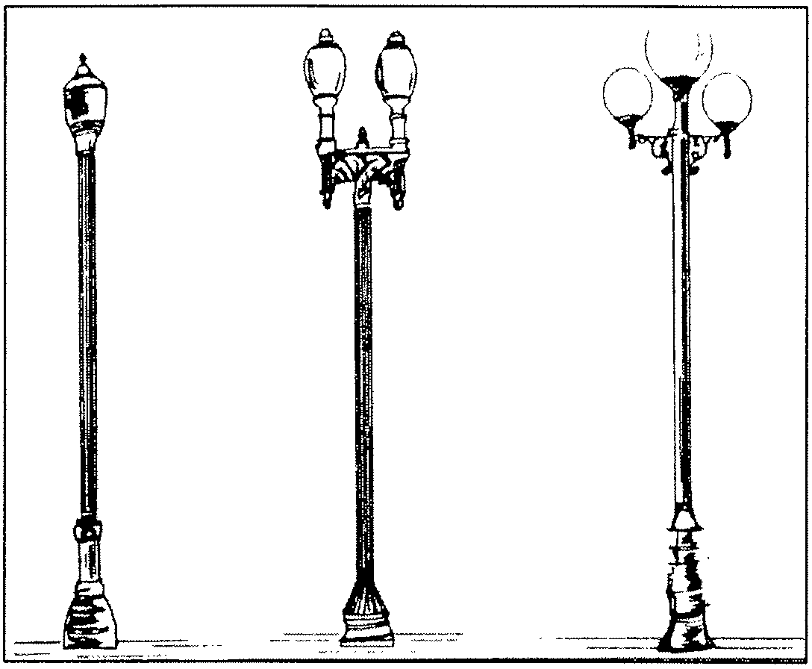
#5) LIGHT FIXTURES WHICH REINFORCE DOWNTOWN CHARACTER SHOULD BE CONSIDERED

Recommended

a. The introduction of traditional light fixtures is appropriate. Many communities have re­ introduced historic designs for street lighting into their downtown areas. These fixtures are generally of cast iron or similar types of metal and have globes based on historic precedents. The design of the lighting should be based on light fixtures originally used in Sumter. If such light designs are no longer available fixtures as close to the original design should be considered. The expense of such fixtures should be carefully weighed against their potential use. Downtown Sumter presently does not have extensive evening shopping or entertainment. However, if substantial pedestrian traffic evolves in the evening the use of period lighting may be a desired amenity.

Historic light fixtures.

COMMERCIAL BUILDINGS-REHABILITATION

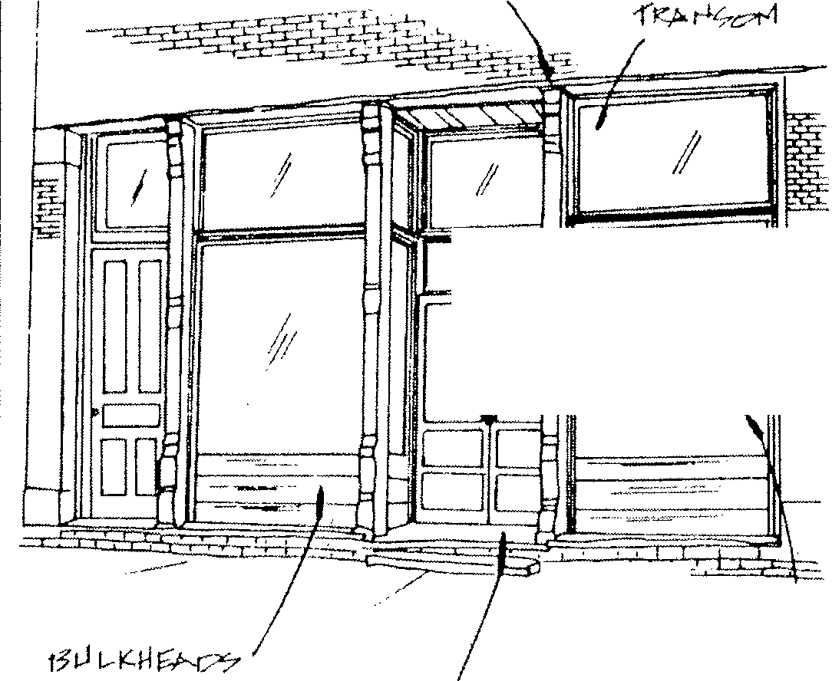
#6) ORIGINAL STOREFRONT CONFIGURATION SHOULD NOT BE ALTERED
./
C.t::'.* C"
t-J-f /2'.'P.- t-l c.f:'.'.
pI"7 F"L>Y
i,1 i t?O i,-1;,-

Normally Required
- Original storefronts that remain in the downtown area should be preserved and maintained. There should be no removal of original doors, bulkheads, decorative glass or other elements unless their deterioration can be demonstrated.
- Original elements that are too deteriorated to retain should be replaced with new elements to match in design and materials.
.1 | f
 | I

- Storefronts that have decorative tile or glass installed prior to 1940 should be retained.
- Buildings that are renovated and have post-1940 storefronts should receive storefronts in keeping with the original architectural character of the building.

The history of storefronts in conununities such as Sumter in the 20th century is one of continual modernization to keep in step with marketing trends and few storefronts retain their original design and configuration. Historic storefronts were generally composed of a central or offset recessed entrance, flanking display windows resting on bulkheads, and large transoms. Much of the storefront was of glass to allow ready viewing of merchandise displayed in the building. Materials such as steel beams, cast iron columns, and brick piers were often employed on the storefront to carry the weight of the upper
facade and allow the extensive use of glass.

Typical historic storefront configuration.

A characteristic found on some late 19th century commercial buildings is the remodeling of the storefront in the 1920s and 1930s with designs from this later period. Such storefronts often have interlocking colored panels known as Carrara glass or Vitrolite, or have designs reflective of the Art Deco or Moderne styles. These storefronts are considered to have architectural and historical value and should be retained.
Later storefront modernization often obscures rather than removes original elements and
details such as transoms, cast iron columns, and decorative glass or metalwork may be found beneath later additions. Such details should be retained and incorporated into the restored storefront. If no original detailing exists a new storefront based upon traditional or historic designs may be added. Historic photographs of downtown commercial buildings exist and these should be consulted when a new storefront is contemplated.

#7) RETAIN ORIGINAL ENTRANCES

Normally Required

- Original doors and transoms over doors shall not be removed and replaced unless extensive deterioration is demonstrated.
- Original door openings shall not be enclosed or reduced in size.
- Unfinished aluminum doors should not be installed on storefronts. Metal doors with a dark bronze finish or anodized aluminum finish may be appropriate.
- Transoms should not be enclosed, covered, or obscured.
- Original designs and dimensions of recessed entrances should be retained.
Recommended

- The rehabilitation of historic entrances should follow the original design if such evidence is available such as historic photographs or "ghosts" of original doors. If such evidence is not available, new doors of wood and glass in historic designs should be installed. Doors of single light and glass are the most appropriate for downtown Sumter.
- New entrance openings on storefronts should not be added. Openings may be added if required by building codes. New entrance openings should be kept simple in design with detailing to match the original door. Single light glass and wood doors would be appropriate for most buildings. New doors should be flush with the sidewalk as opposed to mimicking historic recessed entrances. Such doors may meet building codes if they open into a building rather than outward over the sidewalk. If building codes do not allow doors flush with the sidewalk, recessed doors are acceptable.
Original flush or recessed entrances should be retained and these types of entrance designs should be encouraged for new construction. Most historic doors in downtown Sumter are of wood construction and have a large rectangular glass light. Doors of this design are appropriate for new entrances. Modern aluminum and glass or other metal doors are not appropriate and should be avoided. Solid wood paneled doors or doors with small glass lights should also be avoided. Original transoms over doors should be retained and the use of transoms in new door designs should be considered.

#8) RETAIN ORIGINAL DISPLAY WINDOWS AND DETAILING

-·-
'----
'---
'----
I
,_
e---
1
>----
>----
l------
t------
I----
I----

- f
--
1.---
. ..
>-----

>. ---
,.
............... -- - -- ..,-. -----
-
-

. =-
I
""'' "'' '' /;

Normally Required

- Original display windows should be retained
c-
l =-,::.,,:i
f
=·
I
  - I
"'

and preserved.
- Display window openings should not be enclosed or obscured with added materials.
- l =tb
I I
I
D..
i,.,

- Display windows should remain clear and not be tinted- New display windows should match the original dimensions in size and scale.

Recommended
h CJ -..
k, DC <--·--'
L- I

- New display windows should have mullions or muntins of copper or bronze as opposed to raw aluminum. If aluminum is used it should be primed and painted a complimentary color with the rest of the storefront.
- Clear insulated glass may be installed on storefronts where the original glass no longer exists.
. j

t::
I,, I
- J
I
c--:::::= t::"';;;;::;:::z::: I 1 --

/-- ITA-l ,- ]
= I -- =·"--

Original display window dimensions should not be altered and materials such as copper or bronze should be retained. Original storefront windows should not be enclosed or downsized. New storefront display windows should fill their
= I I!

, .
,,
'--
'/ "--
1---
]] ,I ,_
- 6' ,
D
I

original opening and have mullion or muntin bars
.._ -

of copper or aluminum. Dark anodized aluminum is I,.. DE

preferred for new display windows as opposed to the untreated or "raw" aluminum frames. If used, raw aluminum should be primed and painted. Clear transparent glass should be used. There should be no use of heavily tinted glass. If privacy is desired by the occupant the use of shades or blinds on the inside of the window is a much better alternative than tinted glass.
cl<i
,_ le: ,_ CJ ----
...,
-,

Inappropriate storefront alterations.

#9) PRESERVE CAST IRON, STONE, AND BRICK COLUMNS

Normally Required

a . Original cast iron columns , brick piers , or stone piers should be preserved and maintained . Several storefronts in the downtown area were built with columns, pilasters, or piers which served as structural and decorative storefront elements. The weight of the upper facade was carried by these columns or pilasters and enabled most of the storefront to be of glass for display purposes. Cast iron was a popular feature of storefronts at the turn of the century because of its strength and the various molds available to create decorative designs. Brick piers were often used on buildings constructed after 1910.
b . Decorative cast iron elements , brick or stone piers should not be concealed . Original supportive and decorative elements should be retained and the obscuring or covering of these elements should not take place.

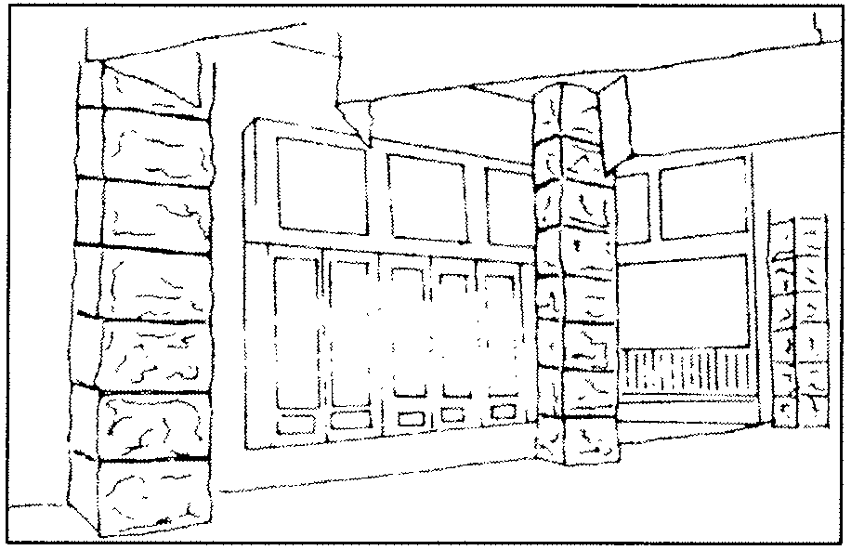
Stone pilasters on Friedhein Building.
#10) RETAIN AND PRESERVE BULKHEADS

Normally Required

a . Original wood or brick bulkheads should be preserved and maintained . Elements such as Carrara glass or glazed tile added in the 1920s or 1930s should also be preserved .
b . Original bulkheads should not be covered or obscured .

Recommended

c . If original bulkheads are missing , new bulkheads of wood designs are recommended . Brick bulkheads may also be added if they match the original brick on a building or if they are painted to complement other storef ront elements .

Bulkheads are the lower panels which support the display windows and are also referred to as kickplates. Bulkheads are most often of brick or wood construction. Common decorative elements of bulkheads include recessed panels or diagonal siding on those of wood, recessed panels or corbelled designs on those of brick, and the use of glazed tile or Carrara glass on bulkheads of the early 20th century. Original bulkhead materials should be retained and preserved. Where replacement is necessary the new bulkheads should be of materials to imitate the original. The new appearance of brick bulkheads can be enhanced through painting the brick and mortar.

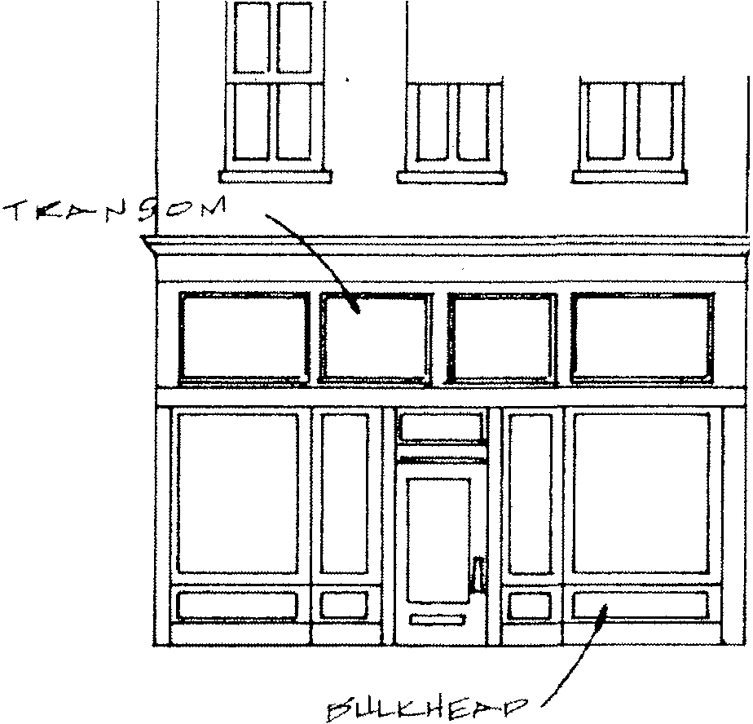
#11) RETAIN AND PRESERVE TRANSOMS

DO DD

Normally Required

- Original transoms should be preserved and maintained.
- Transoms should not be enclosed or obscured with new materials.
- Historic transom materials such as prism glass or leaded glass should be preserved and maintained.

Recommended

- New transom glass should be clear and not tinted.
- If original transoms are not reopened the transom opening may be used as the location for a sign panel.

Transoms are rectangular windows added above the display windows and door openings. The design of transoms allowed sunlight to reach into the interior of the building to help in illumination and heating. Transoms were often hinged to open and close and when opened would allow heat to escape in summer months. Painted signs were often placed on transoms and the use of translucent decorative glass was also used as a decorative feature. Transoms should be retained and preserved on original storefronts and new designs should utilize traditional transom designs. Transoms were often covered over or obscured in past remodelings and the existence of original transoms should be investigated prior to storefront restoration.

Location of transoms and bulkhead panels.

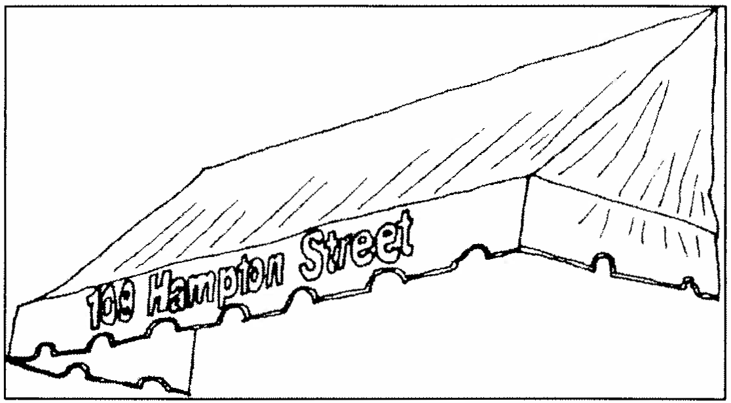
#12) AWNINGS OR CANOPIES ARE APPROPRIATE FOR STOREFRONTS

Normally Required

- Original canopies or awnings of wood and metal construction should be retained and preserved.
- Metal awnings in the downtown area should not be installed.

Recommended

- The installation of retractable canvas awnings at appropriate storefront locations is recommended .
- Canvas, vinyl-coated canvas, and acrylic are the most appropriate awning materials for pre-1940 commercial buildings.
- Awnings should cover only the storefront display windows or transom . Upper facade details should not be obscured.
- For existing metal awnings the application of a canvas overlay is encouraged.
- The most appropriate awning designs for pre- 1940 dwellings are standard or shed awnings. Also acceptable are circular or accordion designs. Box or casement awnings are more nontraditional and less desirable, however , these may be installed if requested. Valences should be in keeping with traditional patterns such as scalloped , wave , or sawtooth designs .

The use of awnings or other sidewalk coverings has always been common in downtown Sumter . Awnings protect pedestrians from the elements , protect merchan dise from effects of weathering , and may serve as a sign or identity for a business. In summer months awnings block sunlight into the first floor area reducing air conditioning costs

Sbed canvas awning at 109 Hampton Street.

and retractable awnings may be rolled up in winter months to allow additional light and solar heat into a building . Awnings were mounted above the display windows often above the transom or below the transom on the transom bar .
The retention of existing awnings and introduction of new awnings into the downtown area is encouraged. Awnings should not be of metal but instead of canvas , acrylic coated canvas, or similar mat erials . Awnings should be placed at the top of openings and not be oversized to obscure the upper facade . Awnings should also be designed to relate to the shape of the opening it covers . Most transoms and display windows are rectangular in shape and rectangular straight sided awnings are best for these openings . Arched awnings are suitable for arched entrance or window openings .

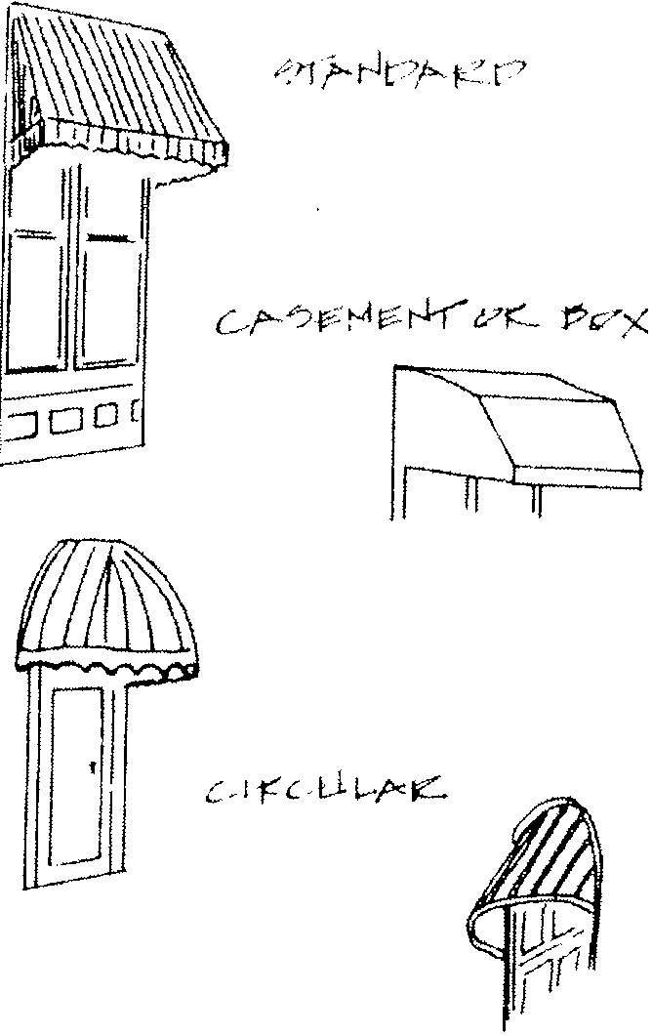
#13) UPPER FACADE WINDOWS SHOULD RETAIN ORIGINAL DIMENSIONS AND DETAILS

Normally Required
  - Original window opening dimensions and details should be preserved and maintained. Original window sash should be retained.
  - Original window openings should not be altered. This includes enclosing original openings or obscuring windows with added materials.
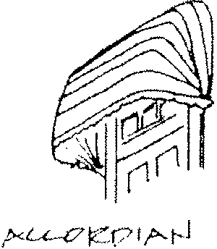
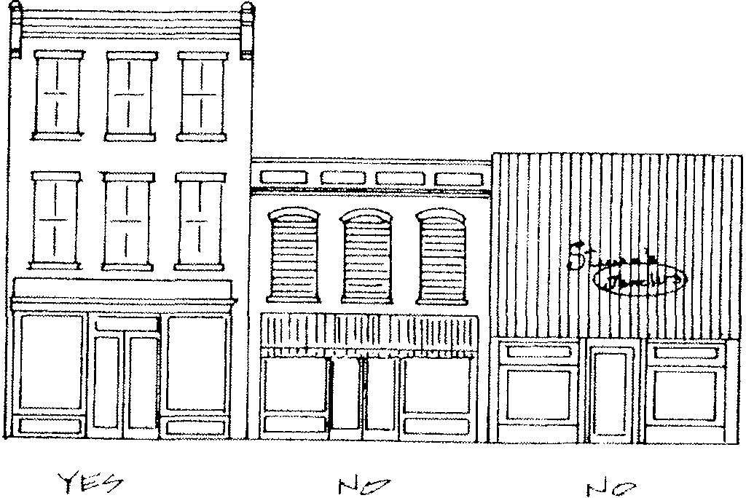
  - Window details such as decorative wood or sheet metal cornices should be preserved and maintained.

Appropriate awning designs.
Upper facade treatments.

Recommended

- If original windows are missing, replacement windows should be of one-over-one sash configuration. These windows should have distinct meeting rails and have the appearance of operable windows. Windows with flush or snap on mullions should not be installed.
- Wood is the preferred material for replacement windows. Also allowed are one-over-one aluminum windows with a baked enamel finish. Raw or unpainted aluminum windows should not be installed.
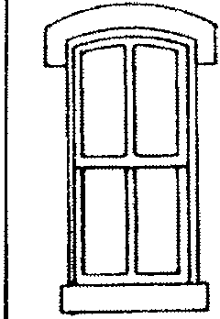
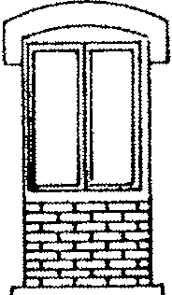
- Storm windows may be applied if they match the original window configuration and have a baked enamel or painted finish.

D D D

Inappropriate window alterations.
Upper floor areas of buildings in downtown areas were frequently vacated in the 1960s and 1970s with only the first floor utilized. This led many property owners in the commercial area of Sumter to cover or enclose upper floor windows or neglect the maintenance of original windows. Windows are one of the most important defining features on upper facades and the openings should be retained and preserved.

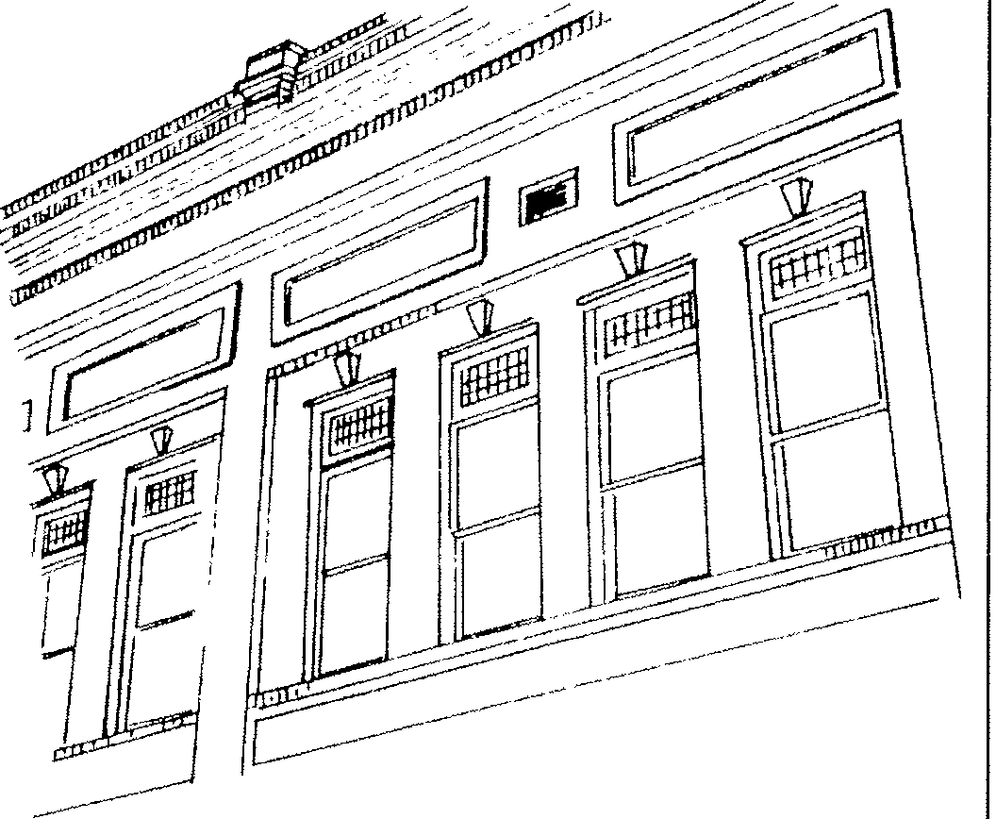
Original upper facade windows

#14 ) RETAI N AND PRESERVE ROOF CORNICES

Normally Required

- Original brick, wood, or sheet metal cornices should be preserved and maintained.
- Original cornice elements should not be removed or obscured.

Recommended

- On buildings that have lost their original metal or wood cornices, replacement based on historic evidence such as photographs or "ghosts" of cornice designs is recommended. If such evidence does not exist a simple cornice of wood or metal should be installed. Materials such as fiberglass reinforced concrete may also be used.
- New cornices should have the same overall dimensions as the original or as commonly found on downtown buildings.
also found in the downtown area. These cornices are of tin or similar metals and were stamped in various decorative designs. Corrunon cornice embellishments include brackets, floral designs, and corner piers or caps. Sheet metal cornices were also custom made and stamped with the building owner's name or the building's date of construction. Cornices that are properly maintained last indefinitely.
Cornices are an important defining element of downtown corrunercial buildings and original cornices should be preserved and maintained. On buildings that have had the original cornices removed future renovation should include the addition of cornices based on historic designs.

Historic corrunercial Sumter were built with line. This decorative terminate or cap the important element for

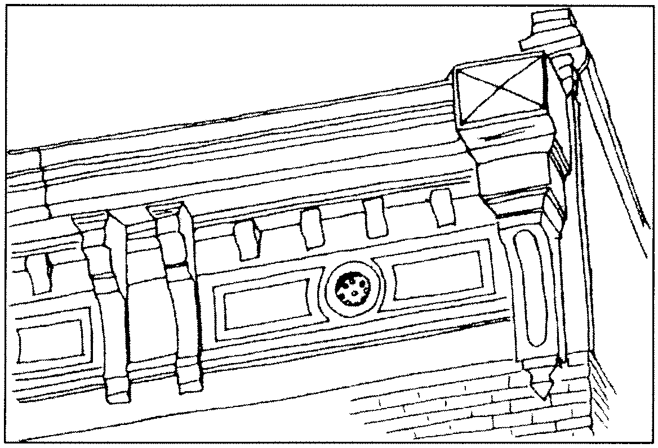
buildings in downtown cornices at the roof feature served to building and is an downtown corrunercial

structures. A number of corbelled brick cornices
brick buildings have at the roofline while

others are of sheet metal construction.
Brick cornices are made up of several horizontal courses of brick which are stepped progressively forward with height. The bricks are often laid in decorative patterns such as diamond patterns or dentil and modillion block designs. Brick cornices were rarely removed but were often covered with added materials in upper facade remodeling.
Sheet metal cornices are less corrunon but are

Retain and preserve sheet metal cornices.

#15) HISTORIC COLORS AND TEXTURES SHOULD BE MAINTAINED

Norm.ally Required

- Masonry walls that have not been previously painted should not be painted unless there are significant contrasts in the brick and mortar.
- Stucco or drivi t surfaces to downtown buildings should not be added.

Recommended

- Colors should be selected to compliment the dominant existing colors of dark red and similar hues.

The downtown area of Sumter contains a variety of colors in elements such as upper facades, storefronts, signs, and awnings. The introduction and use of colors shall not be restricted but it is encouraged that colors complement each building and its neighbors. The overall dominant colors in the downtown area are variations of red, brown, and grey reflected by the widespread use of brick, stone, and concrete building materials.
Paint colors on storefronts, trim, and upper facade openings should relate to the overall color of the building as should added elements such as signs and awnings. In many cases, this will be colors which complement or harmonize with the overall brick or stone colors found on upper facades. The use of contrasting colors to highlight architectural details on storefronts and upper facades is encouraged. The use of intense or vivid hues should not be introduced into the downtown area which would create disharmony with adjacent buildings. Original masonry exteriors should not be painted.
#16) NEW SIGNS MUST FOLLOW THE SIGN CODE
Norm.ally Required
- All signs erected or installed in the downtown area must meet the maximum sign requirements stipulated in the Zoning Ordinance.
- Historic markers and professional name plates which do not exceed two square feet are exempted from review and do not require a sign perm.it.

Sumter has a detailed sign code in its Zoning Ordinance. New signs must meet the minimum and maximum requirements by this code in order to be installed or erected. In addition to these requirements signs should also be in keeping with traditional materials, size, and placement for historic buildings. The color and design of signs shall not be restricted in most cases. Signs should be selected which are legible, clear, and pedestrian oriented.

#17) THE NUMBER OF SIGNS PER BUILDING SHOULD BE KEPT TO A MINIMUM

Norm.ally Required

- Freestanding signs in the downtown commercial area shall not exceed one per street frontage.
- Wall signs shall not exceed 25% of the face of the building to which they are attached. However, less space for signage is recommended. REFER TO SECTION 8.i of the Sumter Zoning and Development Standards Ordinance for all sign regulations.

Recommended

- No more than three signs per building is recommended excluding window signs.
and should be avoided. Plastic letters signs are also inappropriate materials historic commercial buildings.
and for

Signs should not be the primary focus of a building and should not overpower historic design and elements. Excessive information on signs and a large number of signs often causes confusion for shoppers rather than providing clear identification of a business.
#19) SIGN COLORS SHOULD COMPLEMENT OVERALL BUILDING COLORS

Recommended

- No more than two or three colors should be used per sign.

#18) TRADITIONAL SIGN MATERIALS SHOULD BE
USED

Normally Required
- Dark backgrounds with historically appropriate and for sign colors. Dark colors since they complement the masonry in the downtown area.
light letters are should be considered are also appropriate dark red colors of

- Materials such as plywood, plastic substrates, and unfinished wood should not be used for signs in the downtown area.

Recommended

- The use of finished wood, brass letters, carved wood, gold leaf, or glass for signs is appropriate.
- Sign brackets should be of wood or pre-painted or finished metal.
- Signs should be mounted to minimize damage to historic materials. Mounting bolts on masonry building should be applied to go through mortar joints rather than the face of the masonry.

The use of painted or finished wood for signs was the most common type of wall sign or projecting sign at the turn of the century. These types of wood signs continue to be popular as are sandblasted wood signs. The use of plywood or similar types of unfinished wood have textures and appearances which are not appropriate
#20) COLONIAL OR "WILLIAMSBURG" SIGNS SHOULD BE A VOIDED

Recommended

- Contemporary sign designs and signs based on styles from the turn of the century and early 20th century are appropriate.
- Signs which reflect an earlier period of history such as colonial Williamsburg or New England are not appropriate and should be avoided.

#21) SIGNS SHOULD NOT CONCEAL ARCHITECTURAL DETAILS

Recommended

- Signs should not conceal original decorative designs or detailing.
- Original transom glass should not be covered or obscured with a solid sign panel.
- Temporary signs such as banners which conceal architectural details may be used for a limited period of time.

#22) SIGNS SHOULD BE PLACED AT TRADITIONAL SIGN LOCATIONS

Normally Required

- Wall signs should not exceed the height of the building cornice. Wall signs are allowed to extend 10 feet above the roof parapet of a building. However, this could encourage signs which obscure or overshadow historic detailing and is inappropriate for the downtown area.

Recommended

- Wall signs should be confined to the flat surface of the building.
- Wall signs may be painted or applied directly to the face of the building.
- Wall signs should be placed at traditional locations such as above transoms, on cornice fascia boards, or below cornices.
- Slgn brackets for projecting signs should be located no higher than second floor window sills.
- Awning valences are appropriate locations for signs.
- Neon may be used on the interior of buildings. The application of neon signs to exterior locations is not appropriate.

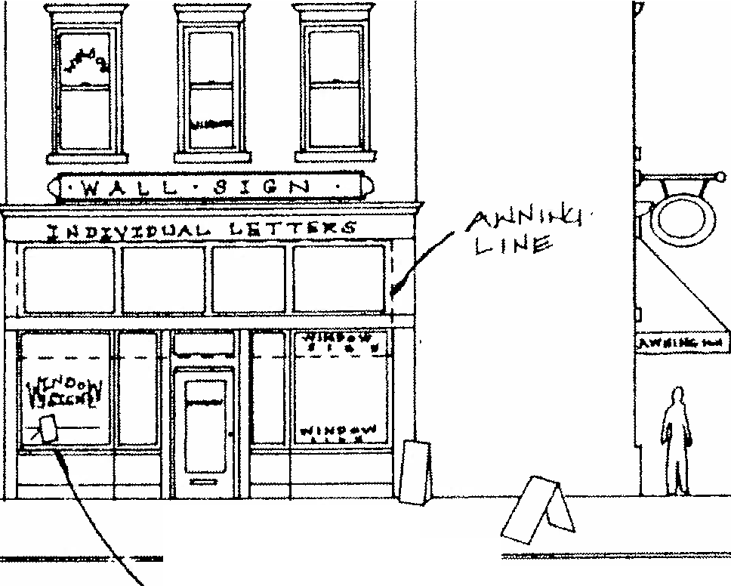

rL 7 .,
r-1 f>'f?>l..--fi" 71Ltt-1
t7 N(J7

Appropriate sign locations.

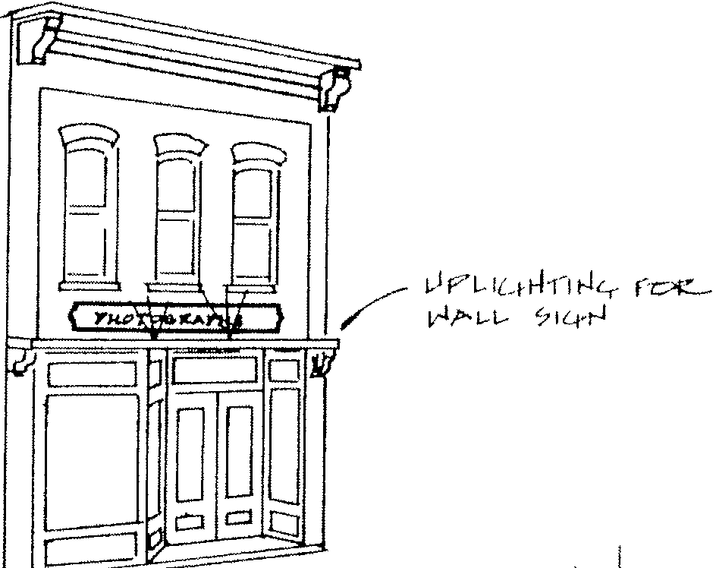
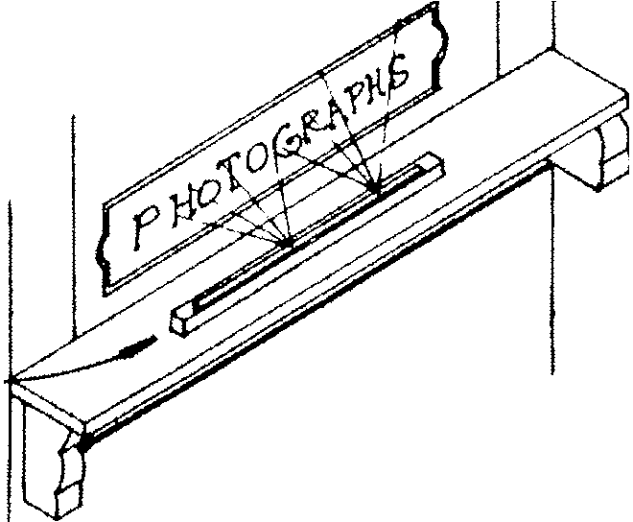
#23) TRADITIONAL LETTERING IS RECOMMENDED
L,.I e;+h-1rJc:.- f-1 Iv't71!> t-1
t"Kor-1
P' 17
VI LG v1
11'-r-l
---f's:--

Recommended

- Letters should not exceed 18 inches in height.
- Serif style letters are appropriate and their use should be encouraged.
- No more than 60% of a sign's total area should be occupied by lettering.

#24) HISTORIC WALL SIGNS SHOULD BE PRESERVED

Recommended

- Historic wall signs painted on exterior masonry walls should be preserved and maintained.
- Historic wall signs may be touched up with new paint if desired as long as the paint and design matches the original.

Several exterior brick walls in the downtown area retain painted signs applied in the late 19th and early 20th centuries. These wall signs are a unique aspect of downtown and contribute to its historic character. Such signs should be preserved and maintained.

#25) LIGHTING FOR SIGNS SHOULD BE CONCEALED

Recommended

- Light fixtures for signs should not be readily visible from the street or sidewalk.
- Incandescent lights rather than spot or flood lights are preferable.
- Internally lit signs are not recommended.

Light fixtures should be concealed.

#26) SIGNS SHOULD BE COORDINATED WI TH ADJACENT BU ILDI NGS

Recommended

a . The location , size , and placement of signs should compliment those of neighboring or adjacent buildings .
b . Avoid signs that are out of scale or have substantially different locations as signs on adjacent buildings .

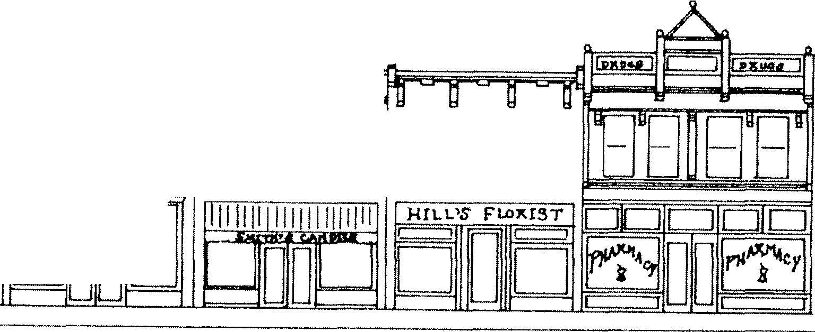
Signs on buildings that do not compliment one another vie for the attention of the shopper and can create confusion. Signs that can be read easily from one building to another are easiest for identification.
888

A,e Hswu< BBB 888
BBB ====

Signs should be coordinated on
#27) THE USE OF SYMBOLS AND LOGOS ARE ENCOURAGED FOR SIGNS

Recommended

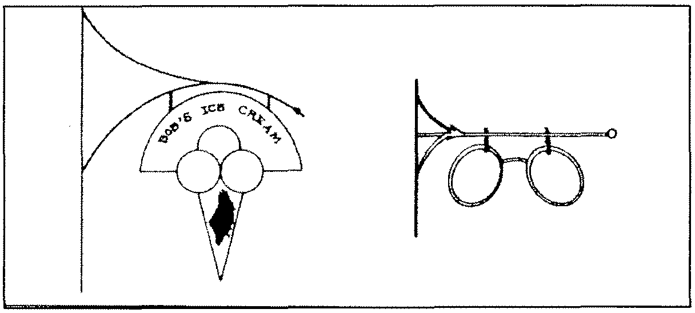
a . Symbols and logos provide for ready identif ication of a business and their use is encouraged.

adjacent buildings.

NEW COMMERCIAL BUILDING GUIDELINES

#28) NEW CONSTRUCT ION SHOULD BE CONTEMPORARY IN DES IGN AND H I STORIC REPRODUCT IONS SHOULD NOT BE BUILT

Normally Required

a. New construction in the commercial area should be of its period. Historic reproductions should be avoided.

Compatibility of new buildings within historic commercial areas poses particular challenges for designers. Historic commercial areas often have similar setbacks, similar storefront and upper facade alignment, and certain rhythms to the streetscape. These built-in parameters assist in defining new construction but they may also result in restricting building design to appear as reproductions of historic buildings as opposed to an appearance of present day construction. Successful new construction in historic commercial areas is clearly of its period but avoids direct imitation of historic designs such as reproducing window lintels or elaborate sheet metal cornices. Direct reproductions may cause observers to confuse the old with the new.
No building should be constructed in downtown Sumter which imitates ante-bellum architectural styles. Such buildings would reflect a time period which precedes Sumter's growth and development.

#29) RECONSTRUCT I ON OF H I STORIC COMMERCIAL BUILDINGS MAY BE ALLOWED

Normally Required

- Reconstruction of buildings that are clearly documented may take place on their original site.
- Reconstructed buildings should be constructed with materials, detailing, and decorative features to match or closely approximate the original building.

Many original historic commercial buildings have been razed in downtown Sumter in recent decades. Reconstruction of an historic commercial building is allowed under certain provisions. For a reconstruction to be approved there must be ample evidence of the building's original appearance such as floor plans, drawings, or photographs. Reconstructed buildings must be on their original site, be constructed in accordance with their original design and materials, and be compatible with adjacent structures. Reconstructed buildings should also be clearly designated as a reconstruction as opposed to an original historic building. This may be done through a marker applied to the exterior of the building, freestanding sign, or other method of designation.

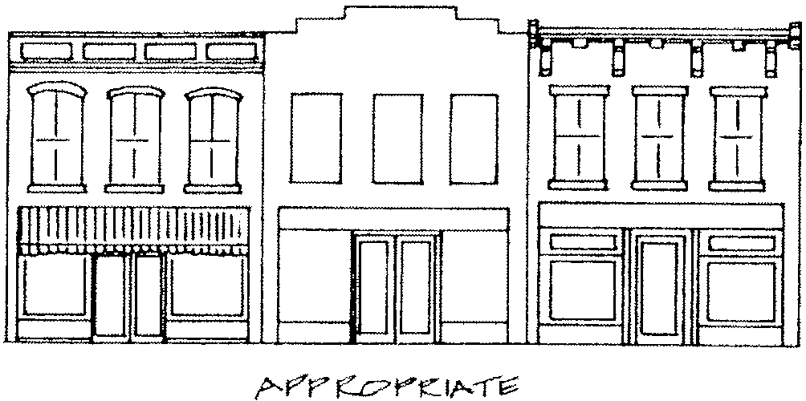
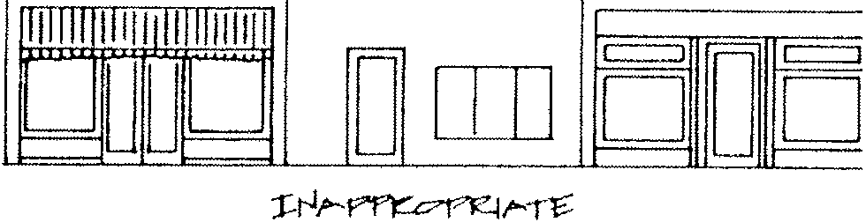
#30) ORIGINAL FACADE WALLS SHOULD BE PRESERVED

c::::J C:::J c::::J c:::J
IDIEffi I I JillID illffJ

Normally Required

a. Original primary facade walls should be retained and preserved. New construction that maintains the original design and appearance of the building should be encouraged.

Due to fires and demolition buildings in historic commercial areas may sometimes be lost with the exception of their exterior masonry walls. Walls on primary facades often retain much of their original design and detailing and rather than razing these walls they should be stabilized and preserved. New construction that restores the building's original appearance should be encouraged.

#31)
NEW
CONSTRUCTION SHOULD MAINTAI N

STOREFRONT AND UPPER FACADE CONFIGURAT ION

Normally Required

- New construction should respect and maintain the existing appearance of storefront and upper facade arrangements.

Recommended

- Recessed storefronts are recommended.

Historic buildings in downtown Sumter share a number of characteristics. One of the most important of these is the delineation between storefront levels and upper facades. Storefronts contain the primary entrances and are largely transparent with large expanses of

Storefront and upper facade alignment.

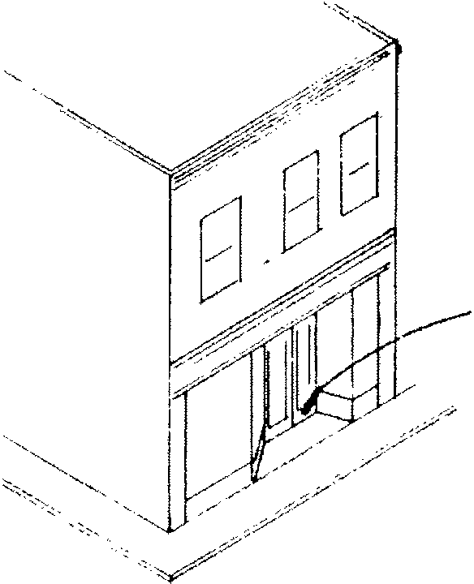
display windows. Above the storefronts the upper facade is composed of solid masonry walls. On buildings larger than one-story the masonry walls are divided by window openings. The division between the storefront and upper facade is usually clearly defined through a cornice, brick belt coursing, steel lintel, or other architectural element.

{,,.or-"1 f"!ot--l
,cs;. 6t<'.'?"?"'" t7
f;::: t-¥16
New construction should maintain the appearance of the storefront/upper facade arrangement. The first floor areas of new construction should have large expanses of glass and upper facades should be of solid walls with proportional window openings. The difference between the storefront and upper facade should be clearly defined and expressed through architectural design and features.
Many of the existing storefronts in the downtown area also have recessed entrances. This pattern is a common one and new construction should consider the use of recessed entrances to reinforce the rhythm and proportions of storefronts.
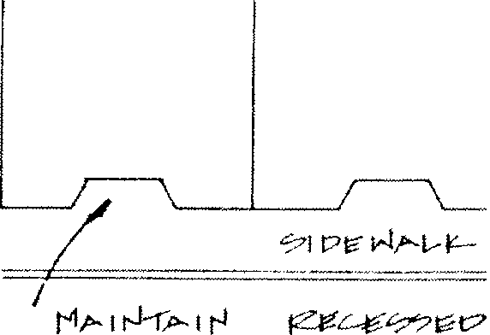

Continue recessed storefront configuration.

#32) NEW CONSTRUCTION SHOULD HAVE VERTICAL DIVISIONS TO REINFORCE FACADE WIDTHS

Normally Required

  - New construction should maintain the appearance and rhythm of vertical divisions to reinforce facade width.
  - Buildings with upper facades of solid brick or glass walls or strong horizontal lines should not be constructed.

Most buildings in downtown Sumter were built on narrow lots of 25' to 60' in width. The lot sizes in the commercial area resulted in buildings which are more vertical in appearance than horizontal. Buildings that were constructed on the larger lots were often defined by vertical masonry piers, or other architectural details to divide the building into narrow, vertical sections. This pattern has resulted in a uniform rhythm on the primary building facades in the downtown area.
New construction should respect and maintain the spacing and rhythm of buildings in the downtown area. New buildings that are constructed on narrow lots will largely conform to this guideline. However, buildings that are constructed over several lots, or are 50' or more in width, should be built with designs to reinforce the spacing and arrangements of adjacent buildings. This can be done through the introduction of architectural elements on primary facades such as vertical divisions, through stepping of building heights or widths, and through the use of differing textures or colors.
Buildings with blank walls of masonry or glass or designs with strong horizontal lines should not be built in the downtown district.

,_
I==-=
mmm 88888E BBE HHE HJ
Ir I II 11='
r
11 - g a - u
111111 111 11 ll!HIII c=::J c::JC=:l c.::::::11
=
0
- -
.,.
DDD
ICJ c::=J c:::::J c=i
-
-
u no
. -":
-
,- --
D
t:::::::J
D

Vertical divisions reinforce facade rhythms.

#33) NEW CONSTRUCTION SHOULD MAINTAIN SETBACK
,, I
I
)
/1
ALIGNMENT

Normally Required

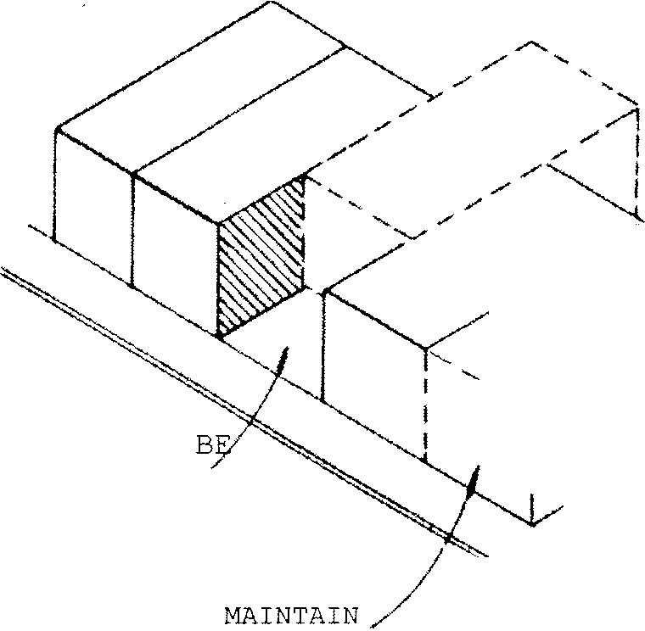
- New construction should maintain the existing alignment and lack of setback of existing historic buildings.
/
SHOULD NOT
RECESSED
'y /
I
I
,,
/
- Buildings that are constructed on the edges of the district or that do not share party walls with adjacent structures may have minimal setbacks for landscaped areas or pocket parks.

Buildings in the downtown historic district were constructed flush with the sidewalk to maximize building exposure on the primary facade. This lack of setback is uniform for historic structures and new construction should maintain this alignment. Buildings should not be recessed back from the sidewalk in the commercial area. Buildings that are constructed on the edges of the historic district or that do not share party walls with adjacent buildings may have setbacks for landscaped areas or pocket parks. The Zoning Ordinance of Sumter does not require any setback in the CBD zone and there is no minimum lot coverage.

Facade alignment should be maintained.

#34 ) UPPER FLOOR WINDOWS SHOULD MAI NTAI N AND CONTINUE ALIGNMENT

Normally Required

- New buildings in the downtown area should maintain the existing alignment and proportions of upper facade windows.
- Windows which are undersized or oversized should not be built on upper facades.
- Historic window details should not be added to new buildings.

Most upper facades in the downtown area have a minimum of two to three windows on each floor.
These window openings are generally uniform in size and are closely aligned with window openings on adjacent buildings. The window arrangements and location on upper facades create a rhythm and pattern, which is characteristic of the commercial area. New construction should be built to reinforce this pattern through the size and location of window openings on the upper facade. Appropriate window shapes are rectangular and arched with vertical, rather than horizontal proportions. Square windows, narrow width horizontal windows, and other designs out of keeping with traditional window forms and shapes should not be added.
Historic details such as bay windows, window balconies, or sheet metal cornices should not be added to new buildings. The use of brick corbelling or banding to define or decorate windows is appropriate.

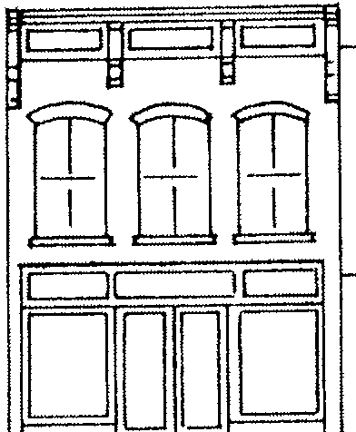

JL. ..L--ll. ..---U- - - --- - - - _J _ - --- - - -
Li-1i::- l-Oi-1?(ic J0f,or1 _J
r1f"t Af 1 rJ
.-J.1 t-l t?c1l f"-L.- ll.t-1" r-l
r-1--f
-1---:z -,:;:- -:- -:; -.;. ; ,
,
.. c::::J c:::::::::J c::::::J
r --i -,
1 r, r -1 r -,
1J ] Q bl
I
I
I
I
I l I I I I I
I I I
L_ _ I
i_ _ _l
I I I I I I I
I I
I
I
I
t
! I_ ,_ _I L_I
- - - - - - - I_ --- - - - - -
I
mmm
·m Bl
r 1 c::J 0 CJ
-
l
I
c::::J
D
lJ
c::::J
r 1
D
-
=
D
c:::, -=
l.L
0

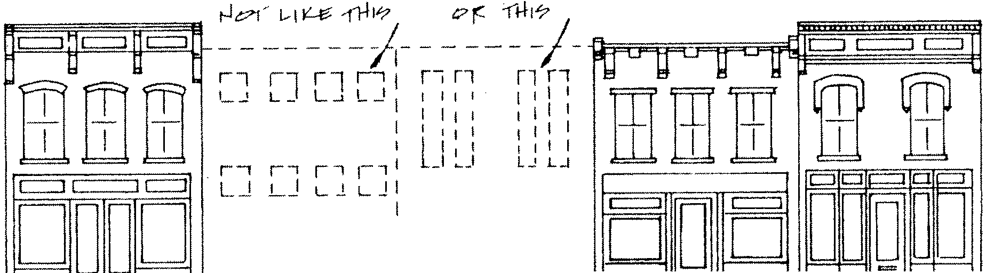
Window alignment should be maintained on new construction.
,-, r,
I I ' I
l I I t I
I I I I
I I I
I
.LL..--1----L--l----L...I - - - -- - - _J -!_._, LJ - - - ....U- -"'---'-'.1---...L.JJ'--....._., ., , ----'-'
Lr-1t,qJ U?"111k:..,·n f-] _J

25

#35) NEW CONSTRUCTION SHOULD MAINTAIN TYPICAL BUILDING HEIGHTS

Normally Required

a . New building heights shall be in accordance with the existing building heights in the downtown area . Heights of buildings will vary depending on the dominant heights f ound on each block .
b . In no instance should a building be constructed that is larger than six stories in the central business district .

The majority of buildings in the downtown area are two to three stories in height.
New construction should be respectful of the building heights that dominate various blocks. The maximum building height of 90 feet is also the maximum allowed under the CBD zoning classification.

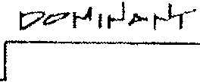
r - - -,
I r1nr, I
I L L: ._ _l ,
: t, r -1 r,
1 r ,r, r ] I'1,70 1A14-t-,t
I 1.._t U J I
I u!_ _I L I
I r1 r-, II
-
II l_t L 1 t J I
D OD
I
ur, r!_-_,,ur -, I
I
I U UL
r1 nr-1
D O D O DD
D O D L1 LI
r-
L:
r-1r -1
D D
r-, r -,
!... J LI
OD O
DO D 0 1]0
Dominant building heights on each block should be maintained

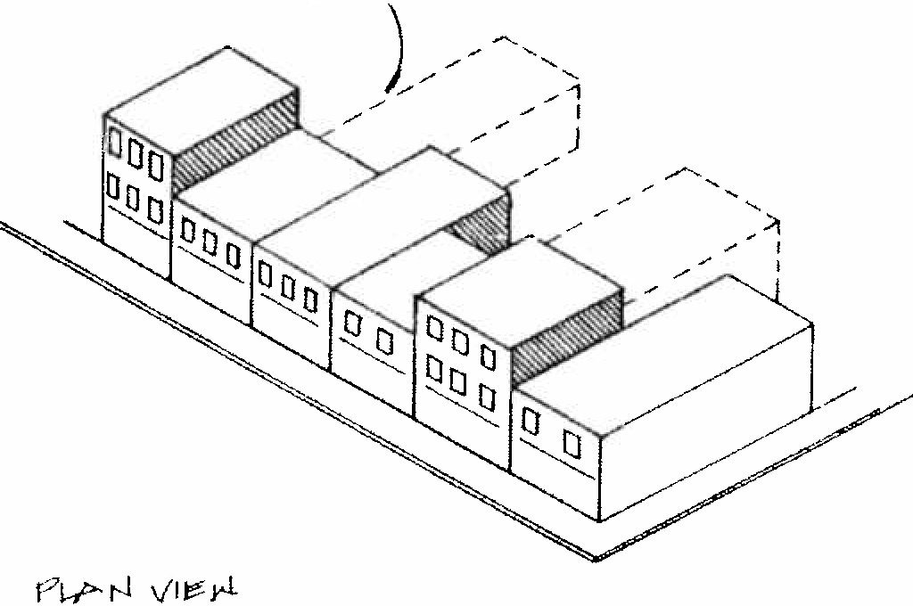
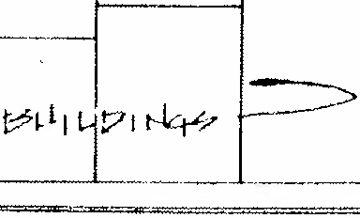
#36) ADDITIONS MAY BE ADDED AT REAR FACADES
'(F f"f?!;ir> t?cvl ,-J
I"" L-1 t-le'
rvr M·
I
I
\_,
'
--1

Normally Required

a . Rear facades are appropriate locations for additions to commercial buildings . Additions should clearly be contemporary in design and not historic reproductions or mimic the original building .
b . Rear addi tions should be simple in design and not be constructed as the primary entrance to a building .

Additions to low-rise commercial buildings are generally of two types rear additions and the rooftop additions. Rear additions are possible where a building's lot line is deeper than the existing building. The construction of a new addition could therefore extend at the rear of the original building to encompass the entire lot. Present zoning requirements and the configuration of lot lines will restrict additions on the primary or side facades.
Rear facades are appropriate locations for additions to existing buildings. Most rear facades are not visible from the major street elevations and face rear alleys or parking areas. Rear additions should be stepped lower than the roofline of the original building. This would aid in clearly defining the original building versus the new addition. Acceptable materials for rear additions include brick, concrete,
and combinations of metal and glass.

Additions may be added to rear facades.

Rear additions should be contemporary and compliment the original building . They should not be exact copies of the original building or reflect an historical appearance out of keeping with downtown's character. The construction of the addition should also not result in the loss of substantial material on the rear facade of the original building . The wholesal e removal of sections of an original rear wall should not take place unless significant structural deficiencies can be demonstrated . Such removal of original fabric would not allow a future owner to remove the addition and restore the building back to its original dimensions and appearance.
Rear facade additions should be kept simple in design and not be constructed as the primar y entrance to a building. Many building s in the CBD have secondary entrances facing rear parking lots. Additions to these buildings are appropriat e. However , because of their visibility property owners may desire to construct additions that have elaborate entrances and decorative facades. This facade orientation would not be in keeping with the historic orientation and primary entrance locations of downtown buildings and should be avoided.

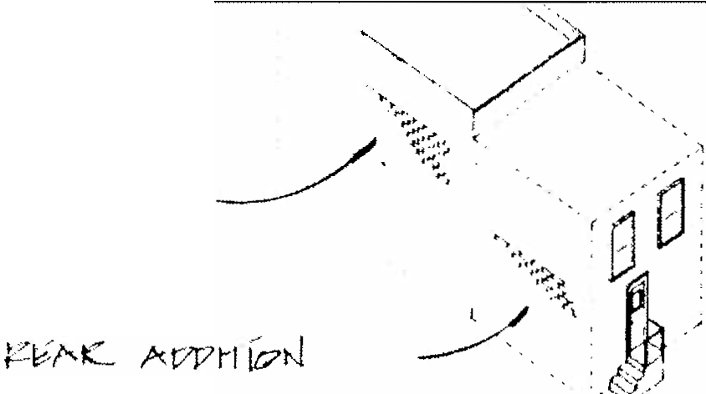

C"f:ILH ri?"< t-­
f7l 11,. n1-kp

Rear additions should be simple in design.
#37) MINIMAL ROOFTOP ADDITIONS MAY BE ALLOWED

Normally Required

a . The construction of an extra story at the roof of a commercial building may be acceptable as long as the addition is not readily visible from the street.
- Additions should be contemporary in design to distinguish them from the original structure .

The construct ion of an additional story on existing buildings in the downtown area is acceptable under certain conditions. Additions must be stepped back from the main facade of the building so that no part of the addition is visible from the street . The addition must also be of such scale that it is not readily visible from within a one block area surrounding the building . Roof additions are encouraged to be contemporary in design to distinguish the addition from the original building.
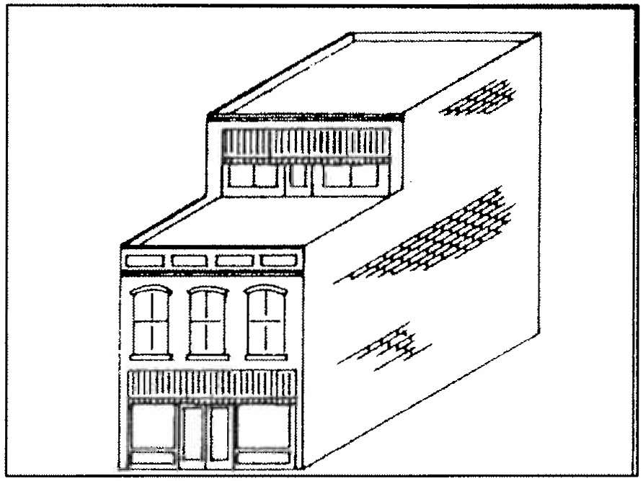
Appropriate roof addition.

#38) MATERIALS FOR NEW CONSTRUCTION SHOULD BE COMPATIBLE WITH EXISTING MATERIALS

Normally Required

  - Brick is the preferred building material for downtown Sumter. Buildings with exterior surfaces of glass and metal, wood, vinyl, or stucco should not be constructed.
  - Masonry materials should be compatible in
size, profile, and detailing with historic materials.

Virtually all buildings in downtown Sumter are of some type of masonry construction. Buildings are predominantly of brick construction with concrete and stone used for foundations, decorative elements, and belt courses. New construction materials should match existing materials in color, texture, and dimensions. Brick is the recommended building material for downtown although concrete may be allowed if scored or textured to be resemble brick. Buildings with exterior surfaces of glass and metal, wood, or vinyl and aluminum siding should not be constructed.
New brick buildings should have brick that matches in dimensions and profile of typical historic bricks in the downtown area. Smooth bricks of dark red colors are preferred over textured bricks or brick with light colors. Oversized or undersized bricks should not be used. The use of concrete for foundations, upper facade decoration or divisions is acceptable.

Wood windows are recommended
for
new

construction but metal windows such as anodized aluminum are acceptable.
dark

RESIDENTIAL GUIDELINES-SITE AND SETTING

#39) MAINTAIN ORIGINAL LANDSCAPE FEATURES

Recommendations

- Existing trees shall be protected and retained wherever possible. This is especially important
bushes and flowering shrubs such continuous hedges, small ornamental dogwoods, and ivy beds. The majority have grass lawns with many yards hedges or other landscape materials lot boundaries.
as azaleas, trees such as of residences separated by to delineate

due to the loss of trees from Hurricane Hugo in 1989. The planting of new trees to replace those lost is encouraged in the residential areas.
- Plant materials such as shrubbery and hedges should be native to Midland South Carolina to ensure their health and longevity.
- Landscaping should be secondary to the historic structure itself and not overly conceal or obscure the primary facade.
- Historic retaining walls should be preserved and maintained. New retaining walls should be of stone or brick rather than poured concrete, concrete blocks, wood timbers, or cross ties.

The residential areas of Sumter contain a variety of landscape features which help define a street's character. The most obvious landscape feature are the large oak trees and other shade trees which are located in front yards, side yards, and in the median strip between the sidewalk and street. Calhoun Street, W. Hampton Street, and others all possess numerous shade trees. Despite the losses during Hurricane Hugo shade trees remain an integral part of Sumter's historic residential streets.
In addition to the large shade trees, most residences have some type of landscape elements in the front yard. Common landscape features include
Another landscape feature found in the
historic districts is retaining walls. Retaining walls are found where the residence and yard are above the grade of the sidewalk and street level. The wall serves to provide a clear termination of the yard, prevent erosion, and add a decorative feature to the front of the house. Many of these retaining walls are of stone construction or brick construction and were constructed in the early 20th century. Another historic retaining wall material found in the districts is rock faced hollow core concrete blocks.

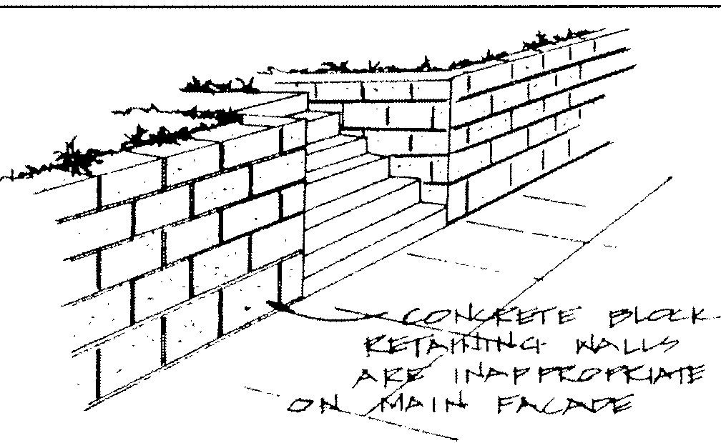
Inappropriate retaining wall.

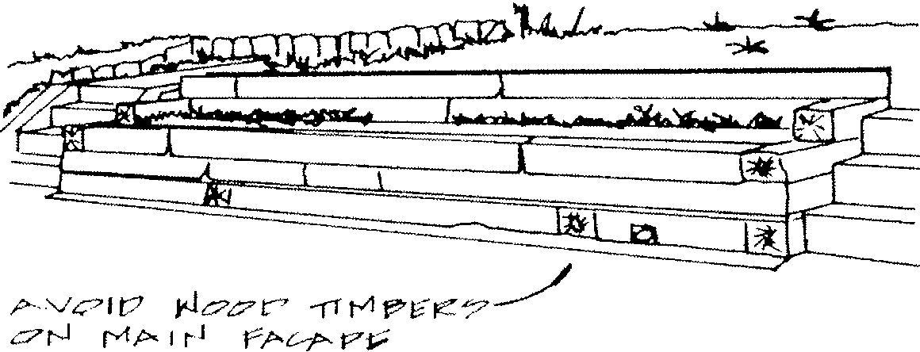
Landscape elements in the Sumter districts shall not be restricted. However, the retention of shade trees and planting of new trees is encouraged to maintain and enhance the appearance of the districts. The preservation of historic retaining wall materials is also encouraged as is their proper repair. Landscape materials should not overly conceal or mask a historic structure. Care should also be taken to plant trees and bushes at least several feet away from a building's foundation to prevent damage from roots and moisture infiltration.

Inappropriate retaining wall material.

#40) MAINTAIN ORIGINAL DRIVEWAY CONFIGURATION

Normally Required

- Parking areas between the street and primary facades of residences should not be constructed.
- The introduction of circular driveways between the street and primary facades should not be constructed.

Recommendations

- The use of concrete, concrete aggregates, patterned concrete, and brick pavers is encouraged over asphalt. If asphalt is used the use of a coloring agent to create lighter tones is preferred over standard black asphalt.

The majority of residences in Sumter's historic districts were constructed between 1880 and 1930 and accessory buildings were often located at the rear of lots. These accessory buildings or outbuildings included stables for horses and carriages and later garages for automobiles. To reach these buildings and provide for access of vehicles driveways from the street were built adjacent to residences. Oriveways in the districts were built primarily in linear fashion and measured from five feet to ten feet in width. Early driveways were of dirt or gravel with concrete introduced in the 1910s. Early concrete driveways were sometimes built of solid concrete or with grass median strips. In recent decades asphalt and concrete aggregates have been used for driveways.
Driveways in the residential areas are primarily linear and extend from the street to the rear or partially to the rear of lots. The Sumter' s Zoning Ordinance prohibits off street parking areas in the required front yard in residential areas. In most historic neighborhoods of Sumter this prohibits parking in the forward 35' section of a yard between the street and primary facade. Parking areas on any part of the yard between the street and a primary facade should not be allowed.

#41) THE VISUAL IMPACT OF PARKING LOTS SHOULD BE MINIMIZED

Normally Required

a . New parking lots in the residential area
shall meet the minimum. standards set forth by the Zoning Ordinance .

Ingress and egress shall be provided through driveway openings only. The landscaped area within the parking lot shall not be less than 5% of the surface area of the parking lot. A minimum of one tree shall be provided within the landscaped areas in the parking lot for each three parking spaces in the lot. Trees to be planted must be from an approved list supplied by the City Arborist. Trees

b . The introduction of landscape greater than the minimum. required is encouraged.
elements strongly
must be 2 inches in diameter six inches above
ground at the time of planting. Existing trees and vegetation shall be retained wherever possible.

The Sumter Zoning Ordinance has specific requirements for new parking lots which must be followed. Parking areas shall be separated from the street right-of-way by a landscaped strip at least ten feet in width and should be separated from property lines by a similar distance.
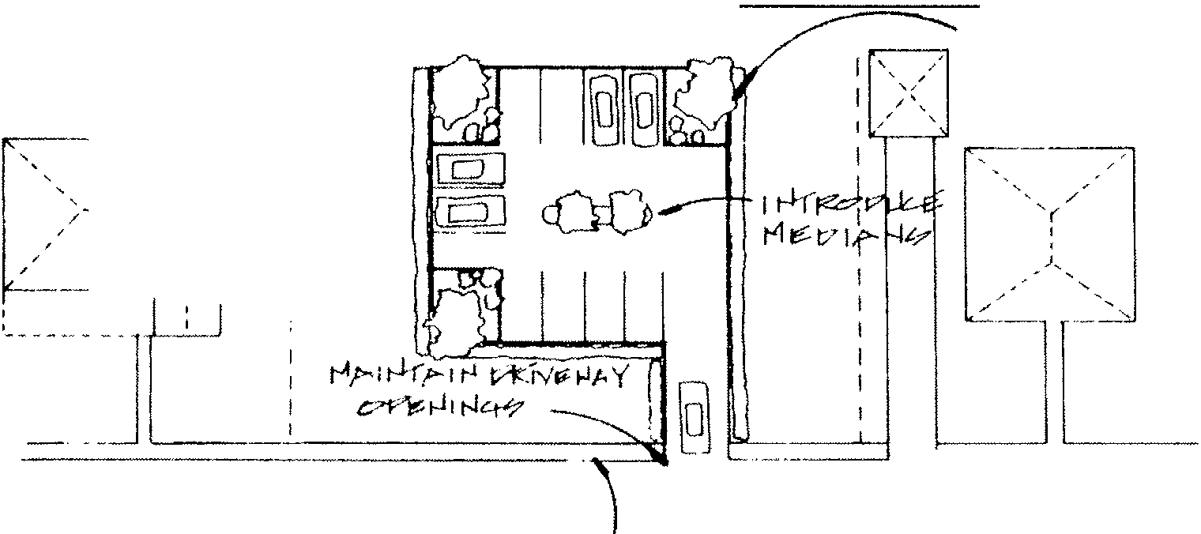
l c7 Pr PM
t,:FcfY L,i tJi;,,1" I
.
- -"---:I
Ir-,l C'KILHt-l;,-1.--
Nt--l li? t:::
PI IJ" L-t£
,/
/
- -- -< /
''
'
.,/f"-,
--- I
I
I
?ff'.'.'.tt Pf f(.l'.'.+-ti-r t?v l'-¥'-'r
'""" f't f'fCC?M

Parking lots should have landscaping and screening

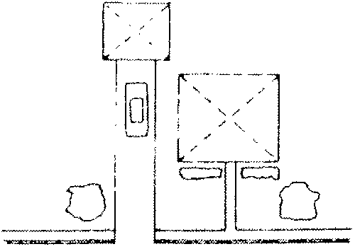

- -
'''

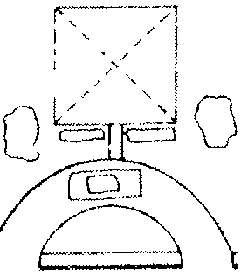
Parking lot placement,

,,'
i '/
i l ' ,-
i (I}) 0
: C5J
E: --.
#42) PRESERVE HISTORIC FENCE AND RETAINING WALL MATERIALS

Normally Required

a. Original historic fence and retaining wall materials should be preserved and maintained.

Few buildings in the residential historic districts have fences installed on the primary facade adjacent to the sidewalk. Most of those that presently exist are some type of brick fence or of modern wrought iron. Historic fencing materials such as cast iron or open weave brick are rarely found in the districts. Those that exist are important defining elements of a residence and should be preserved and maintained.
Retaining walls are also rare. These retaining wall materials should be preserved and maintained. If repair is needed matching materials or the best available match should be utilized.

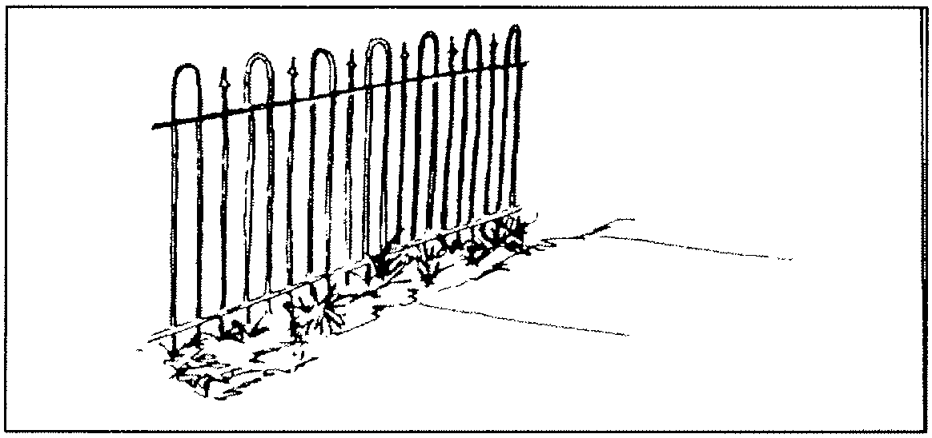
Cast ironfence,

#43) THE ADDITION OF HISTORIC FENCE DESIGN AND MATERIALS IS APPROPRIATE

Norm.ally Required

a . Fences may be erected along all f our property

Recommendations

e . The use of ivy , materials to cover or is encouraged .

vines or other plant screen chain link f ences

lines of a residence . The most appropriate fencing material at the sidewalk or property line on primary facades is wood in historic picket designs . Other allowable fence materials are open weave brick designs or cast iron.
b . Wooden plank fences , solid wall brick fences ,
and chain link fences and other metal designs shall not be installed at the sidewalk or property line on primary facades . Wooden plank fences and solid wall brick fences may be added
on the side property lines of residences located on corner lots adjacent to a street, however, chain link or other similar metal fences shall not be allowed. These fence materials may not be
added on secondary or side yard property lines unless they are recessed back at least fifteen feet from the plane of the residence's primary facade.
c . Fences at the sidewalk or property line on
primary facades should not exceed 3 ' in height while fences on the property lines of secondary and rear facades should be no higher than 6 ' . Fence heights lower than the maximum allowable height are encouraged. Fences placed along property lines on corner lot residences must follow regulations listed in the Zoning Ordinance. d. Wooden split rail fences are not historic designs f or urban areas of the late 19th century and are not appropriate .
In recent decades most fencing materials
added in the districts have been metal chain link designs or wooden plank fences. For the most part these fences have been added along the side or rear property lines and there are few examples of chain link or wood plank fences along the sidewalks or property lines of primary facades. New fences at the sidewalk or property lines on primary facades should be of traditional wood picket design. Solid plank fences or chain link fences should be added only at property lines of rear facades or side facades which have sufficient setback.

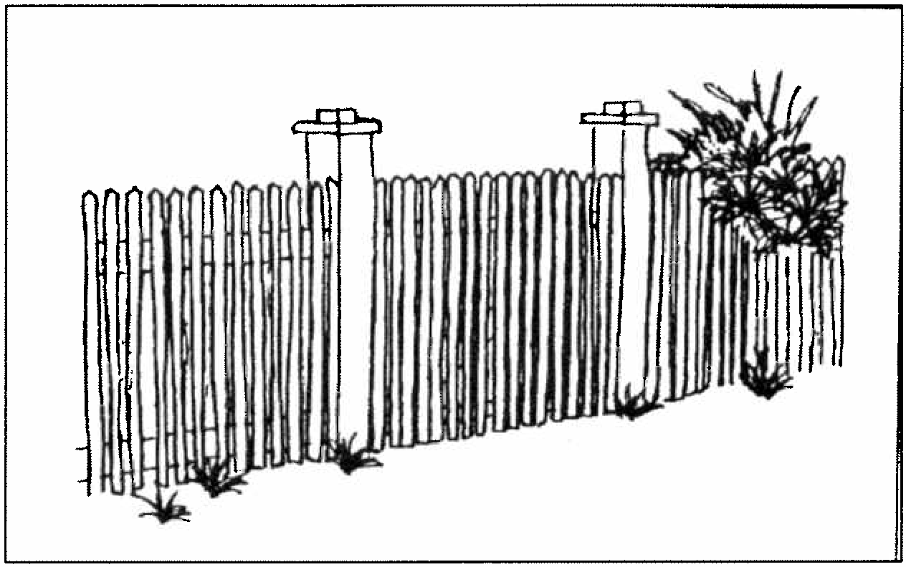

Appropriate wood picket fence design.

#44) EXTERIOR LIGHTING SHOULD BE SIMPLE AND ORIGINAL FIXTURES SHOULD BE MAINTAINED

Recommendations

- Original light fixtures on a pre-1940 building should be retained and preserved. Many of those that exist are electric lights from the 1910s and 1920s on Bungalow style residences. Several companies now have replacement parts for these types of lights and rewiring of these lights is also common.
- New light fixtures should be ceiling mounted in the porch or mounted adjacent to the primary entrance or entrances on the main facade. Porch ceilings are traditional locations for light fixtures and light fixtures mounted directly to the ceiling or recessed within the ceiling are appropriate. Light fixtures which are suspended several feet from the ceiling should be discouraged. Wall mounted light fixtures adjacent to entrances are also appropriate.
- Exterior lighting designs should be reproductions of fixtures for residences built between 1880 and 1940. Contemporary lighting fixtures in simple designs are also appropriate. "Williamsburg" carriage lights and other designs of the 18th and early 19th century are not appropriate for Sumter' s districts and should be avoided.
- For walkways and driveways small footlights are preferable to large freestanding post mounted lights. If post mounted lights are used they should not exceed 10' in height and be of brass, copper, painted steel or other painted metals. Mounting posts should be of wood, cast iron, or painted steel.
- Security lighting mounted at eaves or at rooflines on residences shall not be prohibited
as long as the fixtures and illumination are located on secondary or rear facades.
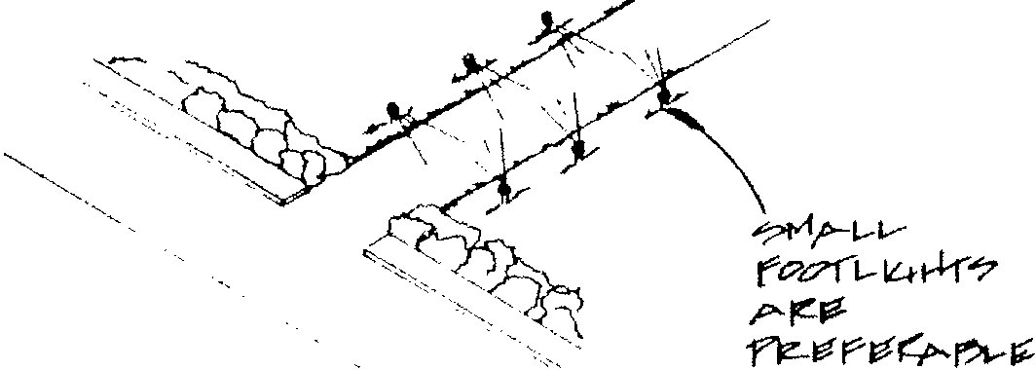

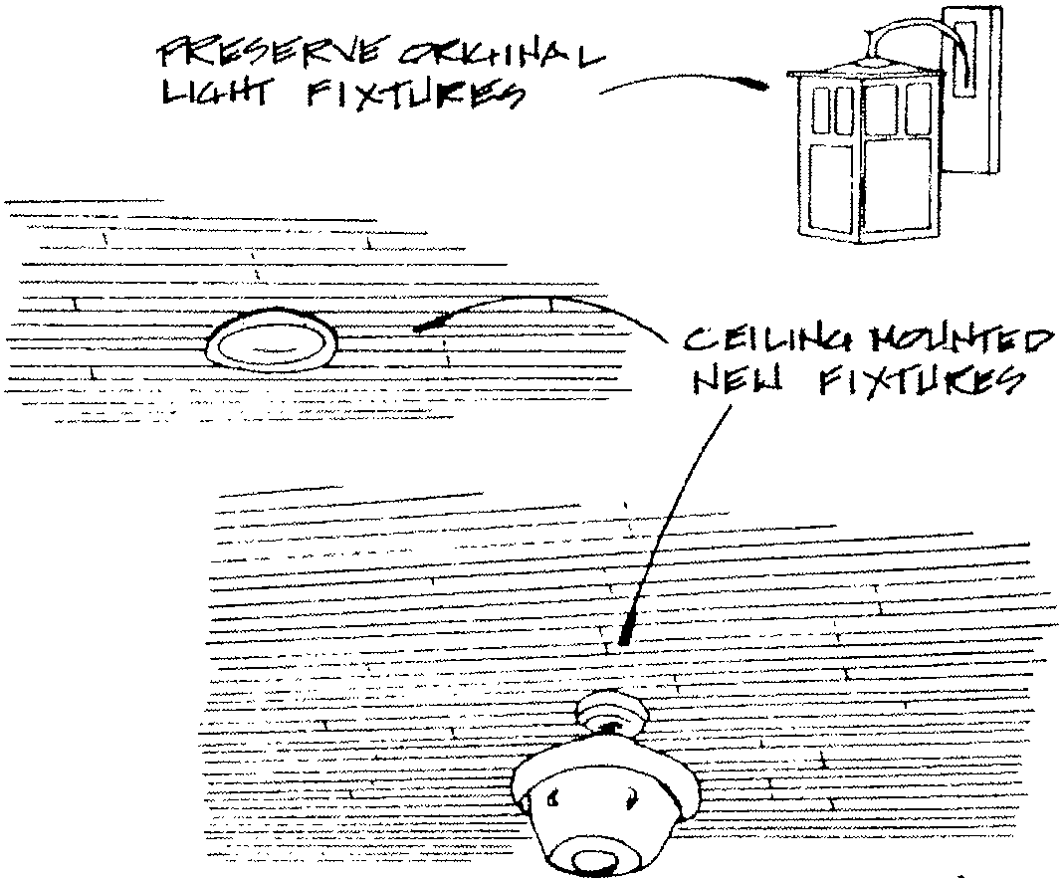
Exterior lighting locations.

#45) SIGNS IN RESIDENTIAL AND OFFICE AREAS SHALL FOLLOW THE SIGN CODE

Normally Required
areas and it is recommended that signs be restricted to a maximum height of 10'. The design of signs, lettering, and materials should follow guidelines previously set forth for freestanding signs in the commercial area.

- Signs erected in professional historic provisions of the City's Zoning Ordinance.
the residential or areas shall follow Sign Regulation in the

- Signs which flash, are animated, or rotate, shall not be permitted.
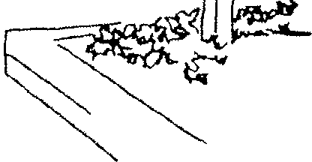
- Freestanding signs in residential and office areas which are for non-residential use shall not be higher than five feet.
[L. 11
Jf
- Freestanding signs which are for residential use shall be no more than five in height.
- Freestanding signs shall not exceed a maximum area of 6 square feet for non-residential use and
2 square feet for residential use.
Recommended

- Freestanding signs in residential and office areas that are for non-residential use should be no more than 5 feet in height.

Signs along East West Calhoun Street are a mixture of various types of materials, design, and construction. The majority of signs used in these areas are freestanding signs on metal poles or on brick piers. These signs are oriented towards automobile traffic and are sited in the front yards of the property.
Zoning Ordinance revisions through December 1999 include minimum standards for new signs in these areas. For the most part these standards are compatible with historic commercial and residential areas located along wide, busy streets.

Appropriate freestanding sign.

RESIDENTIAL GUIDELINES-REHABILITATION

#46) PRESERVE AND MAINTAIN EXTERIOR WOOD SIDING

Normally Required

- Original wood siding should be maintained and preserved.
- Cyclical maintenance such as repair and, painting should be performed regularly to frame residences.
- Original wood shingles should be maintained and preserved.

Sumter's historic residences were built primarily between 1880 and 1940 and have a variety of exterior siding materials. The majority of exterior siding is horizontal lap siding such as weatherboard or clapboard. Weatherboards are long narrow boards with one edge thicker than the other and applied to overlap their neighbors in a continuous pattern. Most exterior walls are composed of weatherboards from the frieze board beneath the roof to the sill board at the foundation.
Another less common exterior wood siding is that of shiplap siding. This siding is similar to that of weatherboard siding except for rabbeting or a groove where the siding overlaps. Shiplap siding became popular on homes built after 1900 and is found especially on Bungalow design residences.
Wood shingle siding is also found in the historic districts although in a limited fashion on most residences. Wood shingle siding is composed of hundreds of small interlocking wood shingles which are generally of square, elliptical, hexagonal, or sawtooth design.
Common names for these types of shingles are staggered butt, fish scale, and sawtooth. These types of wood shingle treatments are generally found in gables, on the exterior of dormers, and to sheath the upper story of a two-story building. Other uses of these shingles include their application as wide bands around a residence such as belt coursing or to define the exterior of a bay window. On rare occasions the entire residence may be completely covered in wood shingles from the roof to the foundation.
In addition to these siding profiles most frame residences also have a variety of exterior wood treatments. These may be as simple as wide frieze boards beneath the eaves and wide sill boards just above the foundation. These boards border and define the exterior siding and are most often plain, undecorated boards. A smaller number are decorative in nature with details such as dentils or modillion blocks attached to the frieze board or diagonal siding at the sill board (see Decorative Trim).

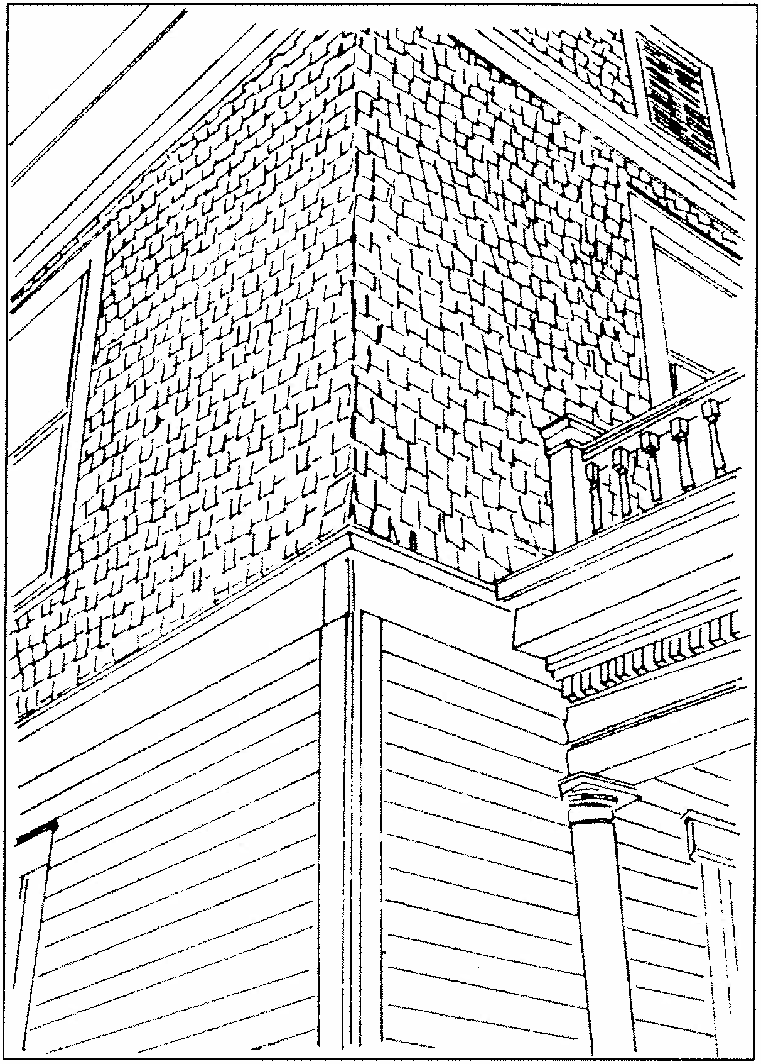

Weatherboard and wood shingle siding.
#47) EXTERIOR WOOD SIDING SHOULD NOT BE CONCEALED

Normally Required

- Original wood siding materials should be preserved and maintained on Sumter residences. Wood siding should not be concealed by aluminum, steel, vinyl, brick and stone veneers, and other artificial materials.
- Soffits, eaves, and porch ceilings should not be concealed with aluminum, steel, or vinyl sidings .

Historic wood siding weathers and achieves its own distinctive appearance over time. This appearance is an important factor in defining the character of a house and establishing its age and style. In recent decades many historic residences in Sumter have had the exterior siding concealed beneath added artificial sidings of aluminum, steel, vinyl, and other materials due to perceptions of the cost effectiveness of these materials as opposed to continued painting and maintenance of the wood siding. This concealment of the exterior siding has often resulted in the visual loss of exterior wood details which define and characterize a house.
Artificial sidings often do not match the dimensions and profiles of the wood siding, and conceal details such as wood shingles and window cornices. Artificial sidings are also inflexible and cannot duplicate curves on wood siding buildings such as projecting bays and bay windows. Instead of following the contours of historic residences artificial sidings impose rigid angles and geometric patterns which detract from a building's original design and appearance.

A further problem with concealment of original wood siding is the reduced ability of the residence to "breathe." Wood has properties that allow it to expand and contract with the heating and cooling process. Artificial sidings compromise this natural process through the creation of a sealed barrier between the original siding and outside air. This can trap moisture between the original and added artificial sidings and lead to deterioration of not only the wood siding but also the structural framework beneath. More significant moisture problems from faulty roofs or gutters may also be hidden from view by the added siding. In addition to hiding moisture problems artificial sidings can also mask insect and termite infestation and make their detection difficult. Proper installation of these siding materials cannot completely seal out these pests and damage to the wood siding and structural framework of a house can go undetected for long periods of time.
Concealment of the original siding may also not be cost effective. All materials have certain life spans and aluminum, steel, and vinyl sidings are no exceptions. Numerous houses covered with these materials in the 1960s and 1970s have had the siding surface dent, fade, mottle, crack, or flake which has necessitated the painting of the siding. The initial expense of installation and later required maintenance and painting will often not be economical in comparison with continued maintenance and painting of the original wood siding. The application of artificial sidings also has extremely low thermal values in terms of insulation, and cost savings in energy bills are negligible.

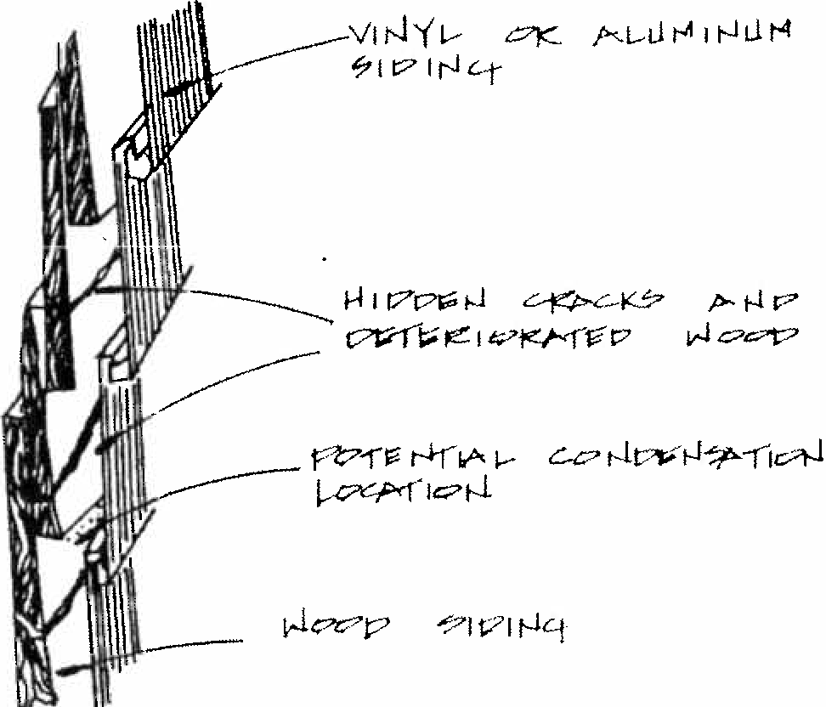
Possible effects of artificial sidings.

#48) REPAIR OR REPLACEMENT OF EXTERIOR WOOD SIDING SHOULD MATCH THE ORIGINAL

Normally Required

- Repair and replacement of original wood siding should be with materials, profiles, and designs to match.
- Repair of original wood siding is the preferred alternative to replacement with new wood siding.
- Replacement of wood siding should be kept as minimal as possible. Wholesale removal of wood siding should not take place unless deterioration of the original siding is clearly demonstrated.

Repair and replacement of exterior wood siding should always be of wood and follow the profiles and design of the siding which it replaces. This includes horizontal weatherboards, frieze or fascia boards, sill boards, wood shingles, and other siding elements.
Replacement of exterior wood siding should be as minimal as possible. It is best to repair and patch cracks and holes in siding with caulking compounds or to do localized replacement as opposed to removing and replacing entire boards. If the overall condition and appearance of wood siding is sound, replacement should be discouraged.
#49) PRESERVE AND MAINTAIN ORIGINAL MASONRY

Normally Required

- Exterior masonry details should never be removed or obscured.
- Repair of masonry walls and details is preferred over replacement.
- If replacement is required, new masonry should match the original as close as possible in color, texture, and profile.
- The painting of masonry which has not been previously painted should not take place. Exceptions to this are for masonry walls which have had extensive replacement or rebuilding resulting in a patchwork of brick or stone surfaces and contrasting mortar.

Exterior masonry found in Sumter's residential areas include brick, stone, concrete; and terra cotta. Brick is the most common masonry material in Sumter and is used primarily as exterior walls, foundations, and chimneys. Exterior walls are of both brick and brick veneer. Late 19th century brick residences were built with the exterior walls providing structural stability and support. The use of brick veneers consisting of a single course of brick over frame support walls became popular for Bungalow era residences. In both instances an exterior wall surface of brick defines the appearance and character of a building.
Exterior brick can be used not only as a wall surface but is also used to create decorative details and textures. Some residences have corbelled brick patterns and inlays while others have textured or colored brick. Different brick colors are used to define floors or as belt courses between floors. Other bricks are molded

into decorative forms such as curves, and classical motifs such as egg and dart designs.
The color and texture of bricks is an important defining feature as is the mortar which bonds the bricks. Mortar consisting of mixtures of sand or aggregates and lime was used to bond individual bricks during the late 19th and early 20th century. Typical mortar joints between the brick are white or off-white in color and are recessed or raked slightly from the face of the brick. On some houses the mortar was mixed with dyes or other coloring additives to provide color in the joints such as reds or browns.

#50) EXTERIOR MASONRY SHALL NOT BE CLEANED WITH ABRASIVE METHODS

Normally Required

a. Exterior masonry should be cleaned using the least abrasive means possible. Detergent cleaning or steam cleaning is preferred over the use of chemicals. Sandblasting and other abrasive cleaning methods are prohibited.

The cleaning of exterior unpainted brick should be undertaken only if the need for cleaning is clearly demonstrated. The weathering and light staining of brick over time helps to create brick's texture, coloring, and appearance. Some staining such as efflorescence from salt leaching can be harmful and should be cleaned. However, before initiating the wholesale cleaning of a brick facade there should be careful consideration as to whether or not the expected results would be worth the trouble and expense.
If brick cleaning is undertaken it should be with methods which are the least abrasive possible
possible. A test panel of any proposed cleaning technique should be performed to determine its effectiveness and ensure that no damage to the brick would result. Simple detergent cleaning with water and brushes is recommended for removing light layers of dirt and soot. Low pressure rinsing is acceptable as long as the pressure is kept below 500 to 600 pounds per square inch. Anything above that could damage the brick and erode the mortar. Steam cleaning is also an acceptable cleaning method for most brick surfaces.
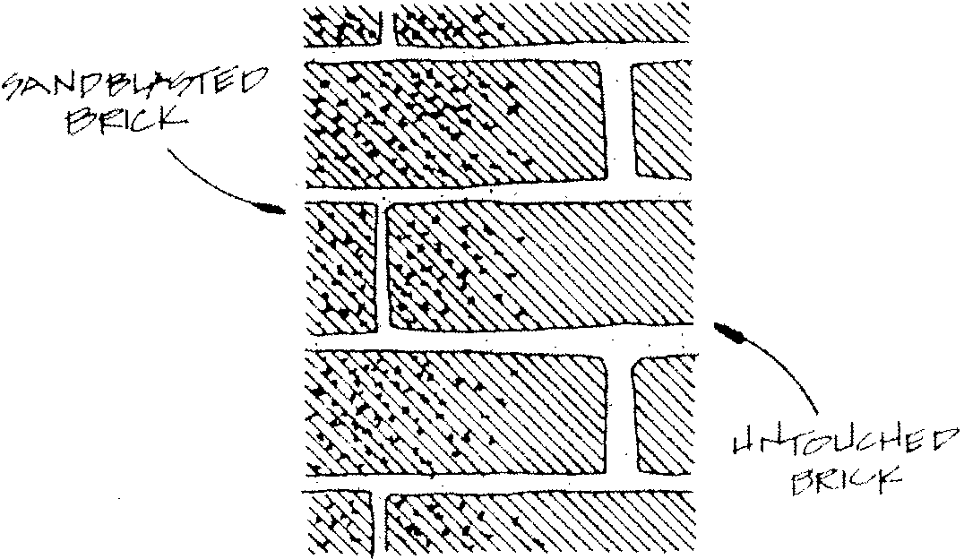
The use of chemicals to remove stains on exterior brick has been a popular and effective method of cleaning in recent years. Chemical products are applied to the brick surface and then washed off after reacting with surface materials. Chemical cleaning can be effective, but is also costly and must be done by professionals. If handled poorly, this cleaning method can be harmful to not only the brick but the area's immediate environment.

Sandblasting and other methods of abrasive cleaning are not appropriate for bri ck surfaces and should not take place under any circumstances. Sandblasting and related methods remove the outer patina of the brick and lay open the soft core to the elements . This can lead to moisture infiltration into the brick and spalling . Sandblasting can easily erode an inch or more of mortar joints and often requires repointing .

#51) MASONRY REPOINTING SHOULD HATCH THE ORIGINAL

Normally Required

- The repointing of masonry should be with mortar to match the original in composition and appearance.
- New mortar joints should be raked to match the original.
Mortar for most pre-1940 buildings is composed of a mixture of lime and sand. This mortar composition allows for expansion and contraction of mortar joints betwe en the bricks during hot and cold weather . Masonr y repointing for pre-1940 structures should be of similar mortar composition and match in color or texture . The use of Portland cement may be appropriate for some buildings constructed in the early 20th century. Where the original use of Portland cement is demonstrated , replacement in kind is appropriate . However, for most pre-1940 brick bui ldings Portland Cement is not an appropriate morta r material since it does not
allow for joint expansion and contraction.
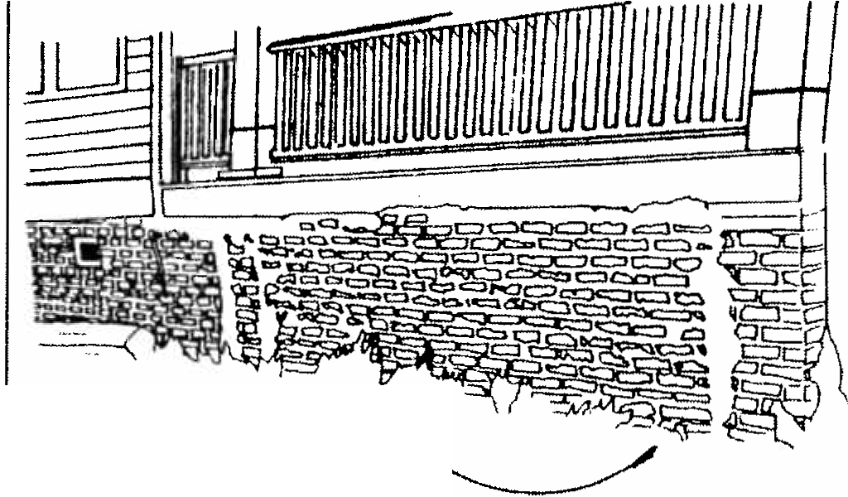
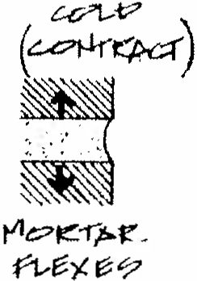
Most residences and commercial buildings have flush or concave joints and repointing should follow these original profiles . Mortar application should not extend to cover any part of the brick or masonry surface . Mortar should also be tinted or colored to match the origina l color after cleaning.

Fz;,.:;:,!e t·1.::;:, ,e-r-;--,e..
j>-- f"Pf..-,1 L1<11or-J

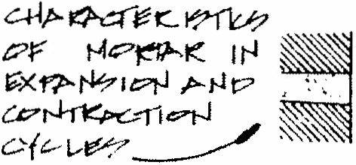

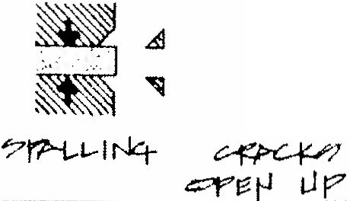
iJo,b-1..-
-fYMi.-
.::rOJ r-,.rr
ne'.°o f"l 1-- 7
=
+b,--
( '? rq:'f..Jt:,)
1-'t?
t-11"" 1:<?
=
-

#52) MAINTAIN AND PRESERVE ORIGINAL FOUNDATION WALLS

Normally Required

- Original brick pier foundations should not be enclosed with concrete or artificial materials such as stone or vinyl veneers.
- Foundations constructed of poured concrete or hollow core concrete should be retained. Concrete foundations should not be painted or stuccoed. Artificial materials such as stone veneers, aluminum, or vinyl siding should not be applied to obscure these foundations.

Recommendations

- To effectively screen out debris, pets, etc., it is recommended that wooden lattice panels be
utilized. Lattice panels were widespread at the
turn of the century and allow ventilation under a residence while effectively screening the area beneath the house. Wood lattice panels built in 45 degree or 90 degree angles are appropriate and the use of lattice panels should be considered. Pre­ fabricated lattice panels available at home improvement stores are usually too thin and fragile to be cost effective. The openings on pre­ fabricated panels are also usually too large. Another alternative is the introduction of vertical wood slats between brick piers. This type of design is particularly effective for small openings beneath porches.
- The use of concrete between brick piers is discouraged but may be allowed if a smooth stucco surface or wash is added to the exterior surface of the new concrete wall. The added concrete walls should be recessed four to six inches behind the original brick piers. It is also recommended that frame lattice panels then be added in front of the
stucco to effectively screen its appearance.
- The introduction of brick lattice or pierced walls between brick piers is also acceptable. The new brick should match the original brick as close as possible but if such a match is not feasible then both the original and replacement brick should be painted the same color. Dark reds, dark grays and similar tones are more appropriate than bright colors. Added brick walls should also be recessed four to six inches behind the original piers.

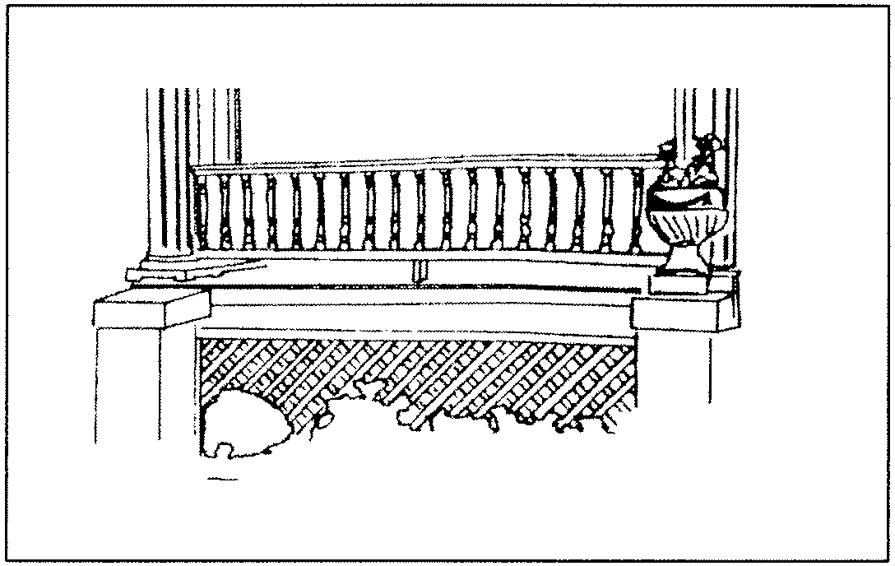
Effective use of lattice at Foundation wall.

Foundations are structural elements above
or below grade that support a building. In Sumter the overwhelming majority of residences are built on brick foundations which are between l' and 2 1/2' above grade. These brick foundations are both continual walls and piers. Most residences with brick pier foundations have had the areas between the piers enclosed with brick or concrete in recent years. Some residences constructed after 1910 were built with foundations of poured concrete or hollow concrete blocks but most Bungalows and other house styles of the 1920s and 1930s continued to be built with brick foundations. The relatively high foundations found in Sumter's historic districts are important visual elements and they contribute to a residence's overall appearance.
Solid brick foundation walls are primarily of common bond or stretcher bond brick and usually have some type of venting system to allow air flow under the house. These may be openings in the brick such as pierced open weave patterns or square openings with metal grilles. Brick pier foundations were built in square or rectangular designs of stretcher bond brick. The openings between the piers were left open or enclosed with wood lattice panels. In recent decades these openings have frequently been filled in with new brick or concrete. The contrast between the original brick and replacement brick is often quite apparent and the contrast between the original brick and added concrete is even more striking. Original brick foundations should be preserved and maintained and changes should be as unobtrusive as possible.

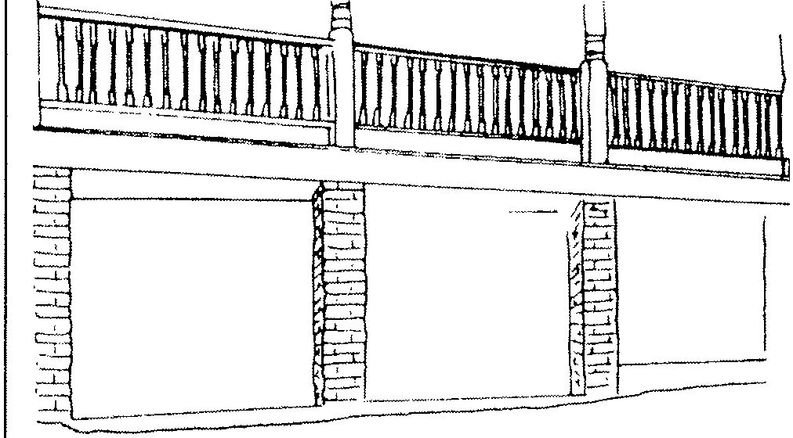
Sumter foundations are often supported by brick piers.

#53) PRESERVE AND MAINTAIN ORIGINAL PORCH LOCATION AND CONFIGURATION

Normally Required

  - Porch elements that have become deteriorated should be repaired rather than replaced.
  - Original porch elements such as columns, floors, and railing details should not be removed. Repair of porches should be made with materials to match the original.
  - Porches may be enclosed with screen panels as long as the panels have the minimum number of vertical and horizontal framing members necessary to support the screening. These panels should be recessed behind the existing porch columns and railing and framing should be of wood; metal frames should be avoided.
  - Porches on primary facades should not be enclosed with glass or other materials to create living space. Porches on secondary or rear facades may be enclosed with glass if the glass is set behind porch columns and railings and if there are minimal vertical and horizontal framing elements.
  - Porches shall not be added to a primary or secondary facade on residences that originally did not have porches on these facades. If architectural or historical evidence exists that supports the previous existence of a porch, its restoration may be permitted.
  - Porches or decks on rear facades may be added as long as they are not readily visible from the street.

Porches in the historic residential areas of Sumter are found on the primary facades of most buildings. Porches are also found to a lesser degree on side and rear facades. In some cases, a large porch on the primary faade
extends or wraps around a portion of the side facade. One-story, shed roof, full width and partial width porches are the most common forms found on Sumter residences. Two-story porches are uncommon. Another porch form also found are recessed or incised porches which are located beneath the primary roof structure of the house. Porches are used not only as sheltered outdoor space but also serve to provide a transition from the exterior to the interior of a house.
Porches are one of the major defining elements of a residence's style, age, and character. Basic components of porches include the porch floor, columns, railings, decorative trim and ceilings. While the overall plan and form of porches remained much the same, porch treatments often changed from 1880 to 1940.

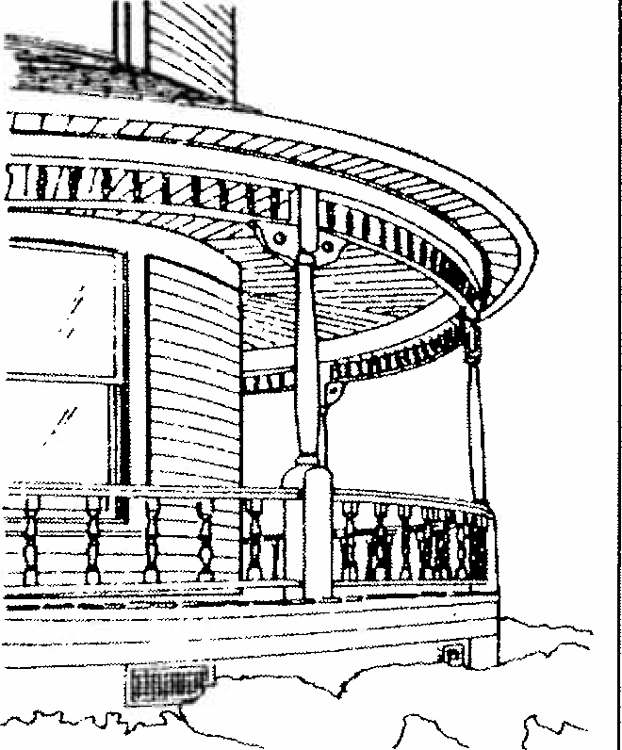

Queen Anne porch

The invention of woodworking machines such as high speed lathes and jigsaws in the mid-19th century made it possible to turn out a wide variety of designs for house components. Because of their prominence on the primary facade of a residence highly decorated porch columns, railings and decorative trim were often applied. Columns were milled with various decorative profiles and both rounded and square designs were often combined in a single column. Turned balusters in various shapes and forms were applied beneath handrails and milled panels, vergeboard, brackets, and spindled friezes were frequently applied at porch eaves. These decorative elements help define several styles of the late 19th century such as the Italianate, Queen Anne and Eastlake styles.
The economy and availability of these porch features also made them popular for more modest homes and are often the center of decoration. One­ story porches with ornate columns and railings are found on various Folk Victorian plan residences in the districts and distinguish an otherwise simple or plain appearance.
From 1900 into the 1920s, a resurgence of interest occurred in the Colonial heritage of the country. Houses reflecting the Colonial Revival and Neo-Classical styles were constructed and with them came porch columns reflecting formal Greek and Roman orders. The most common of these porch column forms were Tuscan columns. These columns are essentially simplified Doric columns with minimal detailing. Tuscan columns were mass produced and applied to many high style Colonial Revival homes as well a- Folk Victorian versions such as Foursquare residences. Other columns also used in this period were Ionic columns which were distinguished by their circular voluted capitals.
Corinthian designs with their ornate floral capitals are rare.
Balusters in porch railings for the Colonial Revival style are predominantly of two types: circular turned balusters in historic designs; and simple square balusters measuring between one inch and two inches square. These baluster designs are found on both the large Colonial Revival homes anc the simpler Foursquare designs. The frieze boards of porches were either left plain or decorated with Greek or Roman designs such as dentils or modillion blocks.
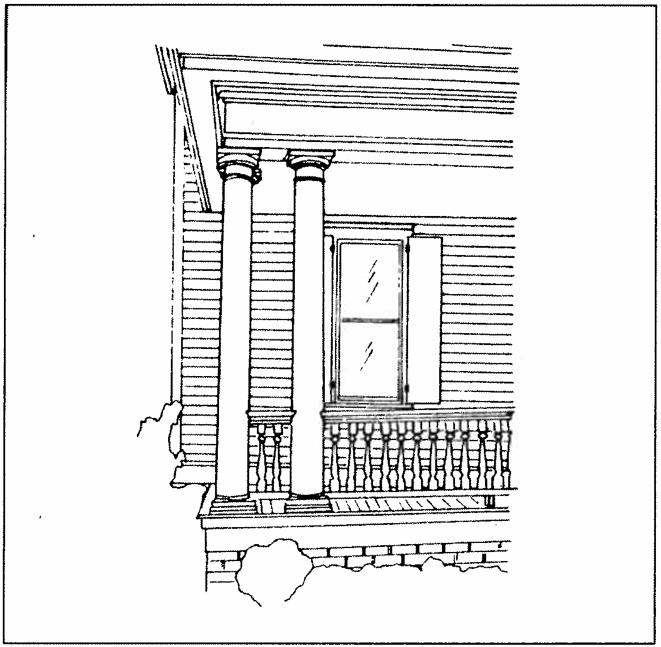

Colonial Revival porch

By the 1920s the Bungalow or Craftsman style became the dominant building form in Sumter and with this style came more changes in porch details. Columns became larger and many designs emphasized a tapering of the column from a narrow, plain capital to a larger, fuller base. The use of brick for porch columns was also widely used with many brick columns also displaying a tapered effect. A common column form in Sumter from this period was tapered wood columns which rest on brick piers. Concrete was also used for porch columns and sometimes stones or rocks were embedded in concrete for decorative effect. Concrete also became popular as the material for porch floors. Balusters in porch railings were fairly simple on Bungalow and Craftsman houses and were generally variations on square or rectangular designs. Other porch railings were built of solid brick or brick with open weave or lattice patterns. Frieze boards were left plain or embellished with wood shingles.
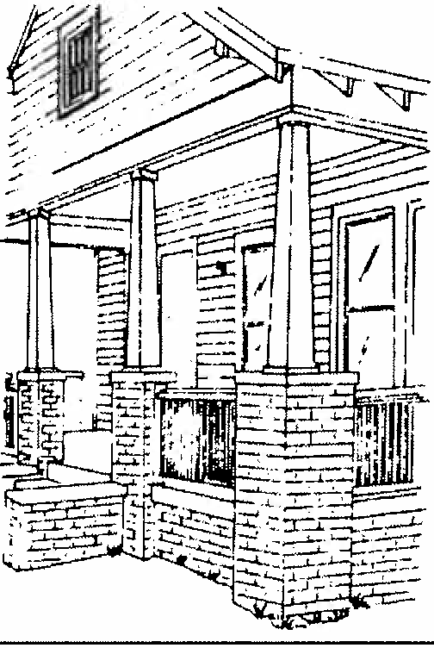
Bungalow porch
Another characteristic of Sumter residences are the numerous homes built between 1880 and 1910 which were remodeled with Bungalow style porches in the 1920s and 1930s. This remodeling is commonly found in houses across the South and suggests that many property owners wished to update their porches in the prevailing style of day. Another explanation is that many of the porches in the 1920s were twenty to thirty years old and rather than repair them in their original form they were simply removed and replaced with more substantial Bungalow style elements of brick and concrete.
The preservation of pre-1940 porch elements on residences is one of the primary guidelines for historic neighborhoods. Porches are one of the most significant defining features of a house and original forms, designs, and details should not be altered.
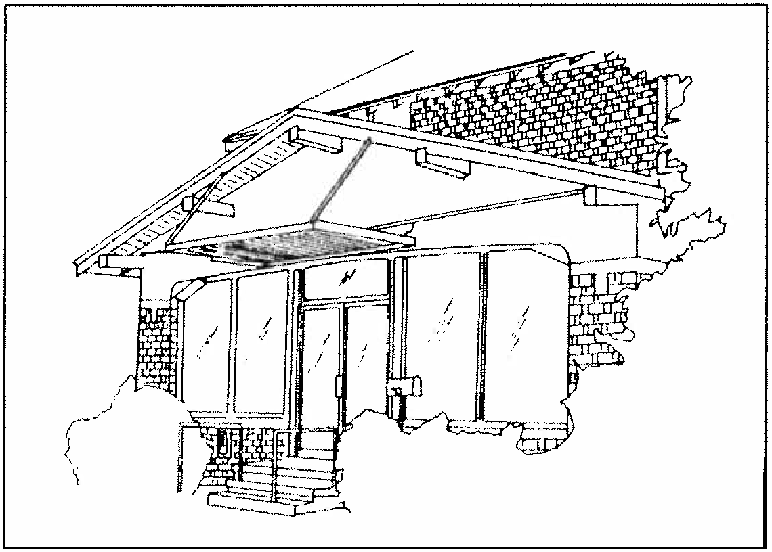

Inappropriate porch enclosure.

#54) REPAIR AND MAINTAIN ORIGINAL PORCH FLOOR MATERIALS

Normally Required

    - Original wood or concrete porch floors should be maintained and preserved.
    - Wood porch floors should not be replaced with concrete.
    - Porch floor areas that are deteriorated or
cracked should be repaired with matching materials.

Porch floors in Sumter built prior to 1905 were almost always of wood construction. The most common designs were tongue in groove boards which interlocked and laid in one direction over a structural framework. Because porch floors are frequently exposed to the elements, they require periodic maintenance and repair. Where porch floors were not maintained the result was often the replacement of sections of floor boards, especially in areas most prone to weathering. Rather than replace wood floors, some property owners hac poured concrete porch floors added after 1910. Residences built after this time also had concrete porch floors added as opposed to wood floors. The use of modern poured concrete or brick for replacement of a wood floor is inappropriate.
#55) MAINTAIN AND PRESERVE ORIGINAL PORCH COLUMNS

Normally Required

- Porch columns that are deteriorated should be repaired rather than replaced. If the base of a column is the only major site of damage the replacement of the base rather than the entire column should occur.
- Wood columns to match original wood columns should be used on primary facades. Metal or aluminum columns should not be installed on primary facades.
- Aluminum or metal columns are discouraged but may be used to replace wooden porch columns on rear facades.
- Wood or brick columns should not be replaced with modem wrought iron columns.

#56) MAINTAIN AND PRESERVE ORIGINAL PORCH RAILINGS
in recent decades but ar e st ill impor t ant in mainta ining the cha r acter of a r esidence . Af t er 1910, t he use of pou red concr ete or combina t ions o f concret e and br ick became common f or st air s .

Normally Required

- Original porch railing details shall be preserved and maintained.
- Handrail or baluster replacement shall be with materials to match the original.
- The introduction of a new porch railing for a porch that was originally built without a railing is discouraged. If required for safety or access reasons the railing should be simple in design with square balusters.

#57) MAINTAIN AND PRESERVE ORIGINAL STAIR MATERIALS
Normally Required

- Original concrete, brick, or wooden stairs leading to a porch or entrance should be preserved and maintained.
- Pre-cast or pre-formed concrete stairs should not be installed on primary facades.
b. Original wood, brick, or concrete stairs should be repaired or replaced with stairs of matching materials.
d. Wrought iron hand rails or rails of other metal materials should not be installed. If hand rails are desired they should be of wood in simple designs with square balusters.

The ma j or ity o f residences built be f ore 1910 in Sumt er had wooden steps or stairs leading t o the por ch or ent r ances . These wooden stair element s we re of t en exposed t o the element s and of t en det er iorat ed over a pe r iod o f twent y t o thi rt y yea rs . Most exist ing wood stairs we r e bu ilt
These origina l st a ir s should be r epaired wit h concret e when necessa r y and t he paint ing repa ir ed concr et e sta irs is encouraged . The of pre-ca st or pr e-f ormed concr ete stairs is appropriat e .

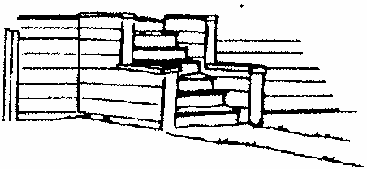

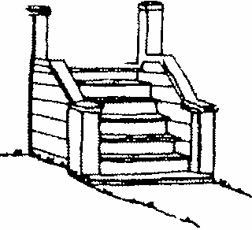

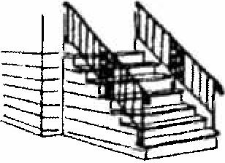

Appropriate stair replacement .
new o f use not

#58) HANDICAP RAMPS SHOULD BE LOCATED ON REAR OR SECONDARY FACADES

Normally Required

Recommended

c. Alteration or removal of original entrances on rear facades or facades not readily visible

- Handicap ramps facades or secondary visible.
should be located on rear facades which are not readily
from the street is discouraged but may be allowed. If removed, it is recommended that original doors be saved.

- Primary facades or secondary facades that readily visible are inappropriate locations handicap ramps.

Recommended
are for

The location and configuration of original entrance openings is essential to defining the character of a residence. Original entrances should be left in their original location and there should be no removal of original elements.

c. New handicap ramps construction and their should be compatible structure.
should design
with
be of wood and detailing the original
Original entrance openings should not be enclosed or downsized for smaller doors.
In several areas of Sumter new entrances have been added on primary facades in the conversion of single family dwellings to multifamily dwellings.

Situations may arise where handicap ramps are required for historic buildings. Handicap ramps are generally sloped with a low pitch to connect with porches or entrances. Ramps should be installed on rear facades or facades not readily visible from the street. Wood construction is recommended and detailing should be as simple as possible.

#59) MAINTAIN ORIGINAL ENTRANCE LOCATIONS

Normally Required

- Entrances on primary or readily visible secondary facades should not be enclosed or altered.
- New entrance openings should not be added on primary facades or readily visible secondary facades.
These new entrances have been added on both the first and second stories and significantly alter the residence's appearance. New entrances for multi-family dwellings should be added only at rear facades or facades not readily visible from the street. If new entrances are added it is recommended that window openings be enlarged rather than have extensive removal of the exterior wall and siding. This would assist future single family conversion through the removal of the entrance opening and recreation of the original window.

#60) MAINTAIN AND PRESERVE ORIGINAL ENTRANCE ELEMENTS

Norm.ally Required
d. Original doors shall not be replaced with modern solid core wood doors and similar variations. Doors with ornate designs of wrought iron or similar metals shall not be installed.

a. Original door-, surrounds should be

transoms, sidelights, and preserved and retained.
Recommended

Original hardware such retained.
as locks should also be
e. Doors which have not been previously painted
should be left in their natural condition. The

- Replacement of original doors should not take place unless significant deterioration can be demonstrated.
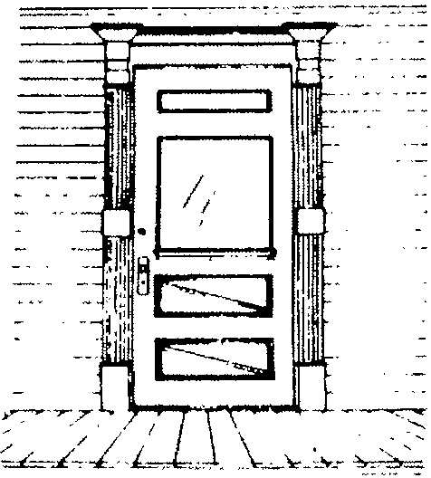
- New doors on primary and readily visible secondary facades should be of designs appropriate for pre-1940 residences. For residences built between 1880 and 1915 this may include single light glass and wood designs and doors with four or five recessed panels. For residences built between 1915 and 1940 doors with multiple glass light designs or single light designs are appropriate.
painting of doors which have a grained or stained
finish should only take place if severely weathered.
- If an original door on a primary facade requires replacement an original door from a rear or secondary facade may be removed and installed in its place.
- Screen doors are appropriate if they are of wood design and have large expanses of screening. Rail and stile framing should be minimal. Screen doors which match the rail and stile arrangement on doors is encouraged.

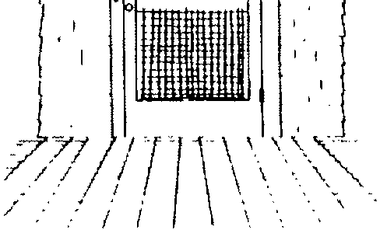
I, . ! f ,-J:-T
J • ...!. .1 1 f ·r ·
i
1 ,--_
CL_ l(
:;;]
I
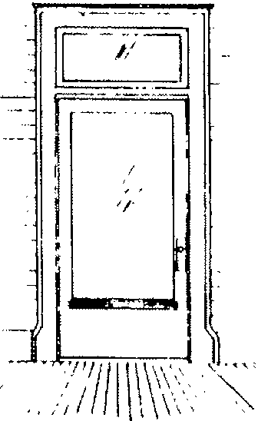
Single light door Original screen door Queen Anne door

Entrances on historic residences in Sumter are often the location of extensive decorative elements. Many excellent examples of Queen Anne style doors exist with detailing such as incised panels, stained glass lights, or raised milled decoration. Entrance openings from this period also feature sidelights, transoms, and milleci surrounds.
The majority of residences built in Sumter from 1880 to 1915 were built with rectangular doors at the primary entrance with large single

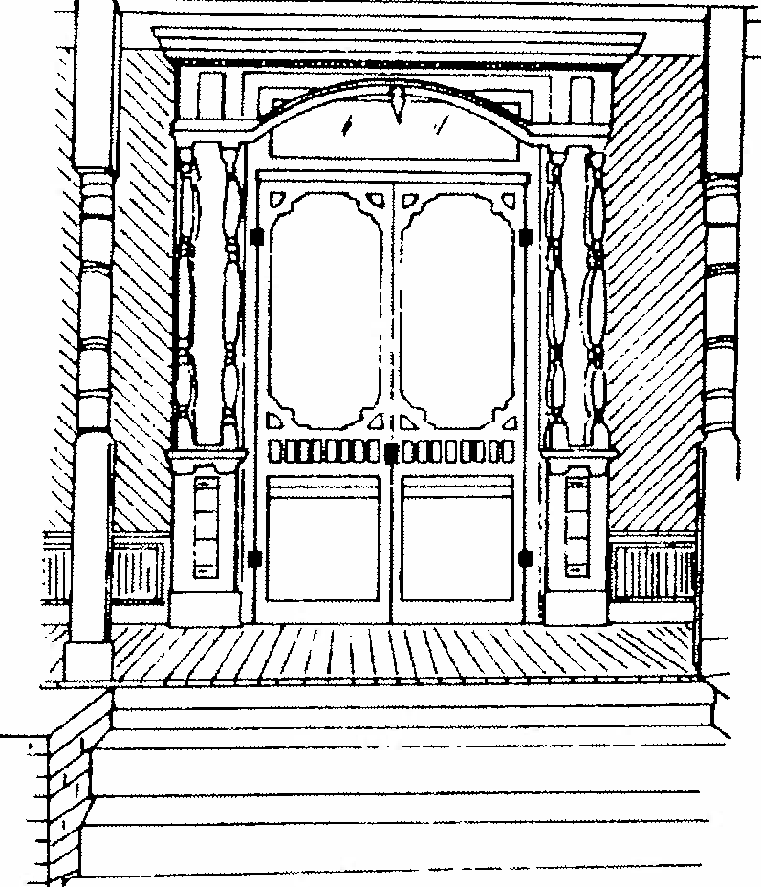
Original screen doors.
glass lights. This design is common throughout the historic districts and was popular until the
Bungalow era of the 1920s. Bungalow doors were \
I
often built with smaller panes of glass arranged
in decorative designs. The use of beveled glass for doors, sidelights, and transoms was also popular for Bungalow residences. All original entrance features on residences built prior to 1940 are significant defining elements and should be preserved and maintained.

---["""'I I /;
-----
0 -------
==--== 1
===::Iij n:n,
I r="'
-
I -
--
-
1111111111:i
-=--=-
----·1•
I; 1111111 1-------
llll
li
-
-----; I I
----i...9 01
n1 ----
l 0 -·-==-===-
j , -
---------,l'!J11.Jl
-----i-,. I
-------10
====:1l1j
I =- ---
;;;;,;; -----
; ::-------
01------
---
Original screen door

#61) SCREEN AND STORM DOORS SHOULD MATCH PROPORTIONS AND DESIGN OF THE ENTRANCE

Normally Required

- Original wood screen doors should be preserved and maintained.
- Storm doors added to entrances on primary facades or readily visible secondary facades should be plain, full-view design to allow for visibility of the original entrance.
- Storm doors of unpainted or raw aluminum should not be installed.
- The installation of plain, full view security doors at the primary entrance may be allowed. Security doors with extensive metal grillwork should not be installed on primary facades but may be installed on rear entrances or entrances not readily visible from the street.
- New screen doors should be of wood construction and plain, full view designs are recommended. Screen doors with vertical and horizontal stiles and rails should match the rail and stile design on the original door.

Recommended

- Storm doors added to rear entrances or entrances on facades not readily visible from the street are recommended to be of plain, full view design. Doors of varying types of metal and glass panels may also be allowed.
- Storm doors should be of wood or anodized aluminum in dark colors. Aluminum storm doors may also be installed as long as the door is primed and painted and the raw aluminum surface is concealed.
- Screen doors should be painted with colors to match the entrance.
The use of screen, security or storm doors on primary entrances is acceptable and appropriate as long as the design allows visibility of the original door. Security doors with extensive metal grilles or bars should not be installed at primary entrances but may be appropriate for rear entrances or those on secondary facades.

If  I  l | II
I/ | I
i

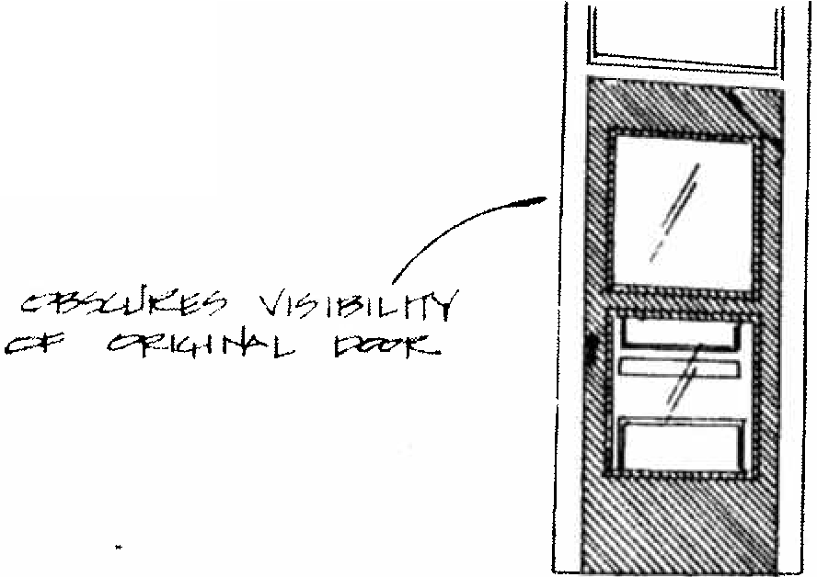
Appropriate and inappropriate storm doors.
IL
]
v---
Ll71:: rt.?-1 r-J f'iJ W.-
\/ Ii::.JJ ;;:7 c:tJr:. t r Y Pt'.A?
/'

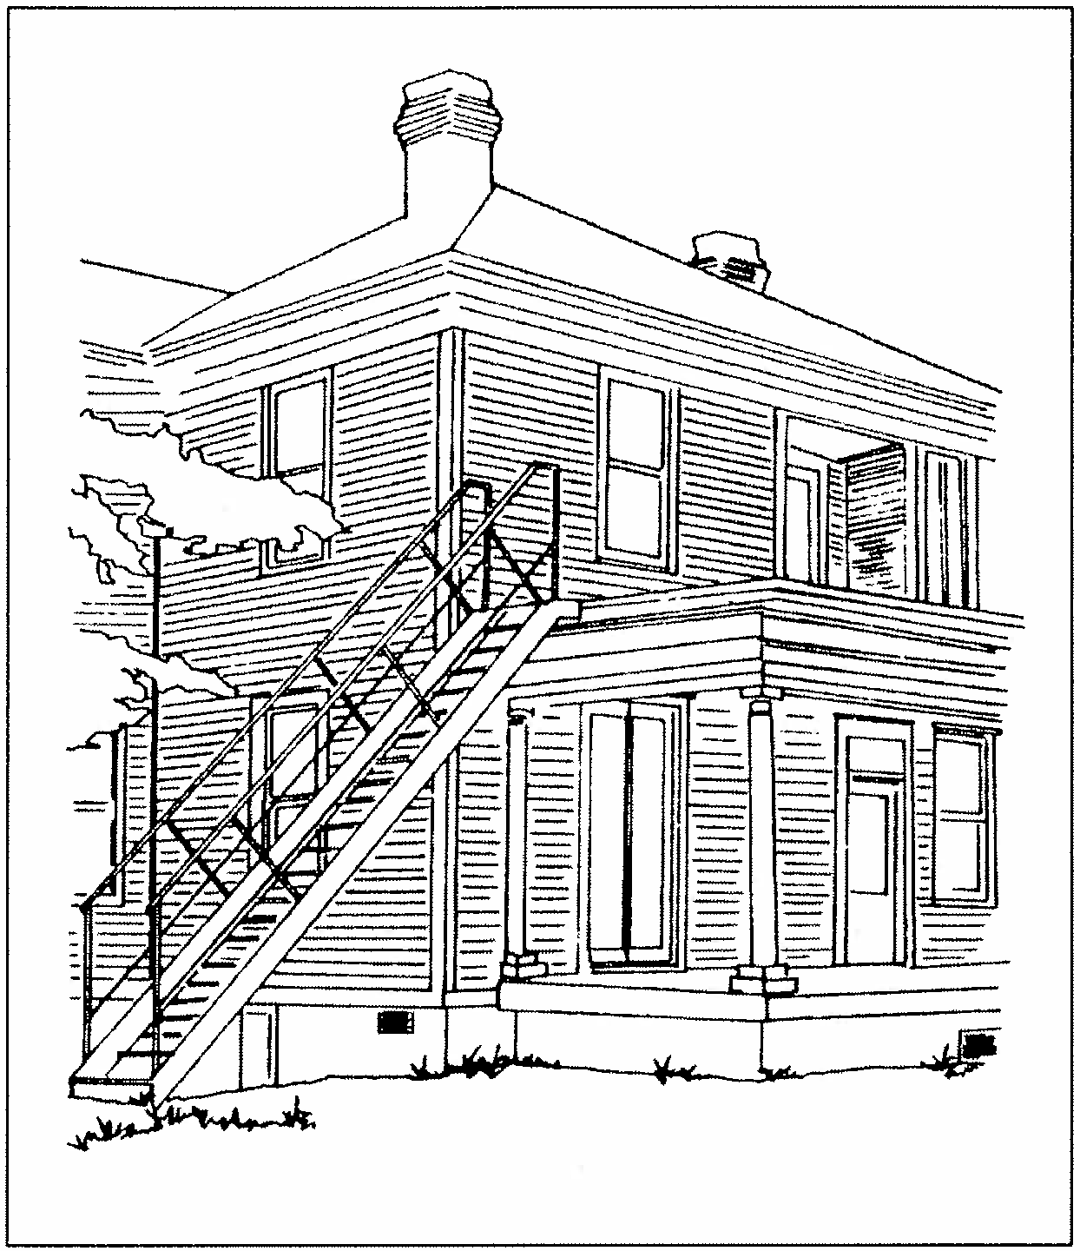
#62) EXTERIOR ENTRANCE STAIRCASES SHOULD NOT BE PLACED ON PRIMARY FACADES

Normally Required

  - Staircases leading to upper floor entrances shall not be placed on the primary facade or on readily visible secondary facades.
  - Rear facades or secondary facades not readily visible from the street are appropriate locations for staircases.

Recommended

  - Staircases of wood construction are more appropriate than those of wrought iron or other metal construction.

A number | of | residences | in the Sumter
districts have | been | converted | to multi-family

dwellings in recent decades. To access upper floor apartments and meet code requirements it has often been necessary to install exterior staircases. Staircases placed on rear facades are appropriate but those placed on primary facades detract from a property's original design and character. Exterior staircases may be installed only on rear facades or towards the rear of secondary facades. New staircases on primary facades should not be constructed. Wooden staircases are appropriate for historic residences and metal staircases are discouraged.

Exterior staircases should never be located on primary facades.

#63) MAINTAIN AND PRESERVE ORIGINAL WINDOW OPENINGS

Normally Required
- Original window openings should not be enclosed, reduced, expanded, or concealed.
- New window openings should not be added to the primary facade or readily visible secondary facades.

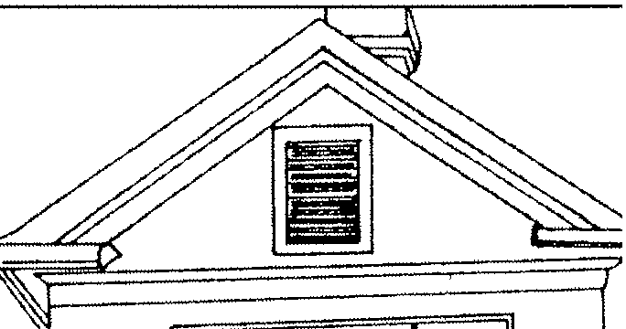
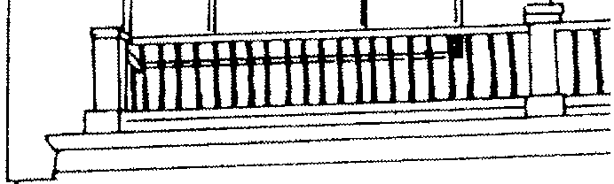
The location and size of original window openings are important defining features of a residence. Historic window openings were generally built with a vertical emphasis with the height at least double that of its width. Original window openings should not be reduced or enclosed to make way for modern stock windows.
I
j
Original window openings should also not be concealed beneath modern materials or expanded for large picture windows or entrance openings. Window alterations on rear facades is discouraged but may be allowed as long as these alterations are not readily visible-
New window openings on primary facades should not be added. Windows may be added on rear facades or areas which are not readily visible.

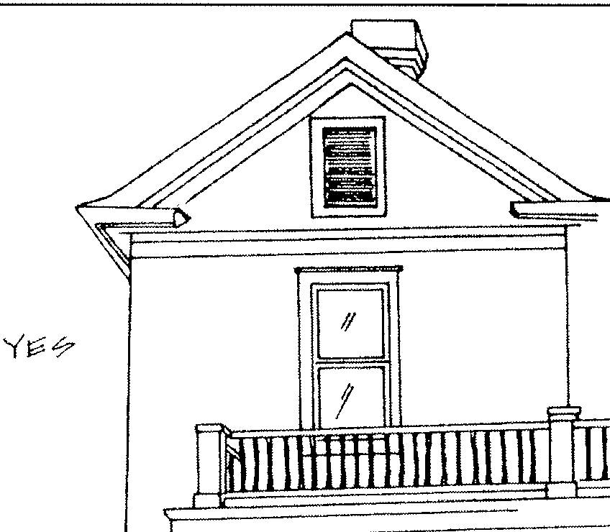

Original window openings should be maintained.
Original openings should not be enlarged.

#64) MAINTAIN AND PRESERVE ORIGINAL WINDOW DETAILS

Normally Required

- Original windows should be maintained and repaired with matching materials. Replacement of original window sash should take place only if deterioration is clearly demonstrated.
- The sash configuration of windows should not be altered. Replacement windows should match the original designs in dimensions and lights.
- Single light fixed windows, picture windows, and modern metal designs should not be added on primary and readily visible secondary facades.
- Original stained glass, leaded glass, and other decorative glass features should not be removed from window openings. Conversely, elaborate stained glass or other decorative glass lights should not be added to a residence's primary or readily visible secondary facades if there is no evidence that such window features were ever present on a house.
- Snap-in muntins should not be applied to original window sash.
- Replacement glass or lights should be of clear glass on the primary and readily visible secondary facades. Tinted glass may only be installed on rear or secondary facades not visible from the street.
Recommended

- Window sash and frames should be painted a contrasting color than the body of the house to provide contrast and depth to the window openings.

The majority of historic residences in Sumter have rectangular one-over-one wood sash windows.
These windows are generally simple in design with minimal decoration in the moldings or surrounds. The use of stained, leaded, or etched glass was also limited in these years and these decorative glass features are most often found as small decorative windows adjacent to entrance openings or on secondary facades to illuminate stairwells.
Windows on Colonial Revival-influenced residences are also one-over-one wood sash but windows based on colonial designs such as six-­ over-six wood sash can also be found. Bungalow style windows were generally divided into smaller lights or with the upper sash divided into narrow vertical lights. Window design is an integral part of a residence's character and alterations and replacement should be with materials and designs to match the original.

0
00
D0D
LJ LJ
DD

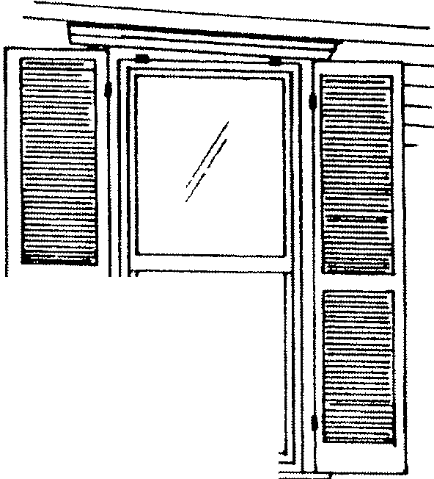
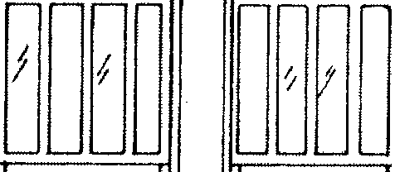
Historic window designs in Sumter

I
,'I
,//
f /
/
It
I
--
I
/,
,I;1//
I
e,iJr-141'< "7fY L-tii=
;,it ecvl J,-11--n-1 v'¢'tc 1Cf>-{.-
1,-14--.J--f7

57

#65) STORM WINDOWS SHOULD MATCH ORIGINAL WINDOWS IN DIMENSIONS AND PROPORTIONS

Norm.ally Required

a . Storm windows should match the original window opening in proportion and dimension . Storm windows should have a meeting rail location to match that of the original window. For small window openings single pane storm windows are appropriate.
- The installation of raw or untreated aluminum
f rames is acceptable only if the aluminum is primed and painted .

Recommended

- Storm windows should be of baked enamel or anodized aluminum in dark colors . Hues of red, brown and dark gray are preferred over white.
d . Interior storm windows which match the
original window opening are appropriate and may be installed .

The installation of storm windows is acceptable for energy conservation and protection of the original windows. New storm windows should be of solid full view glass or have the meeting rail match that of the original window profile. The use of raw or untreated frames should not occur unless painted and anodized aluminum frames in dark colors are preferred.
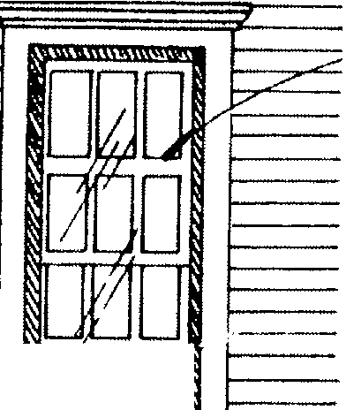
qfc';::,,:::'t-1 i,.J Ii-J t;::::t;>y-l<;7
-
-- -- C'V
\/1 r-1 41..-f""?"?
I? fJ'J.1.-,l,

DOD

F.f" I? +tA L-­
Cf:; /'<H c?t? I Z'..¢ 17
/'-I..- LlM l tJ tJr1 IrJ
j<'.....

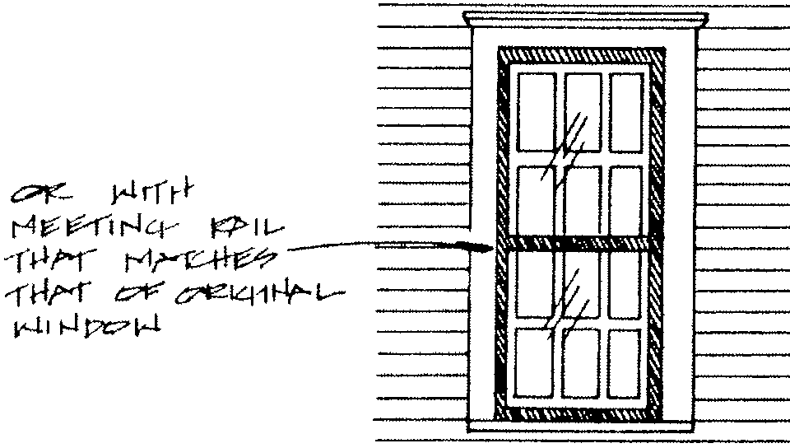
Appropriate storm window designs.

#66) WINDOW SHUTTERS AND BLINDS SHOULD FIT WINDOW OPENINGS

Normally Required

- New shutters and blinds should be sized to cover the window opening if closed. Shutters which are not proportional to the opening should not be installed.
- Original wood shutters and blinds should be preserved and maintained. Repair should be with materials and designs to match the original.
- If the need for replacement of original shutters and blinds is demonstrated, replacement should be with materials and proportions to match the original shutters.
- Metal or vinyl shutters or blinds shall not be installed.

Recommended

- Window openings which never had shutters or blinds should be left in this condition. If new shutters and blinds are desired for windows should be of wood construction and be of louvered designs rather than solid or raised panel designs. Metal or vinyl shutters shall not be applied.
- Shutters and blinds should be painted a contrasting color to the body of the house and should match the color of the window trim.

Shutters and blinds were originally placed at window openings to protect windows from the elements and block sunlight from entering a house in the summer. Residences were also built with interior shutters and many residences in Sumter appear never to have had exterior shutters or blinds. Original shutters and blinds are important components of window designs and should be

maintained and preserved. Repair should be with matching materials and replacement with matching designs is also appropriate.
With the advent of air conditioning in the 20th century, the use of shutters diminished and many shutters now are used primarily as ornamentation as opposed to having a functional use. Ornamental shutters should not be added to residences that never had original shutters. If evidence of original shutters exists, new shutters should be of wood design and match the proportions of the window opening. Vinyl or aluminum shutters and shutters that are oversized or undersized for the window openings should not be applied.
B

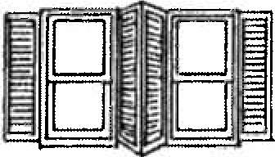
Shutters and blinds should fit openings.

#67) ORIGINAL ROOF FORMS SHOULD BE PRESERVED

Normally Required

- Roof forms and pitch shall not be altered on primary or readily visible secondary facades.
- The addition of new dormers, skylights, or gables shall not be added on primary or readily visible secondary facades.
- Original roofs should not be raised for additional stories.

Recommended

- The addition of new dormers or gables on rear or secondary facades is discouraged but may be added if they are in proportion to the building and are not readily visible from the street or sidewalk. Skylights may also be added on rear or secondary facades if they are not readily visible from the street.

Roof forms in the Sumter districts are primarily variations of gable and hipped designs. Other roof forms such as mansard, flat, or shed roofs are rare or do not exist. These original roof forms and pitch are important to the character of the district and no major alteration to roofs should take place. Original dormers and their decorative elements such as vent windows should be preserved and maintained. New dormers should not be added on the primary facade or readily visible secondary facades. New dormers may be added on rear facades if not readily visible.
Skylights are acceptable for rear facades or on areas of roofs not readily visible. Flush or flat skylights are preferred over raised or bubble designs.

60
#68) ORIGINAL ROOF MATERIALS SHOULD BE PRESERVED

Normally Required

- Original roof materials such as metal standing seam, slate, and tile should be maintained and preserved.
- If sections of original roofs are deteriorated they should be replaced with materials to match the original.
- Wholesale removal of metal standing seam roofs should not take place without significant deterioration being demonstrated. Wholesale removal of slate or tile roofs shall not occur unless unrepairable damage can be clearly demonstrated.
- Ornamentation such as finials and balustrades shall not be altered or removed.
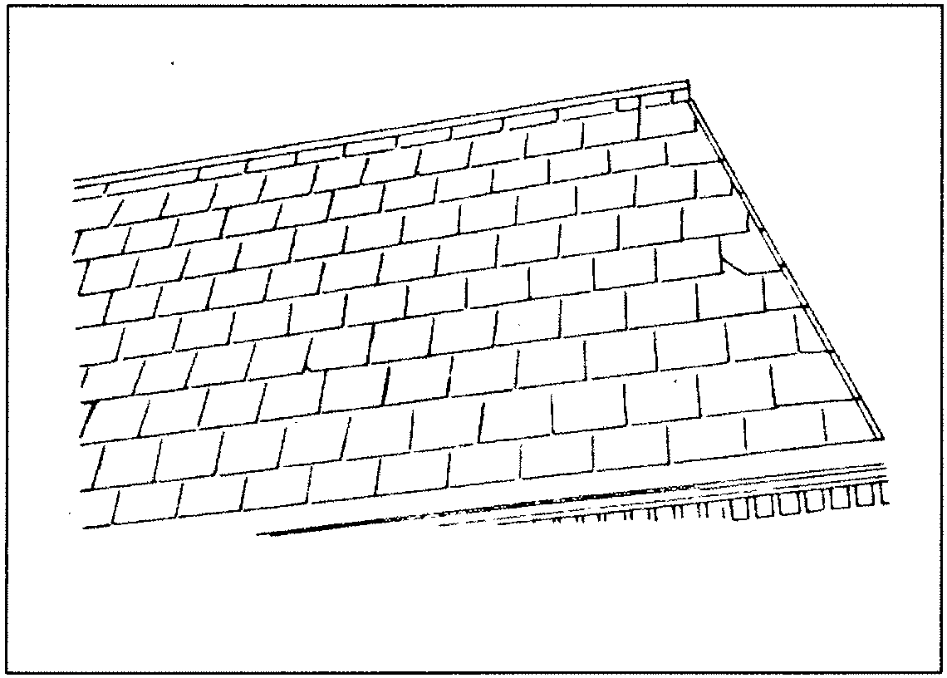

Slate roof.

Recommended

- Asphalt, asbestos or composition roofs that were added on homes after 1940 may be replaced with new asphalt roofs when necessary.
- Residences that have evidence of wood shingle roofs may have replacement wood shingle roofs added if desired. These roofs should be of shingle design to match the original. Residences that do not have evidence of wood shingle roofs should not receive this roofing material.
- Dark colors for asphalt roofs such as black, dark red, brown and dark green are preferred over lighter colors.

Roofing materials in Sumter at the turn of the century would have included slate, metal standing seam, metal shingles, clay tile, and wood shingles. After 1900, the use of asbestos or composition roofs became popular for their economy and fire protection.
Of the historic roofing materials that remain, slate, clay tiles, and metal standing seam roofs are the most common. A surprising number of wood shingle roofs exist in Sumter but are located beneath added asphalt or composition roof surfaces. Historic roof materials should be preserved and maintained. Modern asphalt roofs should only be replaced if the historic roofing materials are clearly demonstrated to be beyond repair. The use of wood shingles for roofs is appropriate if it can be demonstrated that these roofs originally had wood shingles. The existence of wood shingle roofs can be derived from physical evidence. Wood shingle roofs should not be added to residences that did not originally have this roofing material. Dark colors for asphalt roofs are preferable to lighter colors.

61
#69) CHIMNEYS SHOULD BE MAINTAINED AND PRESERVED

Normally Required

- Masonry chimneys shall not be removed above the roofline.
- Repair and repainting of brick chimneys should be with brick and mortar to match the original. If a match proves unfeasible the painting of chimneys is acceptable in shades of dark red and burgundy.
- Decorative brick corbelling and clay chimney caps should not be removed.

Recommended

- Clay, slate, or stone chimney caps are preferred over metal chimney caps.

Sumter residences have both interior and exterior brick chimneys. Chimneys of stone or stone veneer are much less common. Chimneys are important architectural features and they should be preserved and maintained. Some chimneys were built with decorative corbelling and recessed brick panels and are of particular significance.
The repair and replacement of brick chimneys should be of materials to match the original. If a chimney is in poor condition or has been extensively patched and repainted, it may be appropriate to cover the exterior surface with stucco. Stucco should only be used where a chimney's appearance detracts from the appearance of a residence. The use of clay or slate chimney caps is preferred over modern metal caps.

#70) ARCHITECTURAL ORNAMENTATION SHOULD BE MAINTAINED AND PRESERVED

Normally Required
- Architectural ornamentation shall be maintained and preserved. Elements that are deteriorated shall be repaired with materials and profiles -to match the original.
- Replacement of ornamentation should be with matching designs and materials.

Late 19th century homes were often embellished with milled wood decorative elements such as brackets, spindles, and verge board. These decorative elements are essential to the character of a residence and removal of original ornamentation should not occur. Colonial Revival designs also were decorated with modillion blocks, dentils and other designs at frieze boards and porches. Large brackets and exposed eave rafters were popular forms of ornamentation on Bungalows.
Iforiginal architectural ornamentation is too deteriorated for repair, replacement should be with profiles, dimensions, and materials to match the original. Numerous companies across the Southeast can replicate historic exterior features.

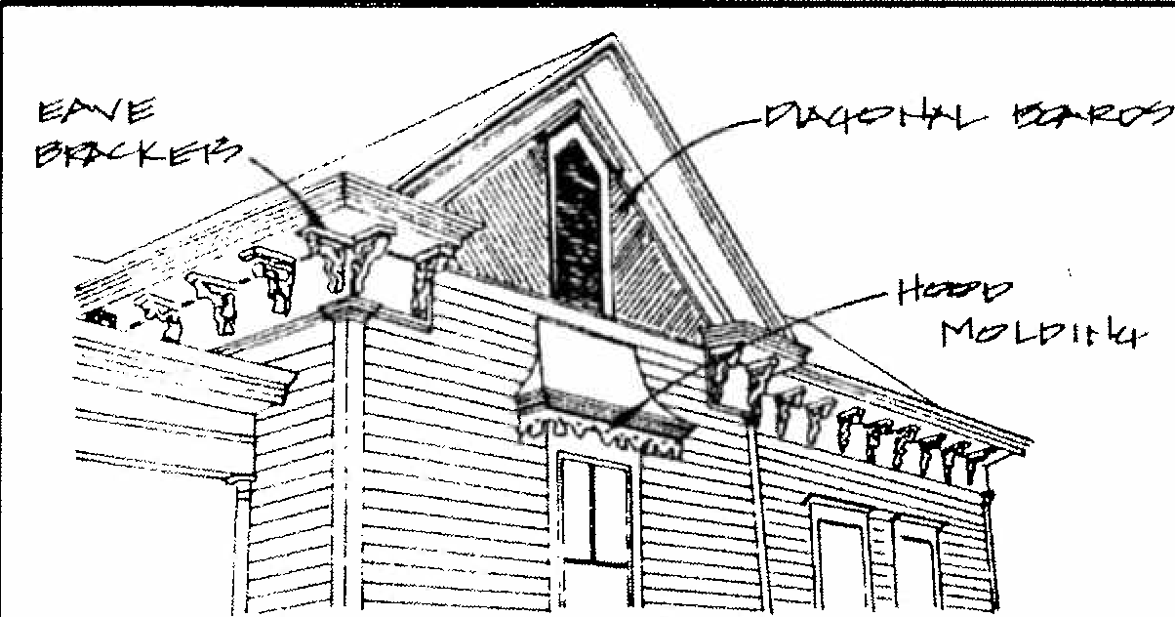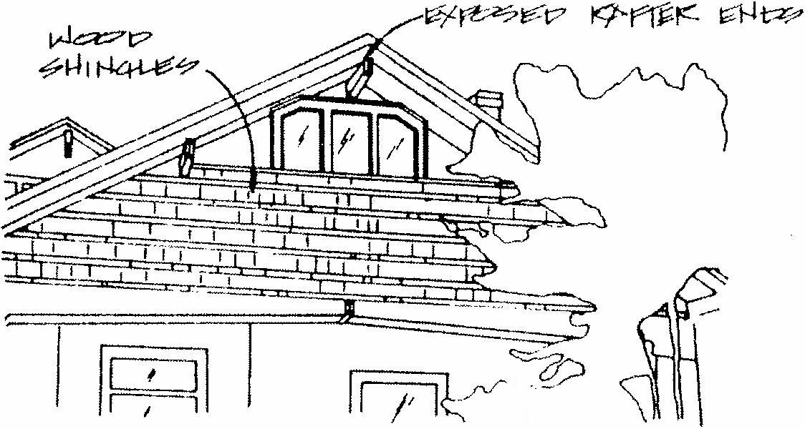

Italianate eave brackets Bungalow roof beams and shingles

#71) ARCHITECTURAL ORNAMENTATION NOT ORIGINAL TOA BUILDING SHOULD NOT BE ADDED

Normally Required

a. Architectural features and ornamentation which are not original to a residence should not be added.

Architectural ornamentation that is not based on photographic or physical evidence should not be applied. The addition of such ornamentation would not be accurate and would create an appearance not in accordance with the original design and style.

#72) EXTERIOR PAINT COLORS SHOULD BE IN KEEPING WITHA BUILDING'S STYLE AND TIME PERIOD

Normally Required

- Paint colors for painted masonry, exterior wood siding and other building elements shall
not be restricted except in cases of bright or arresting hues. Such paint colors as florescent green, orange, and yellow shall not be allowed.
- Paint shall not be removed from wood or brick surfaces through sandblasting or other abrasive methods.
- Masonry which has not been painted should remain unpainted except in cases where the brick or mortar has been patched, repainted, or repaired with significantly contrasting materials, colors, and textures.
Recommended

d. Paint colors should be selected in keeping with a building' s style and time period. Original color schemes based upon paint analysis are encouraged. Several companies also specialize in providing appropriate historic color designs by mail.
e. Exterior surfaces of stained wood shingles should be re-stained as opposed to painted.

Paint is a non-permanent addition to a residence and colors used for exterior siding and trim should not be restricted. Property owners are required to select colors which are in keeping with the original style and time period of the residence.
For buildings constructed between 1880 and 1910, a wide variety of colors were utilized. Colors such as tans, greens, reds, and grays were all widely used for the exterior siding of a residence. After 1900, residences with Colonial Revival influences were generally painted in shades of white or yellow. Bungalows were generally of darker colors such as browns and grays. The use of stained shingles on upper facades of Bungalows was also used to provide color.
In recent decades it has been a common practice to paint historic residences shades of white rather than repeating the historic color arrangement. Property owners are encouraged to return to appropriate colors for their residence instead of continuing white as the dominant color.
Abrasive methods to remove paint on exterior siding such as sandblasting should not occur. Such methods pit and erode the original wood surface. Masonry which has not been painted should remain unpainted.

#73) EXTERIOR PAINT COLORS SHOULD HIGHLIGHT ARCHITECTURAL DETAILS

Recommended

- The exterior siding or body of a residence should be painted dark or muted colors. Lighter colors should be used to highlight architectural trim and ornamentation.
- One to two accent colors in addition to the background color are best for most residences.

Historically, architectural ornamentation and the exterior siding of a residence were rarely painted the same color. Architectural ornamentation was usually painted in a variety of lighter colors to highlight their designs. Light colors are appropriate for details such as vergeboard, eave brackets, and dentils. Window trim and surrounds and wood shingles are also good locations to highlight through light colors. No more than two accent colors in addition to the color of the exterior siding is recommended. Additional colors may result in the residence becoming too busy and confusing.
Numerous publications are readily available to provide recommendations for historic paint colors. Such publications can provide valuable information in choosing paint colors for specific residential styles and designs.
#74) INSTALL HVAC AND AIR CONDITIONING UNITS AT REAR OR SECONDARY FACADES

Normally Required
- The installation of window air conditioning units should not result in the removal or replacement of original window sash or the alteration of window framing or surrounds.
- Window air conditioners should be installed at secondary or rear facades rather than primary facades.
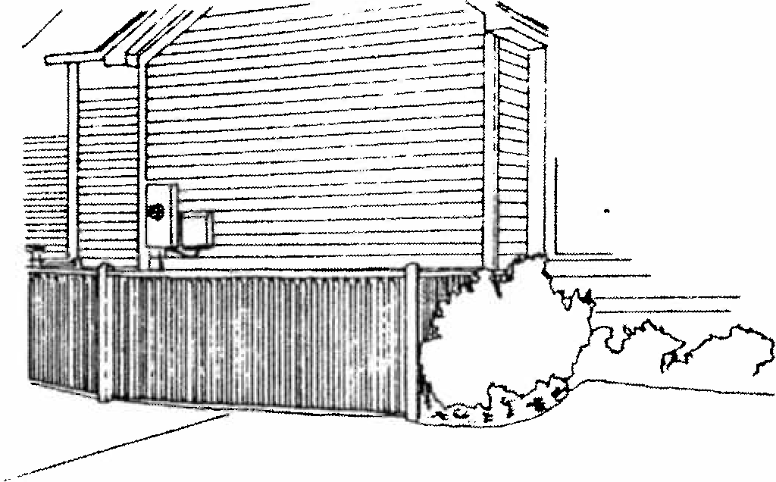
- Exterior HVAC units should be installed at rear facades or non-visible areas of secondary facades. HVAC units should not be installed at primary facades.

S creened HVAC units wi th wood f encing .

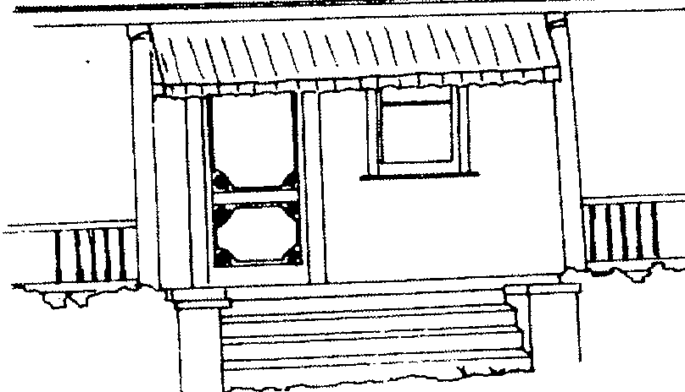
Recommended

- All readily visible exterior HVAC units that are located at grade should be screened with wood or brick fencing, lattice panels, and or landscaping.
- HVAC units adjacent to non-readily visible facades or placed below grade shall not require screening.
- HVAC units should not be placed at the roofs of residential buildings.

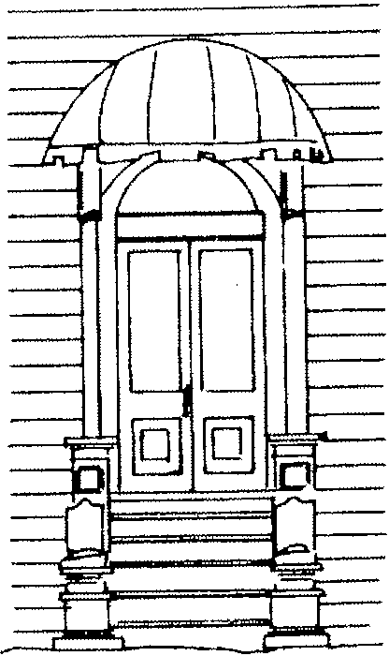
Air conditioning and heating units (HVAC units) are common additions to historic residences in Sumter. The most common types of visible HVAC units are exterior air conditioning condensers and heat pumps placed directly adjacent to a building and air conditioning units placed in windows. Heating and cooling units such as these shall not be restricted, but they should not be placed at or adjacent to primary facades or facades readily visible from the street.

#75) AWNINGS MAY BE APPLIED AT APPROPRIATE LOCATIONS

Recommended

- Canvas, vinyl-coated canvas, and acrylic are the most appropriate awning materials for pre- 1940 residences and should be the materials used on primary and visible secondary facades.
- Metal awnings, vinyl awnings, and other similar materials should not be applied. The only exception to this guideline would be the application of a metal or vinyl awning with a canvas overlay. This awning combination should have the appearance of a canvas awning from the street or sidewalk.

Appropriate awning locations.

- Canvas awnings should fully cover window, door, or porch openings but not be oversized to obscure areas of the facade or detailing.
- The most appropriate awning designs for pre- 1940 dwellings are standard or shed awnings. Also acceptable are circular or accordion designs. Box or casement awnings are more nontraditional and less desirable, however, these may be installed if requested. Valences should be in keeping with traditional patterns such as scalloped, wave, or sawtooth designs.

The use of awnings in residential areas is believed to have been less than in commercial areas in the late 19th and early 20th century but was still fairly widespread. Historic photographs of residential areas from this era often picture residences with canvas awnings over the main entrance, over windows, or placed at the eaves of porches. These awnings served the same functions as for commercial buildings blocking sunlight and aiding in the natural cooling process.
Canvas awnings gradually fell from favor due to their limited life span, the widespread use of air conditioning, and the introduction of new materials. Awnings extensively marketed in the 1950s through the 1970s were primarily of aluminum or vinyl and are still found on many residences in Sumter. Awnings are now used not only to help lower energy costs but are often also added as decorative features to homes. The use of awnings on residences is appropriate within certain conditions of size, materials, and design.

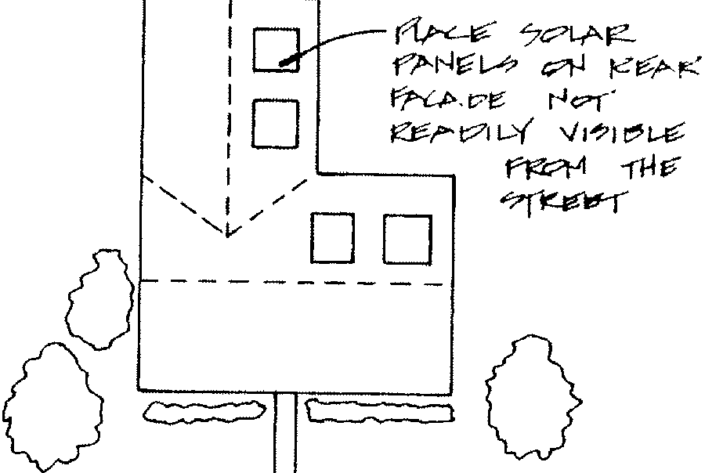

Solar panels should be sited at rear facades.
#76) LOCATE SOLAR PANELS ON REAR OR SECONDARY FACADES

Normally Required
a. Solar energy panels are acceptable as free­ standing structures in rear yards or attached to rear facade roof lines. Solar panels should not be placed on primary facades or readily visible secondary facades.
b. Solar panels on roofs should be installed flush with the roof and follow the slope of the roof.

Solar panels are popular additions to homes for energy conservation. The installation of

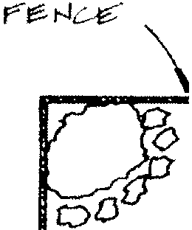
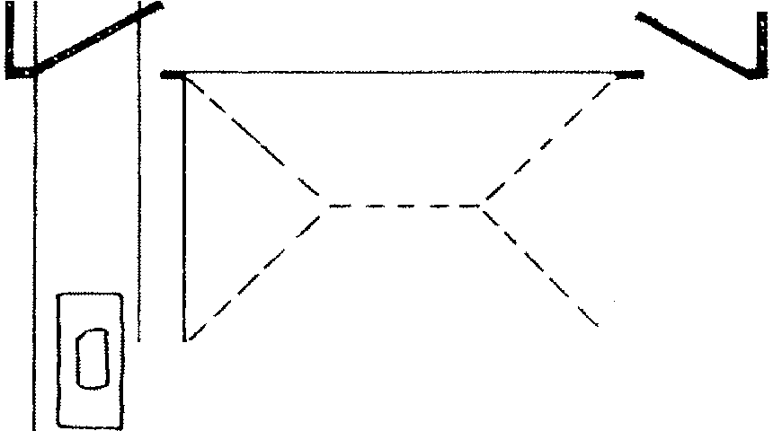
of solar panels is appropriate as long as the panels are placed on rear facades or at areas not readily visible from the street. Freestanding solar units should be placed in rear yards or side yards and screening with plantings or fencing is recommended. Solar panels may also be applied at rear roof lines if they will not be readily visible from the street.
'' /
/ '
'/</
/

/ '
a
'i)
0
0
'
0

#77) LOCATE RECREATIONAL STRUCTURES AND FACILITIES IN REAR YARDS

Normally Required

- Swimming pools, tennis courts, recreational structures and facilities located in rear yards.

and other shall be

Recommended
c:=:::, |  |  | c: :: :: ::i  0

- Screening through fences or recommended to mask recreational public view.
landscaping is facilities from

The installation of above or below ground swimming pools, tennis courts, and other recreational facilities is appropriate in rear yards. Such facilities should be screened from public view through landscaping or fencing.

Recreational structures should be screened.

#78) LOCATE SATELLITE DISHES IN REAR YARDS

Normally Required

- Satellite dishes, antennas, and other signal receiving devices shall not be erected in front or readily visible side yards. Buildings on corner lots shall also not have these devices erected in the side yard adjacent to the street.
- Rear yards are the only appropriate location for satellite dishes and similar devices.
- The installation and siting of these devices shall follow standards set forth in the Zoning Ordinance.

Recommended

- Satellite dishes should be screened from public view through landscaping or fencing.

The erection of satellite dishes and other transmitting devices may not take place in front yards in residential areas according to the Sumter Zoning Ordinance. Rear yards are the most appropriate location for these devices and they should be screened and not be readily visible from the street.

#79) MAINTAIN AND PRESERVE ORIGINAL OUTBUILDINGS

Recommended

- Original outbuildings such as sheds and garages should be maintained and preserved.
- Repair and replacement of original elements and details should follow residential guidelines.
Numerous sheds, garages, and other outbuildings exist throughout the residential areas that are over fifty years old. These outbuildings comprise a valuable collection of simple architectural designs which complement the historic residences. These buildings should be preserved and maintained. However, wood structures were often built with minimal foundations and deterioration to these buildings is common. Demolition of wood out-buildings which require extensive repair such as replacement of at least half of the exterior siding and have badly deteriorated roof structures may be allowed.

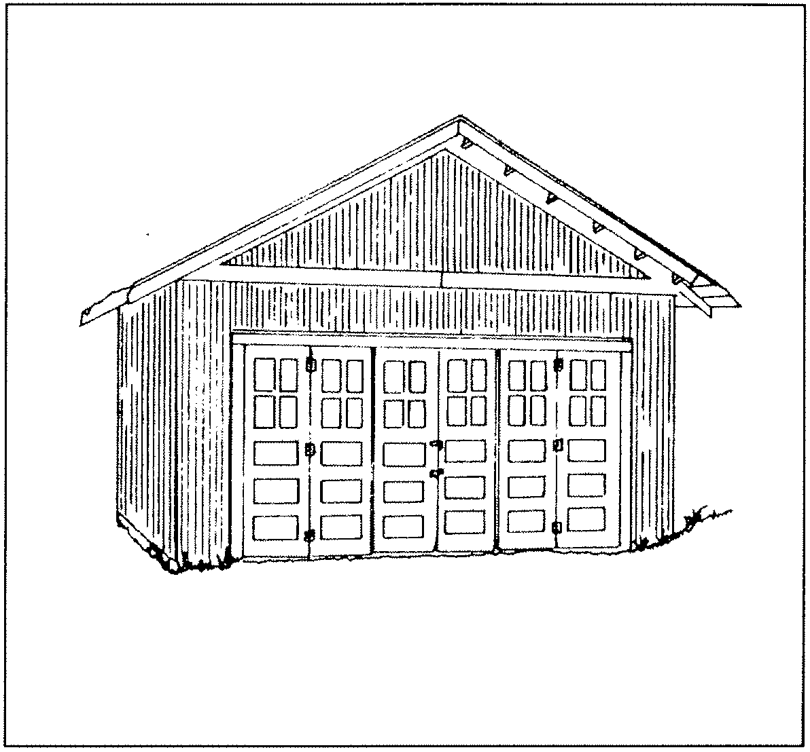
Original garage

NEW RESIDENTIAL CONSTRUCTION

#80) NEW CONSTRUCTION SHOULD BE OF ITS PERIOD AND HISTORIC REPRODUCTIONS SHOULD BE AVOIDED

Normally Required

features to match or closely approximate the original building.
The reconstruction of buildings that originally existed in Sumter may be allowed. For a reconstruction to be approved there must be ample evidence of the building's original

a. New construction in should be of its period. should be avoided.
the residential area Historic reproductions
appearance such as floor plans, drawings, or photographs. Reconstructed buildings must be on their original site, be constructed in accordance with their original design and materials, and be

New construction in historic residential areas should be of its period and direct replication of historic designs should be avoided. Successful new construction in historic residential areas repeats the basic design elements inherent in the district but creates different forms of expression. Direct reproductions are discouraged since they may cause observers to confuse a new building for a historic building.
No building should be constructed in Sumter that imitates ante-bellum architectural styles. Such buildings would reflect a time period which precedes Sumter's growth and development.

#81) RECONSTRUCT/ON OF BUILDINGS MAY BE ALLOWED

Normally Required

- Reconstruction of buildings which are clearly documented may take place on their original site.
- Reconstructed buildings should be constructed with materials, detailing, and decorative
compatible with adjacent structures. Reconstructed buildings should also be clearly designated as a reconstruction as opposed to an original historic building. This may be done through a marker applied to the exterior of the building, freestanding sign, or other method of designation.

#82) NEW CONSTRUCTION SHOULD BE COMPATIBLE IN HEIGHT WITHADJACENT BUILDINGS

Normally Required

a . New construction should be compatible in
#83) FOUNDATION HEIGHT FOR NEW CONSTRUCT/ON SHOULD BE COMPATIBLE WITH ADJACENT STRUCTURES

Normally Required

height wi th adjacent structures . construction should vary no more than 10% the average building height along its block .
New wi th
a . New construction in residential areas must have f oundation heights of at least one f oot above grade on the primary facade . No building shall be constructed at grade in the historic

Building heights for residences in Sumter's
historic areas vary from one to two-and one-half stories. New construction should respect the height of adjacent buildings and the dominant building height found along its block or street. Two story buildings are appropriate for most blocks in the historic districts and it is best that new construction not vary more than ten percent (10%) in height with adjacent structures. One-story buildings are not appropriate for blocks dominated by two-story structures.
Existing zoning regulations presently restrict building heights to 35 feet in all historic areas.
areas .
b . Brick construction must have the foundation level delineated through some type of belt course such as soldier or sailor coursing .

Historic residential structures in Sumter
are built on raised foundations. The height of these foundations varies from one foot above grade to three feet above grade on the primary facade. Foundation heights may increase several more feet on secondary and rear facades due to grade changes on the lot. New construction must be in accordance with the foundation heights of adjacent structures. No building should be constructed with a foundation of less than one foot above grade on the primary facade and should be within 10% of the average foundation height on adjacent structures.

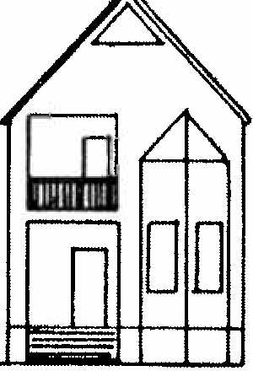

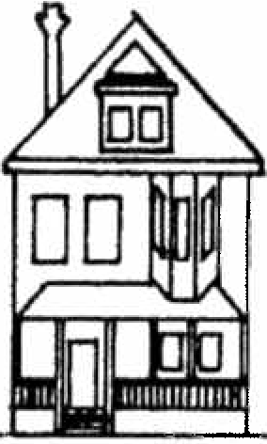
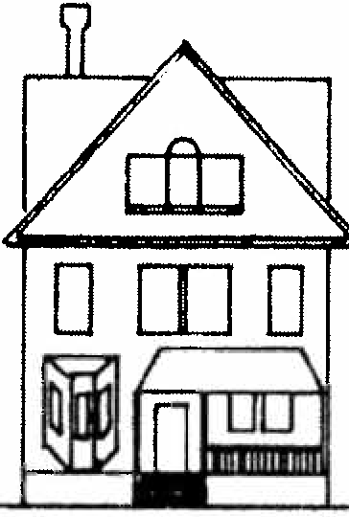
Building heights should be compatible with adjacent structures.

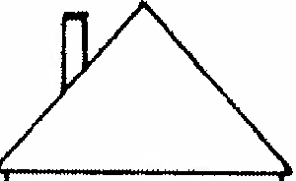
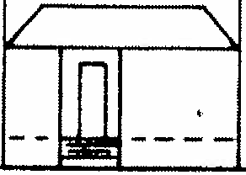

D D D D D

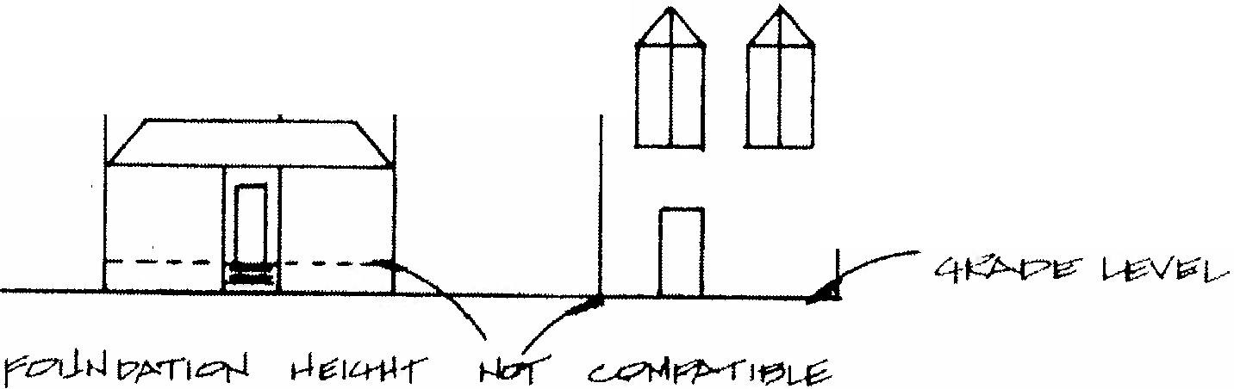
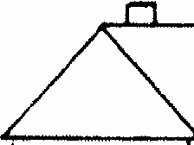
Foundation heights should be consistent with adjacent buildings.

71

#84) FLOOR TO CEILING HEIGHTS SHOULD BE COMPATIBLE WITH HISTORIC STRUCTURES

Normally Required
dimensions. Floor to ceiling heights should not exceed ten feet and not be less 'than eight feet. New construction not built within these dimensions would be out of proportion with adjacent historic residences.

  - New construction should be adjacent structures in floor to Appropriate heights for new eight feet to ten feet.
compatible with ceiling heights. construction are

Historic residences in Sumter have consistent floor to ceiling heights. These dimensions are expressed on the exterior of residences by the size of door and window openings, roof lines, horizontal belt courses, and other elements. New construction should respect these vertical and horizontal

t-l ti;.ftJ-(
it!- 1.?
11.--0-lq a;.'

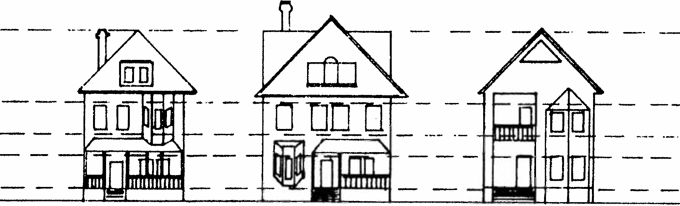
Floor to ceiling heights should be consistent for new construction.

#85) PRIMARY ENTRANCES MUST BE'ORIENTED TOWARDS THE STREET

Normally Required

- New buildings constructed in the residential areas of Sumter should have their main entrances located on the primary or street facades.
- New buildings on corner lots may have entrances located on both street facades.

Historic residences in Sumter were built with the main or primary entrance on the street facade. This characteristic is found throughout the city's older neighborhoods and new construction must maintain this orientation. New dwellings may also have entrances on secondary facades and in some cases these entrances may be the most heavily used. However, the entrance on the main or street facade must have proportions and detailing that gives it the appearance of being the primary entrance. For new buildings on corner lots the entrance should be placed on the facade which is considered to be the primary or dominant street. Entrances on both the primary and secondary facades are also allowable for buildings on corner lots.
#86) NEW CONSTRUCTION MUST HAVE SOME TYPE OF PORCH CONFIGURATION ON THE PRIMARY FACADE

Normally Required

- New construction in residential areas should be built with porches on primary or street facades. The design, placement, and height of these porches should be in accordance with adjacent buildings along the block.
- Two-story porches are less desirable than one­ story porches. Small decorative balconies should also be avoided on primary facades.
- Porches should have depths of at least six feet and have simple columns and balusters.

Almost all Sumter historic residences have some type of porch on the primary or street facade. These porches vary with some extending across the entire width of a facade or being as minimal as a small entry porch at the entrance. These porches are generally one-story in height and two-story porches are rare. New construction must maintain the rhythm and placement of porches of adjacent structures along a block. Porches on new buildings should be compatible in size, height, and proportion of adjacent buildings. Oversized porches or balconies not in keeping with historic Sumter residences should not be constructed.
Porches should have depths of at least six feet. Porch columns should be simple in design with square or round columns acceptable. Porch columns should be a minimum of six inches and a maximum of ten inches in diameter or square.
Ornate milled columns or variations of Greek orders are too imitative and should not be added to porches on primary facades. Simple square balusters for porch railings are appropriate.

#87) NEW CONSTRUCTION MUST MAINTAIN THE RHYTHH OF DOOR AND WINDOW OPENINGS ON PRIMARY FACADES

Normally Required

a . New construction must maintain the rhythm and spacing of window and door openings of adjacent historic residences .
b . Primary facades shall not have blank walls or walls with only one door or window opening .
c . Window and door openings shall not exceed the height and width ratios of adjacent buildings by more than ten percent (10% ) .

The primary or street facades of historic residences in the Sumter districts have at least two and more often three to four door and window openings. The most common arrangements are window-door, window-door-window, window-window­ door-window-window, or window-window-door. This rhythm and spacing of windows and doors is a
significant characteristic of historic residences and this rhythm must be maintained and continued on new buildings. Primary facades should not have blank walls or walls with only one door or window opening. Openings on primary facades should reflect the rhythm and spacing of windows and doors on adjacent buildings.
The height and width of window and door openings should also be in accordance with neighboring structures. Oversized doors or undersized doors or windows should not be built on primary or readily visible secondary facades. Door and window openings should not exceed the height and width ratios of adjacent buildings by more than ten-percent (10%). If window shutters are desired they should meet the size and configuration guidelines set forth in the Rehabilitation Guidelines.

D
D
D
DD
DD
DD

Common window and door opening rhythms should be maintained.

#88) NEW CONSTRUCTION SHOULD MAINTAIN THE RHYTHM AND SPATIAL DISTANCES BETWEEN BUILDINGS

Normally Required

a. Side yard setbacks for new construction should maintain the rhythm and spatial arrangements found along the street.

Streetscapes throughout Sumter have certain rhythms which are created by the spatial distances between buildings. These distances vary from block to block depending on the size of lots and density of construction. This spacing creates a distinct pattern
and new construction should reinforce rather than disturb this rhythm.
Minimal spatial arrangements are largely regulated by the Sumter Zoning Ordinance through side yard setback requirements. Areas such as West Hampton have minimum side yard setbacks of 10' between buildings while in other areas the minimum is 8' . These minimum standards are not acceptable for most blocks in Sumter' s historic areas and the spatial arrangements of 2 0 ' to 25 ' between buildings are more common and appropriate. New construction should go beyond existing zoning requirements for side yard setbacks to correspond with the rhythm and spacing typical of it street and block.

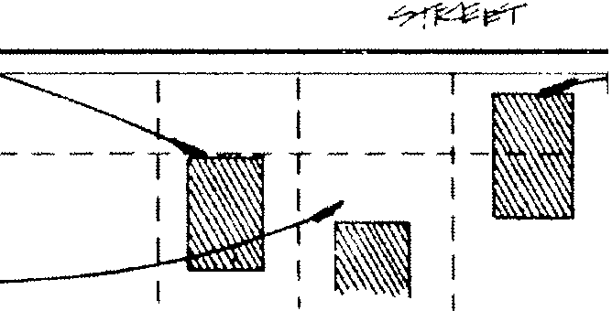
_IJ_R _llL
,
1
1
I I
I I
I
I
.
I
I _
::
VI"-! t-h;-11-l C-&"1o/1'te= cJ.r·
-vf.it...:>-
-r'i _ --- 'I
Setbacks on primary and secondary facades should be maintained.

#89) SETBACKS FOR NEW CONSTRUCTION SHOULD BE CONSISTENT WITHADJACENT STRUCTURES

Normally Required

a. New construction should conform with the minimum zoning requirements for setback on a lot and be compatible with the setbacks of adjacent structures.

Residences in the historic areas are set back certain distances from the street to provide for a front yard. The depth of the setback varies but is generally at least 10' in mill villages and 25' in other historic neighborhoods. New construction should be consistent with the average setbacks along a block.
The importance of proper setbacks is recognized in the Sumter Zoning Ordinance. All residential classifications have a minimum of 35' setbacks on the primary facades while some office and commercial zones have 20' setbacks. This assures that buildings will not be constructed close to the sidewalk and disturb the existing setback rhythm on most streets. New construction should also not be constructed towards the rear lot line to create a deep front yard also out of conformance with most setbacks. The Sumter Zoning Ordinance does make provisions to match non-conforming front setbacks within 200 feet in the same block.
#90) ROOF FORMS AND ORIENTATION SHOULD BE CONSISTENT WITHADJACENT BUILDINGS

Normally Required

- Gable and hipped roof variations are appropriate roof forms for new construction. Flat or mansard roof forms should not be added in the residential areas.
- Roof slope ratio should be a minimum of 6:12 and a maximum of 12:12. Roof eaves should be a minimum of 8".
- Roofs should be oriented with the ridge line parallel to the street. Gable front designs in the historic districts are not appropriate.

New construction should follow the roof forms and orientation of adjacent buildings. The most common roof forms in the Sumter historic neighborhoods are variations of gable and hipped forms. Gable and hipped roofs are found on every street and almost all of these roof forms have their ridge line parallel to the street. Gable front designs with the ridge line perpendicular to the street are uncommon. New construction should have roofs of gable or hipped designs and flat roofs, mansard roofs, shed roofs, and similar designs should be avoided. Roof slope ratio should be a minimum of 6:12 to a maximum of 12:12. Roof eaves should have a minimum depth of 811 •

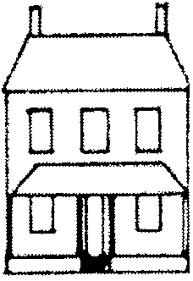
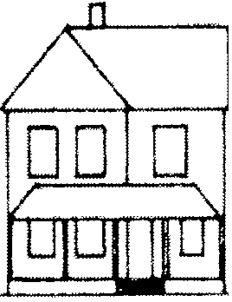
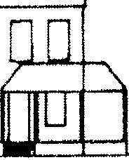
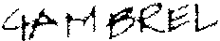

DD
DD
y/E:0. f('J174ft1.,; fS'..
I'? f' f L, L,tl,-> ··fv'
ti '71,.:i;;[::--(
Nc.
t;,dc?µ LV wr r,¢
FL1-ff t-.1 r-l e
f r7!1iJ PL iJt+ ie-
i</
-11-1 i'? qrr1::1&(
I
I I I I
o
'/,_ -
\ I I
I
I
'\
0
0

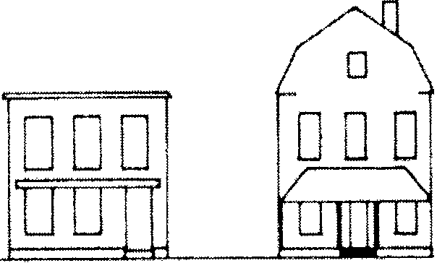
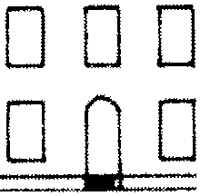
Appropriate and inappropriate roof forms. Rooflines should be parallel to the street.

77

#91) MATERIALS FOR NEW CONSTRUCTION SHOULD BE COMPATIBLE WITHHISTORIC MATERIALS

Recommended

a . New construction should be of f rame for most historic areas of Sumter . Blocks with a minimum ratio of one brick building f or every two frame buildings are acceptable locations f or new brick construction .
widths of four to six inches. Shiplap siding in these dimensions may also be acceptable. Vinyl siding, aluminum siding, and other artificial siding materials are not compatible with the historic neighborhoods and should not be used in new construction.
Brick exteriors should be of brick consistent with the dimensions, color, and texture, or existing brick materials in the districts. Oversized or undersized bricks, light colored or

b . Exterior siding materials should be of weatherboard,
f or frame buildings clapboard or shiplap
patterned brick, or unusually wide or narrow
mortar joints should not be used. Other masonry

siding . Artif icial sidings vinyl should not be allowed .
such as aluminum and
materials such as concrete, stone veneers such as
permastone, or aggregate and stucco mixtures

c . Buildings of brick construction should be compatible wi th historic brick buildings in width of the mortar joints , size and scale of the bricks , color , and texture .
d. Porch details such as columns and railings should be of wood or brick .
e . Foundations may be of brick or concrete . If concrete blocks are used they should be painted or covered with stucco .
f . Acceptable roof materials are asphalt shingles and metal standing seam . Wood shingle roof s should not be added .

Residences in the historic districts of Sumter are primarily of frame and brick construction with frame predominating. Buildings of frame are the most appropriate and compatible material for the historic neighborhoods of Sumter. Brick may also be used as the primary building material on blocks which have a ratio of brick to frame of 1 to 2.
Exterior siding for new frame buildings should be weatherboard or clapboard siding in

78
should not be used.
Porch elements on the primary facade should be of wood or brick. Aluminum, wrought iron, or other metals should not be used as porch elements on the primary facade.
Foundations may be of concrete or brick. If concrete block is used is should have a stucco or painted surface. Concrete blocks that resemble stone or are scored may also be used.
Roofs may be of asphalt shingle or other composition forms and metal standing seam. Wood shingle roofs are not acceptable for new construction.

Note : A General Certif ication to use vinyl siding has been given by Sumter City Council provided it is for the siding only and then owner is made aware of the pros and cons of vinyl siding by the Staff .

#92) ADDIT'IONS TO BUILDINGS SHALL NOT BE BUILT ON PRIMARY FACADES

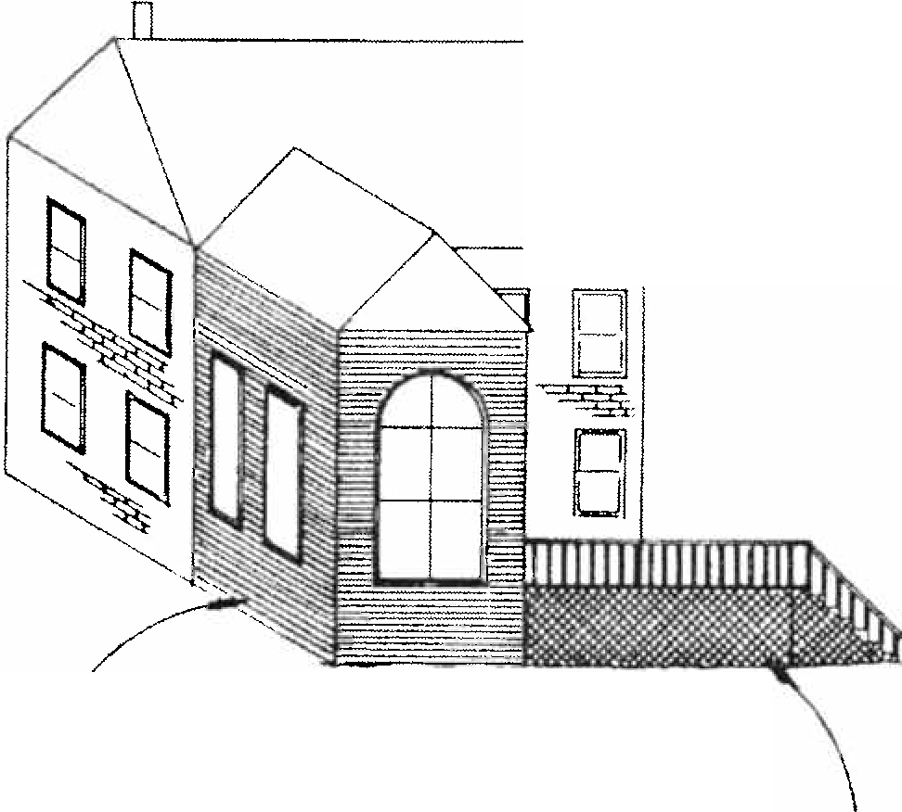
Normally Required

V'ts."' I":'.- m;,-.r;:,;:
t-lC•'( fq;S;,- 171 L,C)/
v'l".C'J f" l-8' PkCf'-'1
-r ,l i; .t 'l r< ?(
0
\

iJ ""o,J-r le'' 0rt> f:l' f--"'f
f'-t=' t'Tf·1 c;;,f-{ or-! v"l'-JC
pf>..:P·Tl ·

f'.:-. VF r p;. !c- t-1,'."'1.
V1-;',1 r3L C: f'f'.'..C"0
·n-.it. .:--tfi.-£ 0-r

- Additions to buildings shall not be built on primary facades.
- Rear facades and secondary facades not readily
visible from the street are appropriate locations for contemporary additions.
- Additions should be contemporary but compatible with a building. Exact replication of historic structures for additions should be avoided.
- Additions should not overwhelm or dominate the original structure. The square footage of additions should be limited to no more than 50% of the square footage of the original building.

Additions to buildings shall not be built on primary facades or secondary facades readily visible from the street. Additions on rear facades are acceptable if they are compatible with the original building and if the square footage of the addition does not exceed the square footage of the original structure by more than 50%. Additions must be compatible in height and no part of the addition's roofline should project higher than the roofline of the original building. An addition may have different siding materials, window and door arrangement, roof form and pitch, and massing to distinguish it from the original building. An addition should not be an imitation of the original building and have reproductions of historic detailing.
The construction of wood or brick decks on rear facades or secondary facades not readily visible from the street shall be allowed.

Rea r f a cad es a re appropria te f or a dd i t ions.

#93) ON-SITE PARKING SHOULD BE LOCATED AT R'EAR OR SIDE FACADES

Normally Required

- On-site parking should be in rear or side yards and never between the primary facade and the street.
- On-site parking should follow site and landscaping regulations of the Zoning Ordinance.

Recommended

- Oriveways should be of textured or colored concrete, brick, or similar paving materials as opposed to smooth white concrete or asphalt.

New buildings constructed in the historic districts should have parking located on the side or rear facades. Parking areas between the primary facade and the street should not be installed. The Zoning Ordinance has an extensive discussion of on-site parking requirements and in most residential zoning classifications parking is prohibited in front yards. The Ordinance also has regulations concerning landscaping and curb cuts for driveways.
In addition to the zoning regulations
#94) HISTORIC BUILDINGS SHOULD NOT BE RELOCATED out OF A DISTRICT

Recommended

- A building or structure in a historic district should not be moved or relocated out of the district if the building or structure retains its architectural and historical integrity.
- A building or structure that does not contribute to the architectural and historical character of a district may be moved or relocated if its removal would result in a more positive visual appearance to the district.

Structures or buildings should not be moved or relocated out of a historic district. The only exceptions should be in situations where necessary for the public welfare of where necessitated by publicly funded projects. Relocation generally results in a negative effect to a district and should be avoided.

#95) HISTORIC BUILDINGS WTHHINA DISTRICT SHOULD NOT BE RELOCATED

Recommended

concerning on-site parking, it
that driveways be of brick, or
is also recommended
textured or colored

concrete as opposed to white black asphalt.
smooth concrete
or a. Historic buildings within a district should not be moved from one site to another except where
threatened with demolition or loss of integrity of site and setting.
b. Buildings that are moved to another location in a district should be compatible with buildings adjacent to the new location in style, height, scale, materials, and setback, and be similar in site and setting.

Relocation of historic buildings within a district should take place only in cases of imminent demolition or where a property's site and setting is significantly compromised. If a building is moved it should be compatible with adjacent structures at its new location, and should have a site and setting similar to its neighbors.

#96) RELOCATION OF HISTORIC BUILDINGS INTO A DISTRICT HAY BE APPROPRIATE

Normally Required

- Relocation of a historic building into a district may be appropriate if it does not result in the loss of a historic building on the site to which it is moved.
- A building may be moved into a district if it maintains and supports the district's architectural character through its style, height, scale, massing, materials, texture, site, and setting. The building must be architecturally compatible with adjacent structures on its new site.

Recommended
- Where buildings have been moved into a district it is recommended that they be identified through a plaque or marker dating both the original construction date and moving date.
are moved into a district should be identified as such to avoid confusion with the original buildings of a district.

#97) HISTORIC BUILDINGS SHOULD NOT BE DEMOLISHED

Normally Required

- Historic buildings in Sumter's districts should not be demolished. Demolition may only be approved if one or more of the following conditions are met:
  - Where the public safety and welfare requires the removal of a structure or building.
Where economic hardship has been demonstrated, proven, and accepted by the Board of Historical Review.
Where the structural instability or deterioration of a property is demonstrated through a report by a structural engineer or architect. Such a report must clearly detail the property's physical condition, reasons why rehabilitation is not feasible, and cost estimates for rehabilitation versus demolition. In addition to this report there should be a separate report that details future action on the site.
  - Where buildings have lost their original architectural integrity and no longer contribute to the character of a district.
After a 120-day waiting imposed by the HPDRC to determine if the building could be saved by others.

Vacant lots are found residential historic districts
throughout of Sumter.
the The

relocation of historic properties to these vacant lots is appropriate if they are architecturally compatible with the adjacent structures and are consistent in site and setting. Properties that

APPENDIX A
QUEEN ANNE STYLE, ca. 1880 - 1905
Windows - One-over-one rectangular sash, use of stained or beveled glass.
Plan - Irregular

Roof - Gable and Hipped Materials - Weatherboard siding, wood shingles in gables, eave vergeboard and milled panels.
Chimney - Both interior and exterior with
decorative corbelling. Porches - Full width, sometimes extending on two to three facades in .wraparound. fashion, use of

Entrance - Ornate milled designs with large
glass lights, sidelights, and transoms.
milled columns, balusters, and friezes.

Details - Often extensive use of milled panels, wood shingles, eave vergeboard, and decorative brick.

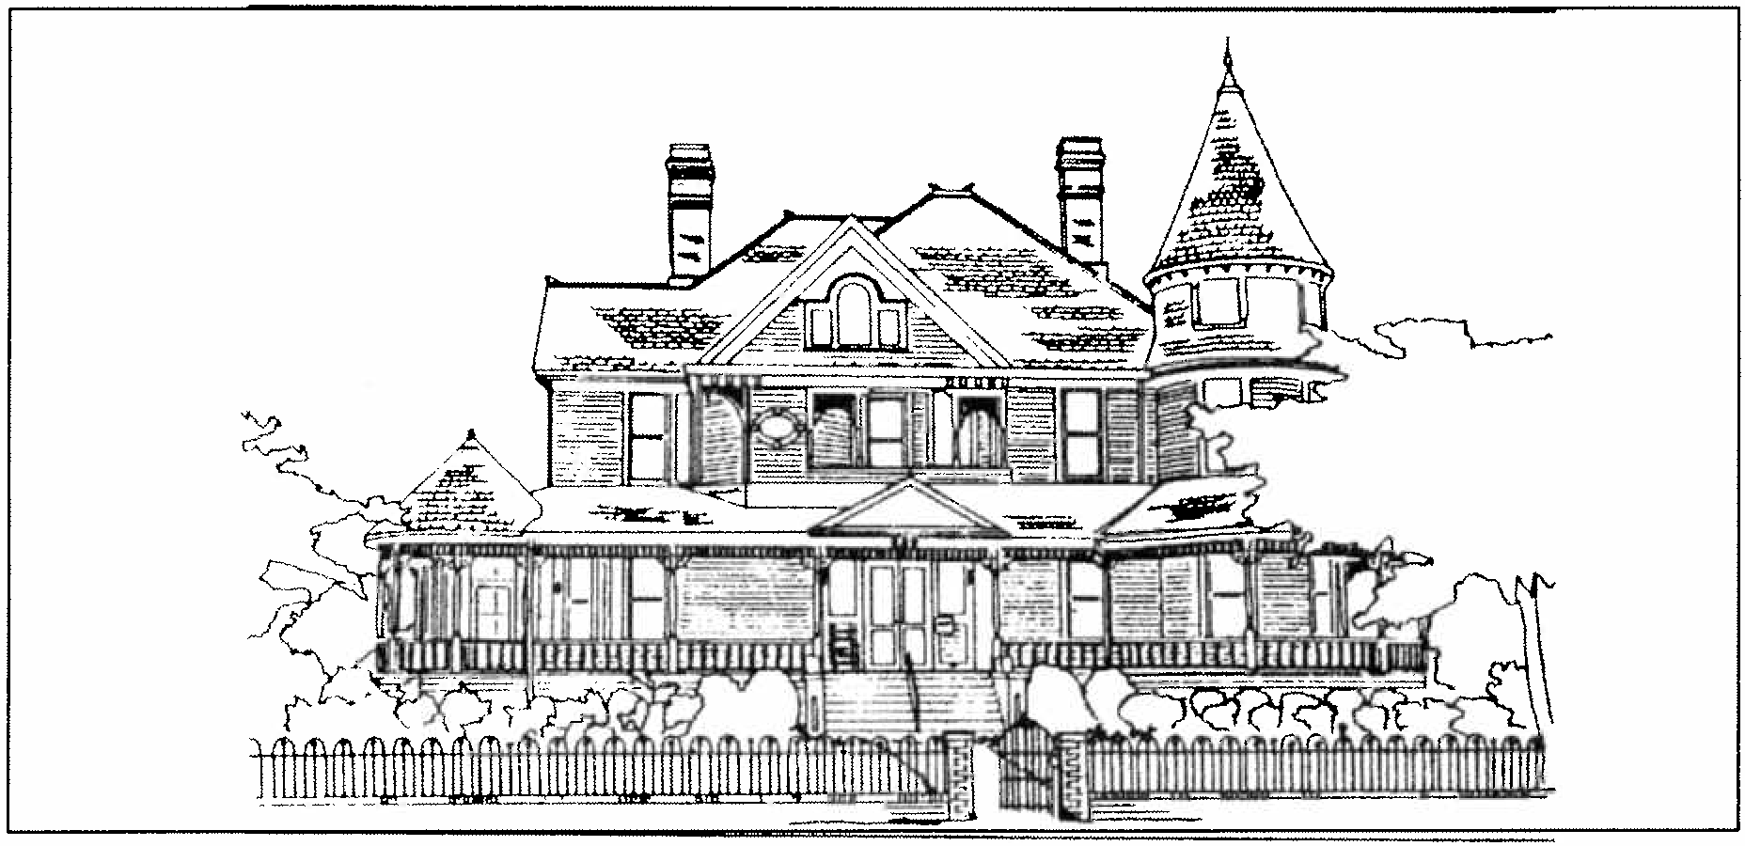
Queen Anne residence.

GABLE FRONT AND WING OR L-PLAN COTTAGE, ca. 1880 - 1910 .

Plan - L-Plan with projecting gabled bay on primary facade.

Roof - Cross gable forms.
Chimney Both interior and exterior with limited detailing.

Windows One-over-one or two-over-two rectangular sash.

Materials - Weatherboard siding. wood shingles in gables, eave vergeboard and milled panels.

Porches - Partial width with shed roofs. use of milled columns. balusters, and friezes.

Entrance - Single light glass and wood designs, sometimes with ornate panels, transoms. small sidelights.
Details - Wood shingles, eave vergeboard, and milled panels.

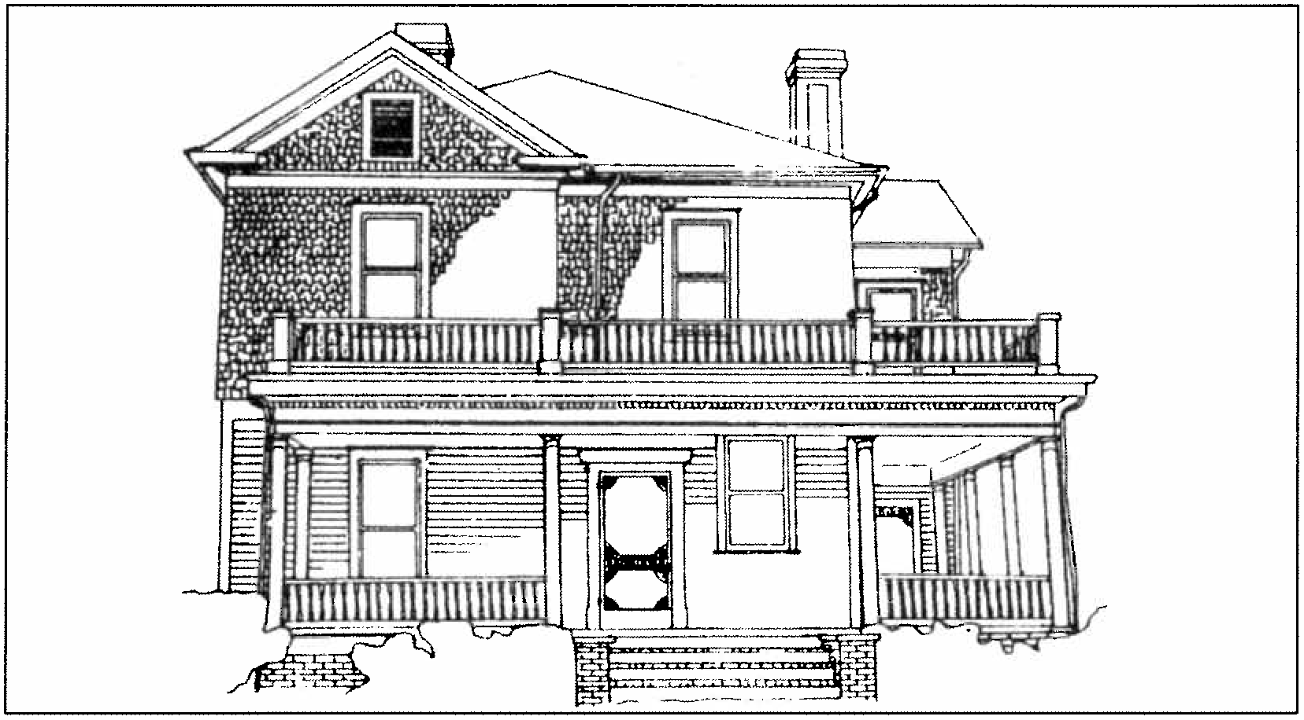

Res i dence .

COLONIAL REVIVAL, ca . 1895 - 1930

Plan
irregular
Rectangular, square, sometimes Windows One-over-one rectangular
sometimes use of Palladian window designs.
sash,

Roof - Hipped with hipped or gable dormers.

Chimney Both interior and exterior with corbelled brick detailing

Materials
gables.

Weatherboard siding, wood shingles in

Entrance - Single light glass and wood designs, framed by pilasters and engaged columns, large transoms and sidelights, use of beveled or leaded glass.
Porches Full width with Colonial influenced columns such as Doric, Ionic, Corinthian, and Tuscan orders, milled or square balusters, eave details such as modillion blocks and dentils.

Details - Eave modillion blocks, dentils, in Neo­ Classical designs large porticos on primary facade, oval shaped attic windows.

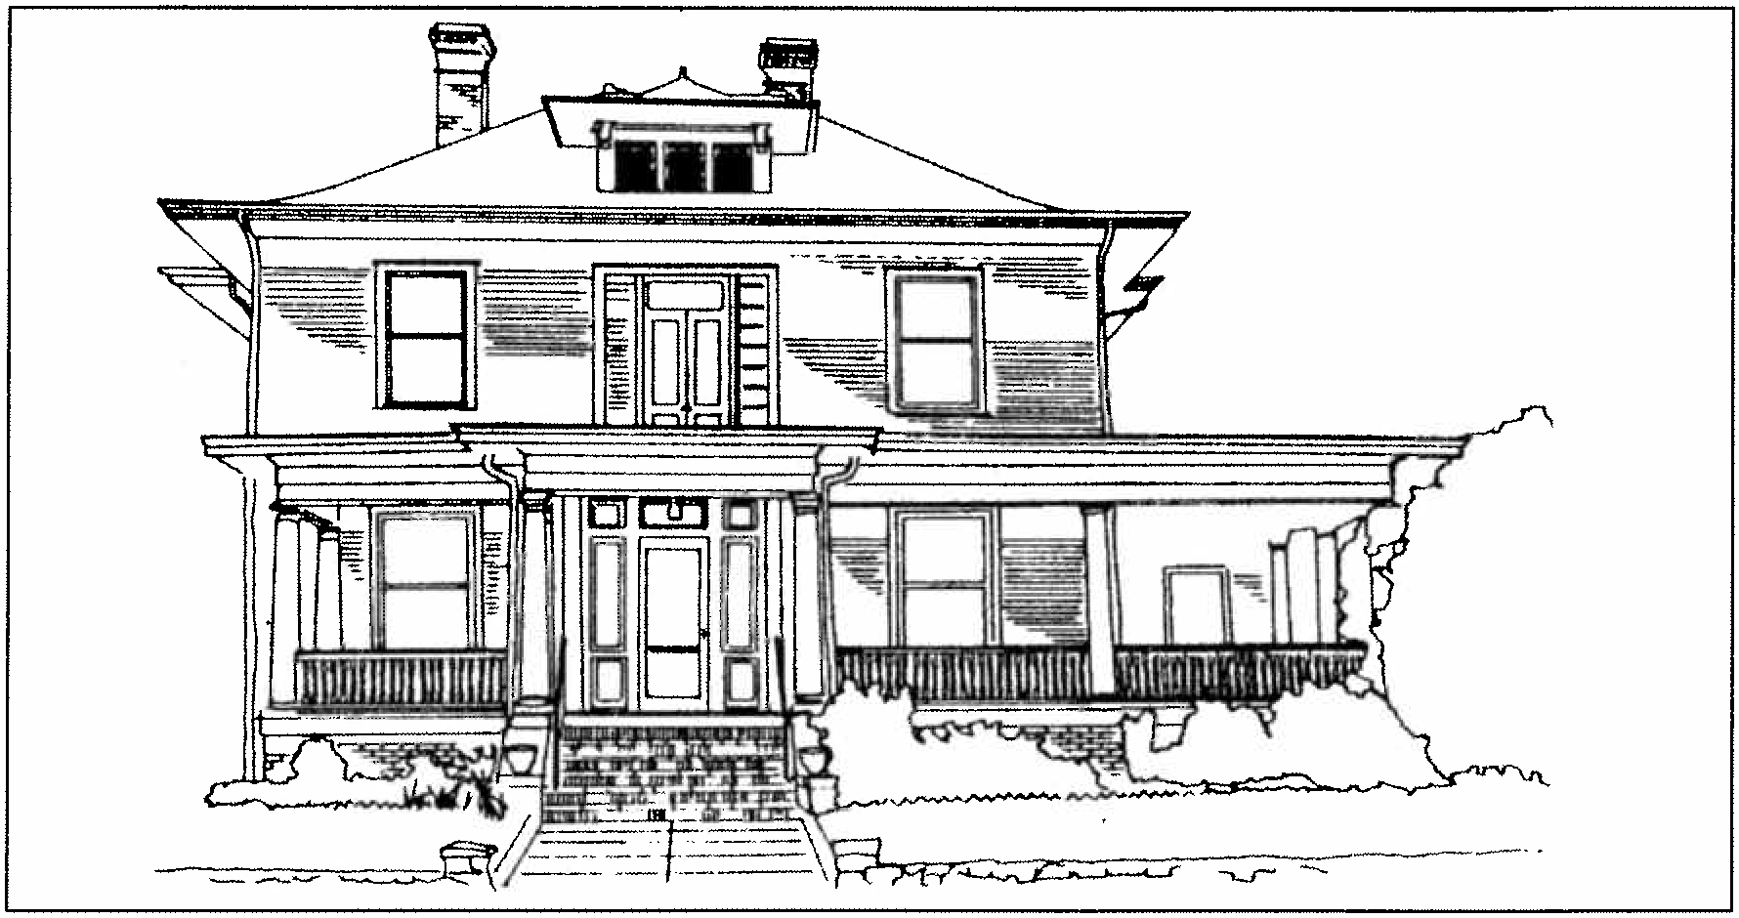
Colonial Revival residence

BUNGALOW, ca. 1910 - 1940

Plan - Rectangular, or square with horizontallity emphasized.
Materials - Weatherboard siding, shiplap siding, wood shingle siding, use of brick veneer in various shades and textures.

Roof - Low hipped with or low gable, sometimes with dormers on each facade.

Chimney - Both interior and exterior with corbelled brick detailing, also use of stone and concrete.

Entrance - Multi-light glass and wood designs, use of beveled or leaded glass.

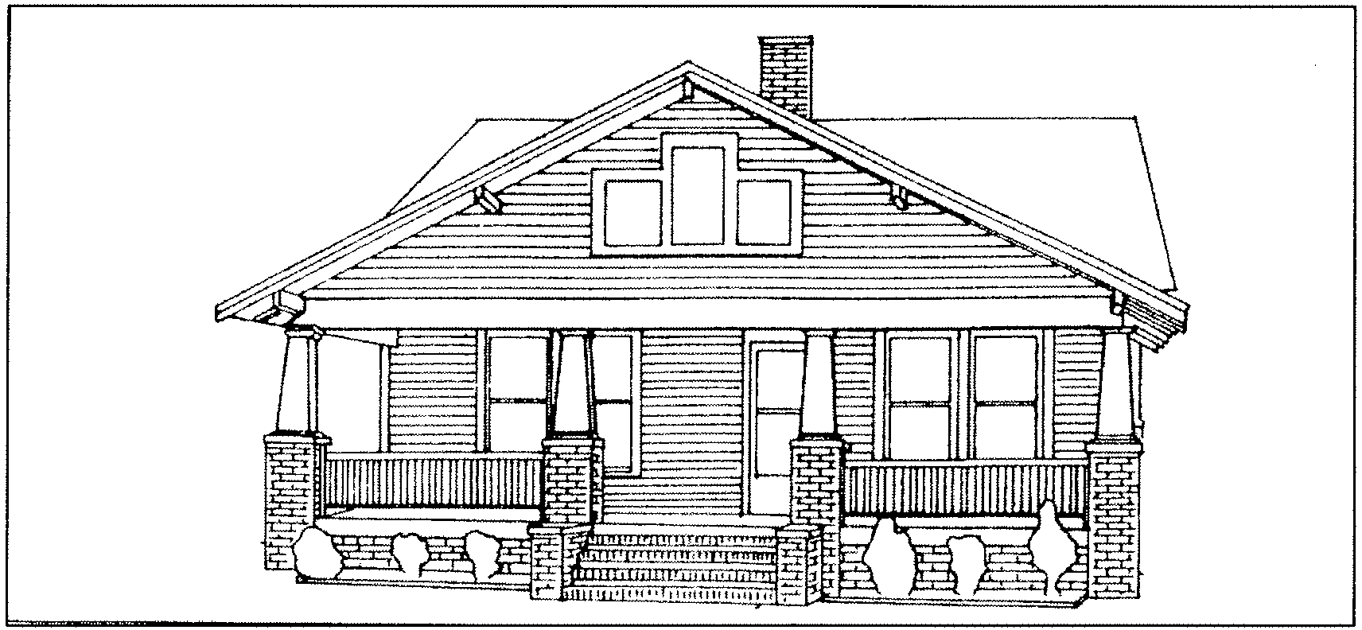
Windows - Three-over-one rectangular sash with the upper sash having vertical divisions, often paired or grouped together.

Bungalow residence.
Porches - Full width shed or gable designs with tapered frame posts on brick or stone piers, square balusters, large eave brackets.

Details - Wood shingles in the gables, large knee brace brackets at eaves, exposed eave rafters.

APPENDIX B

HAMPTON PARK and CENTRAL BUSINESS DISTRICTS OVERLAYS

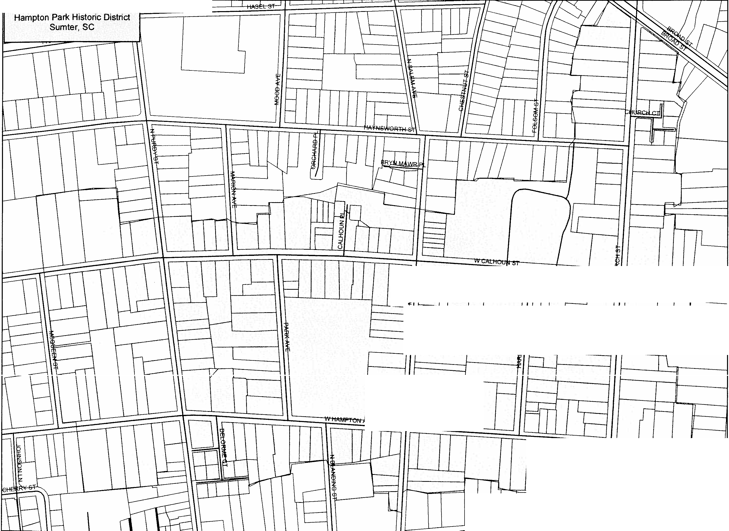
I I

-
-
!
- --
-
-

-

r--r----.----1 II I

r-------11 r U II I I 1
rr=t=r---J -+1 I , r--
L -
I Hampton Park Historic District 245 490 980 Feet
'-----'--...l----1'1....--.L--L- . --l'

Downtown Historic District J
u l 1rl
Sumter.SC N Alm" "'' In
9

t------ I ,,
'i
I I
ST 1
L
'

IT J r
W CANAL ST i . I I
C

"'
....

[ ]
I t-
r---

,-.... 1---.
I
t-----
u = D;W GE
/ fl-{ 1 '-- - -
>---
f
u ...
-.

I-
If I j u ·
I- t=b!}1

'-=I
r- ..
I;: :z ! E)

... 1

t-=h
I I •
r - Q - .3

r-- I
1

I

W U C, /
I
1
II - hr] fit;-==;
L 1J LI
f
I
E UBERTY ST

I:::=:::::!
-, I Ip 1 I I

1
I

I lii rl
L=:;= : --1 -
- 7

1 1 I I I l 1; I
1

LJ
f
1
f
LJ -
L
7 i
1------..:J
1
I
C
i
I
r
.
..._
-r--

-

r----

!:: ,...
:"z'

"' I
:<:.

,5.,' I "' LJ

"' V

VV Ul"ll"'l / l ' '- '-'
-
I
1
1Ul

I I/
-
,
i I
t R '<I TF s
J-_J J

I I I
1 r I I

N
A

150 300 600 Feet
I
Downtown Historic District!

87

APPENDIX C
SECRETARY OF THE INTERIOR STANDARDS FOR REHABILITATION

The Standards that follow were originally published in 1977 and revised in 1990 as part of Department of the Interior regulations (36 CFR Part 67, Historic Preservation Certifications). They pertain to historic buildings of all materials, construction types, sizes, and occupancy and encompass the exterior and the interior of historic buildings. The Standards also encompass related landscape features and the building's site and environment as well as attached, adjacent or related new construction. The Standards are to be applied to specific, rehabilitation projects in a reasonable manner, taking into consideration economic and technical feasibility.

1 . A property shall be used for its historic purpose or be placed in a new use that requires minimal change to the defining characteristics of the building and its site and environment.

2. The historic character of a property shall be retained and preserved. The removal of historic materials or alteration of features and spaces that characterize a property shall be avoided.

3. Each property shall be recognized as a physical record of its time, place, and use. Changes that create a false sense of historical development, such as adding conjectural features or architectural elements from other buildings, shall not be undertaken.

- Most properties change over time; those changes that have acquired historic significance in their own right shall be retained and preserved.

- Distinctive features, finishes, and construction techniques or examples of craftsmanship that characterize a property shall be preserved.

- Deteriorated historic features shall be repaired rather than replaced. Where the severity of deterioration requires replacement of a distinctive feature, the new feature shall match the old in design, color, texture, and other visual qualities and, where possible, materials. Replacement of missing features shall be substantiated by documentary, physical, or pictorial evidence.

- Chemical or physical treatments, such as sandblasting, that cause damage to historic materials shall not be used. The surface cleaning of structures, if appropriate, shall be undertaken in the gentlest means possible.

- Significant archaeological resources affected by a project shall be protected and preserved. If such resources must be disturbed, mitigation measures shall be undertaken.

9. New additions, exterior alterations. or related new construction shall not destroy historic materials that characterize the
property. The new work shall be differentiated from the old and shall be compatible with the massing, size, scale, and architectural features to protect the historic integrity of the property and its environment.

J O. New additions and adjacent or construction shall be undertaken manner that if removed in the essential fonn and integrity of property and its environment unimpaired.

related new in such a future, the the historic would be

APPENDIX D
GLOSSARY OF PRESERVATION AND ARCHITECTURAL TERMINOLOOY

Addition New construction added to an existing building or structure.
Alteration Work which impacts any exterior architectural feature including construction, reconstruction, or removal of any building or building element.
Apron A decorative, horizontal trim piece on the lower portion of an architectural element.
Arch A curved construction of wedge-shaped stones or bricks which spans an opening and supports the weight above it. (see flat arch, jack arch, segmental arch and semi-circular arch)
Attic The upper level of a building, not of
full ceiling height, directly beneath the roof. Baluster One of a series of short, vertical, often vase-shaped members used to support a stair or porch handrail, forming a balustrade.
Balustrade An entire rail system with top rail and balusters.
Bargeboard A board which hangs from the projecting end of a gable roof, covering the end rafters, and often sawn into a decorative pattern.
Bay The portion of a facade between columns or piers providing regular divisions and usually marked by windows.
Bay window A projecting window that fonns an extension to the floor space of the internal rooms; usually extends to the ground level. Belt course A horizontal band usually marking the floor levels on the exterior facade of a building.
Board and batten Siding fashioned of boards set vertically and covered where their edges join by narrow strips called battens.

Bond A term used to describe the various patterns in which brick (or stone) is laid, such as "common bond' or "Flemish bond."
Bracket A projecting element of wood, stone or metal which spans between horizontal and vertical surfaces (eaves, shelves, overhangs) as decorative support.
Common bond A brickwork pattern where most courses are laid flat, with the long "stretcher" edge exposed, but every fifth to eighth course is laid perpendicularly with the small "header" end exposes, to structurally tie the wall together.
Corbel In masonry, a projection, or one of a series of projections, each stepped progressively

Bungalow Common house century distinguished eaves, large porches windows.
form of the early twentieth by horizontal emphasis, wide and multi-light doors and
farther forward with height and articulating a cornice or supporting an overhanging member.
Corinthian order Most ornate classical order characterized by a capital with ornamental

Capital The head of a column or pilaster.
Casement window A window with one or two sashes which are hinged at the sides and usually open outward.
Certified Local Government Any city, county, parish, township, municipality, or borough or any other general purpose subdivision enacted by the
acanthus leaves and curled fern shoots.
Cornice The uppermost, projecting part entablature, or feature resembling it. projecting ornamental molding along the wall, building, etc. Cresting A decorated ornamental finish along the top of a wall or roof, often made of ornamental metal.

National Preservation Act Amendments of 1980 to further delegate responsibilities and funding to
Cross-gable A secondary the primary roof at right
gable roof angles.
which meets

the local level.
Clapboards Horizontal wooden boards thinner at the
Dentils A row of small classical cornice.
tooth-like
blocks
in a

top edge, which are overlapped to provide a
Doric order A classical
order with simple,

weather-proof exterior wall surface.
Classical order Derived from Greek and Roman architecture, a column with its base, shaft, capital and entablature having standardized details and proportions, according to one of the five canonized modes: Doric, Tuscan, Ionic, Corinthian, or Composite.
Clipped gable A gable roof where the ends of the ridge are terminated in a small, diagonal roof surface.
unadorned capitals, and with no base.
Dormer window A window that projects from a roof. Double-hung window A window with two sashes, one sliding vertically over the other.
Eave The edge of a roof that projects beyond the face of a wall.
Elevation Any of the external faces of a building.
Ell The rear wing of a house, generally one room wide and running perpendicular to the principal

Colonial Revival House twentieth century based architectural forms of the to the, Revolution.
style of the early on interpretations of American colonies prior
building.
Engaged column A round column attached to a wall.

Column A circular or square vertical structural member.

Entablature A part of a building of classical order resting on the column capital; consists of an architrave, frieze, and cornice.
Facade The face or front elevation of a building. Fanlight A semi-circular window usually over a door with radiating muntins suggesting a fan.
Fascia A projecting flat horizontal member or molding; forms the trim of a flat roof or a pitched roof; also part of a classical entablature.
Fenestration The arrangement of windows on a building.
Finial A projecting decorative element, usually of metal, at the top of a roof turret or gable.
Fishscale shingles A decorative pattern of wall shingles composed of staggered horizontal rows of wooden shingles with half-round ends.
Flashing Thin metal sheets used to prevent moisture infiltration at joints of roof planes and between the roof and vertical surfaces.
Flat arch An arch whose wedge-shaped stones or bricks are set in a straight line; also called a jack arch.
Flemish bond A brick-work pattern where the long "stretcher" edge of the brick is alternated with the small "header" end for decorative as well as structural effectiveness.
Fluting Shallow, concave grooves running vertically on the shaft of a column, pilaster, or other surface.
Foundation The lowest exposed portion of the building wall, which supports the structure above. Frieze The middle portion of a classical cornice; also applied decorative elements on an entablature or parapet wall.
Gable The triangular section of a wall to carry a pitched roof.
Gable roof A pitched roof with one downward slope on either side of a central, horizontal ridge.
Gambrel roof A ridged roof with two slopes on either side.
Greek Revival style Mid-nineteenth century revival of forms and ornament of architecture of ancient Greece.
Hipped roof A roof with uniform slopes on all sides.
Hood molding A projecting molding above an arch, doorway, or window, originally designed to direct water away from the opening; also called a drip mold.
Ionic order One of the five classical orders used to describe decorative scroll capitals.
Infill New construction where there had been an opening before, such as a new building between two older structures; or block infill between porch piers or in an original window opening.
Jack arch (see Flat arch)
Keystone The wedge-shaped top or center member of an arch.
Knee brace An oversize bracket supporting a cantilevered or projecting element.
Lattice An openwork grill of interlacing wood strips used as screening.
Lintel The horizontal top member of a window, door, or other opening.
Mansard roof A roof with a double slope on all four sides, with the lower slope being almost vertical and the upper almost horizontal.
Masonry Exterior wall construction of brick, stone or adobe laid up in small units.
Massing The three-dimensional form of a building.
Metal standing seam roof A roof composes of overlapping sections of metal such as copper­ bearing steel or iron coated with a terne alloy of lead and tin. These roofs were attached or

crimped together in va rious raised seams for which the roof are named.
Modillion A hori zontal bracket . often in the fo­ of a plain block . ornamenting . or sometimes supporting . the underside of a cornice .
Mortar A mixture of sand . lime. cement . and water used as a binding agent in masonry construction.
Mullion A heavy vertical divider between windows or doors.
Multi-light window A window sash composed of more than one pane of glass .
Muntin A seconda ry framing membe r to divide and hold the panes of glass in multi-light window or glazed door .
Nee-classical style Early twentieth century style which combines features of ancient , Renaissance, and Colonial architecture; characterized by imposing bu ildings with large columned porche s.
Oriel window A bay window which emerges above the ground floor level.
Paired columns Two columns supported by one pier. as on a porch.
Palladian window A window with three openings . the central one arched and wider than the flanking ones .
Panelled door A door composed of solid panels (either raised or recessed ) held within a framework of rails and stiles.
Parapet A low horizontal wall at the edge of a roof.
Pediment A triangular crowning element forming the gable of a roof; any similar triangular element used over windows , doors , etc.
Pier A vert i.cal structural element , square or rectangular in cross-section.
Pilaster A square pillar attached, but projecting from a wall , resembling a classical column .
Pitch The degree of the slope of a roof.
Portico A roofed space, open or partly enclosed , forming the entrance and centerpiece of the facade of a building . often with columns and a pediment .
Portland cement A strong . inflexible hydraulic cement used to bind mortar. Mortar or patching materials with a high Portland cement content should not be used on old buildings . The Portland cement is harder than the masonry, thereby causing serious damage over annual freeze-thaw cycles .
Preservation The act of maintaining the form and character of a buildin g as it presently exists . Preservation stops deteriora tion and stabilizes the structure.
Pressed tin Decorative and functional metalwork made of molded tin used to sheath roofs. bays , and cornices .
Pyramidal roof A roof with four identical sides
rising to a central peak .
Queen Anne style Popular late nineteenth century revival style of early eighteenth century English architecture . characterized by irregularity of plan and mass ing and a variety of texture .
Quoins A series of stone . bricks . or wood
panels ornamenting the outside of a wall . Reconstruction The accurate recreation of a vanished . or irreplaceably damaged structure . or part thereof; the new construction recreates the building 's exact form and detail as they appeared at some point in history .
Rehabilitation The act of returning a building to usable condition through repair. alteration. And or preserv ation of its features.
Restoration The process of accurately taking a building 's appearance back to a specific period of time by removing later work and by replacing missing earlier features to match the original .

113

Ridge The top horizontal member of a roof where the sloping surfaces meet.
Rusticated Roughen ing of stonework of concrete blocks to give greater articulati on to each block. Sash The moveable framework containing the glass in a window .
Segmental arch An arch whose profile or radius is less than a semicircle.
Semi-circular arch An arch whose profile or radius is a half- circle the diameter of which equals the opening width .
Sheathing An exterior covering of boards of other surface applied to the frame of the structure. (see Siding)
Shed roof A gently -pitched, almost flat roof with only one slope .
Sidelight A vertical area of fixed glass on either side of a door or window .
Siding The exterior wall covering or sheathing of a structure.
Sill The bottom crosspiece of a window frame . Spindles Slender, elaboratel y turned wood dowels or rods often used in screens and porch trim .
Stabilization The essential maintenance of a deteriorated building as it exists at present , establish ing structural stability and a weathe r­ resistant enclosure .
Streetscape The over facade, not of a single structure, but of the many buildings that define the street .
Surround An encircling border or decorative frame, usually at windows or doors.
Swag Carved ornament on the form of a cloth draped over supports, or in the form of a
garland of fruits and flowers.
Transom A horizontal opening (or ba r) over a door or window . (see Over-light)
Trim The decorative framing of openings and other features on a facade .
Turret A small slender tower .
Veranda A covered porch or balcony on a building's exterior .
Vergeboard The vertical face board following and set under the roof edge of a gable, sometimes decorated by carving.
Vernacular A regional form or adaptation of an architectural style .
Wall dormer Dormer created by the upward extension of a wall and a breaking of the roofline.
Water table A projecting horizontal ledge, intended to prevent water from running down the face of a wall's lower section.
Weatherboard Wood siding consisting of overlapping boards usually thicker at one edge than the other .

